

**CSCI-5410 SERVERLESS DATA PROCESSING**

**Project Report**

**Group 24**

|  |  |
| --- | --- |
| **Benny Tharigopala** | **B00899629** |
| **Jaswanth Mandava** | **B00874871** |
| **Kandarp Parikh** | **B00873863** |
| **Prit Thakkar** | **B00890731** |
| **Ruchi Shinde** | **B00897784** |
| **Viren Malavia** | **B00895669** |

**Course Instructor: Dr. Saurabh Dey**

**GitLab URL:** [**csci5410_Group24**](https://git.cs.dal.ca/benny/csci5410_Group24)

**Application URL:** [**https://bnb-til6sazzwa-uc.a.run.app/**](https://bnb-til6sazzwa-uc.a.run.app/)

Table of Contents

1. Problem Statement 3

2. Application Summary 3

3. Implementation Details (Explain the serverless technologies used (eg. cloud functions, pub/sub etc. how is it implemented and integrated) 3

**3.1** **User Management** 3

**3.2** **Authentication** 4

**3.3 Online Support** 12

**3.4 Message Passing** 22

**3.5 Room Reservations** 29

**Code Blocks** 32

**3.6 Machine Learning** 34

**3.7 Web Application and Hosting** 41

**3.8 Report Generation** 43

**3.9 Visualization** 43

4. Testing (UI Screenshots) 46

**4.1 User Management** 46

**4.2 Authentication** 46

**4.3 Online Support** 46

**4.4 Message Passing** 49

A. Menu page (available for authenticated and unauthenticated users) 49

B. Cart Items page where the user can check the items, add or remove them and place an order. 49

C. Response for unauthenticated user while trying to place an order 50

D. Redirect to the notifications page once the order has been placed successfully. 50

E. Error when an unauthenticated user tries to visit the navigations page 50

F. Generated downloadable pdf when an authenticated user clicks on Download Invoice. 51

**4.5 Room Reservation** 51

**4.6 Machine Learning** 55

**4.7 Web Application and Hosting** 71

**4.8 Report Generation** 72

**4.9 Visualizations** 73

5. Meeting Logs 75

6. Individual Contribution 76

7. Limitations 77

8. References 77

# Problem Statement

To build a multi-cloud serverless application using Amazon Web Services and Google Cloud Platform for a hotel management service called Serverless Bed & Breakfast with integrations room booking, like kitchen and inventory management, online support to customers, tour recommendations and booking with reports and visualizations for understanding the customer trends and recommend tour packages.

# Application Summary

DALSoft5410 has planned a Bed and Breakfast System (B&B) which is a serverless application that runs using cloud services. The application will be running using cloud services of different cloud providers i.e., multi-cloud architecture. The application will be used to book rooms, order food, and book tours by the users.

The functionalities required by the application are user authentication that allows users to login and logout of the application securely. The user can also book rooms, order food, and book tours after logging in to the application. The other important functionality is features like chat bots which can be used to use all these user functionalities. Apart from there we also have some functionalities handling the messages between the services like pub/sub (publisher / subscriber) and machine learning models running behind the scenes to let the users experience better tour suggestions and feedback analysis which can reduce the human efforts required. Last but one of the key features is visualization which will show the visualized representation of the using the big query and data studio.

All these functionalities together will create an application that is safe and secure application that runs without any server.

# Implementation Details

## **User Management**

For User management, Amazon Cognito [1] would be used for user authentication and validation whereas combination of Cloud Function and Firestore would be used to store user specific data such as First name, Lastname, age, Email and Security question & Answer

At the time of registration, the user will be provided with a random key (1-26) which would be used for Caesar cipher during login and authentication. This generated cipher key will be stored in DynamoDb via Lambda function.

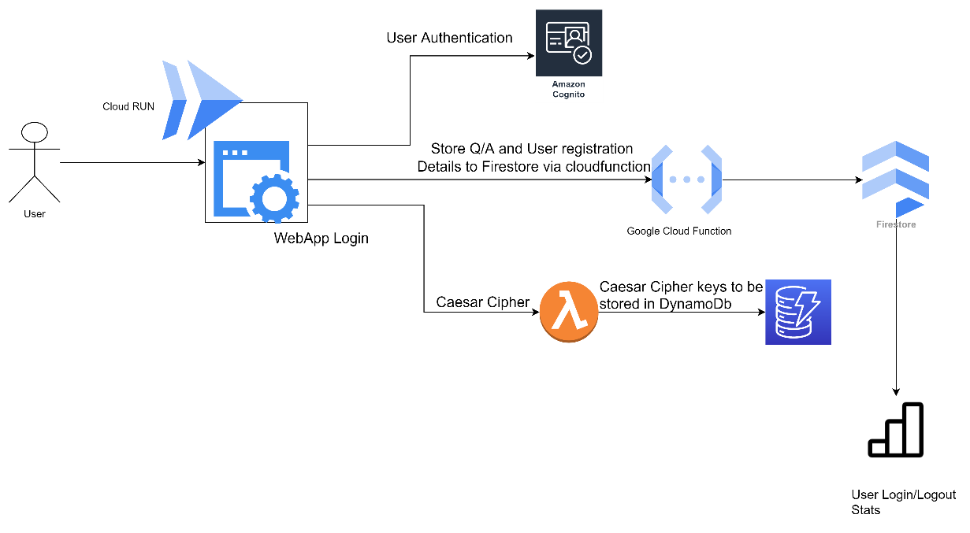

Figure 1 User login and management

## **Authentication**

Once the user is registered, they will be redirected to the login page. Figure 1 shows the flow of the login process. Login process contains three levels of authentication.

1. First level is the Cognito authentication, the user enters their email and password which will be authenticated by Cognito [1].
2. Once the Cognito authentication is successful, the user will be redirected to a new page where the other two steps of verification will take place. Second step of verification is security question and answer. The user will get the security question which will be retrieved from Firestore[11] and user will have to enter the answer which was entered during the time of registration.
3. The third step of authentication involves Caesar cipher. The user will get the plaintext from the system. User will have to convert the plaintext to the cipher text using the key which was generated at the time of registration. The user cipher text along with the plaintext and the email id will be sent to the lambda function. The lambda function will receive these details, retrieve the key from DynamoDB [12] based on the user email id and calculate the cipher text from the generated plain text. If both the cipher texts match then the lambda function will return true result else it will return false.

Once all these three steps of authentication are completed successfully. Figure 2 and Figure3 shows the flow of data between frontend and lambda and cloud function respectively.

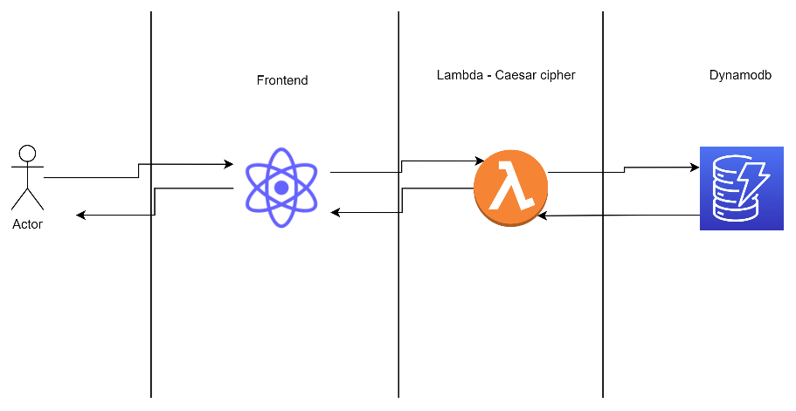

Figure 2 Storing cipher key in DynamoDB using lambda

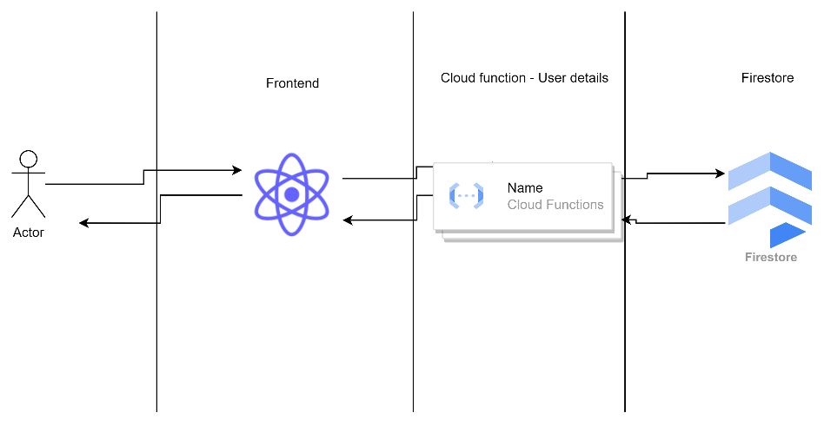

Figure 3 Storing user details in Firestore using cloud functions

* Figure 4 shows the flow of the data during the Login process

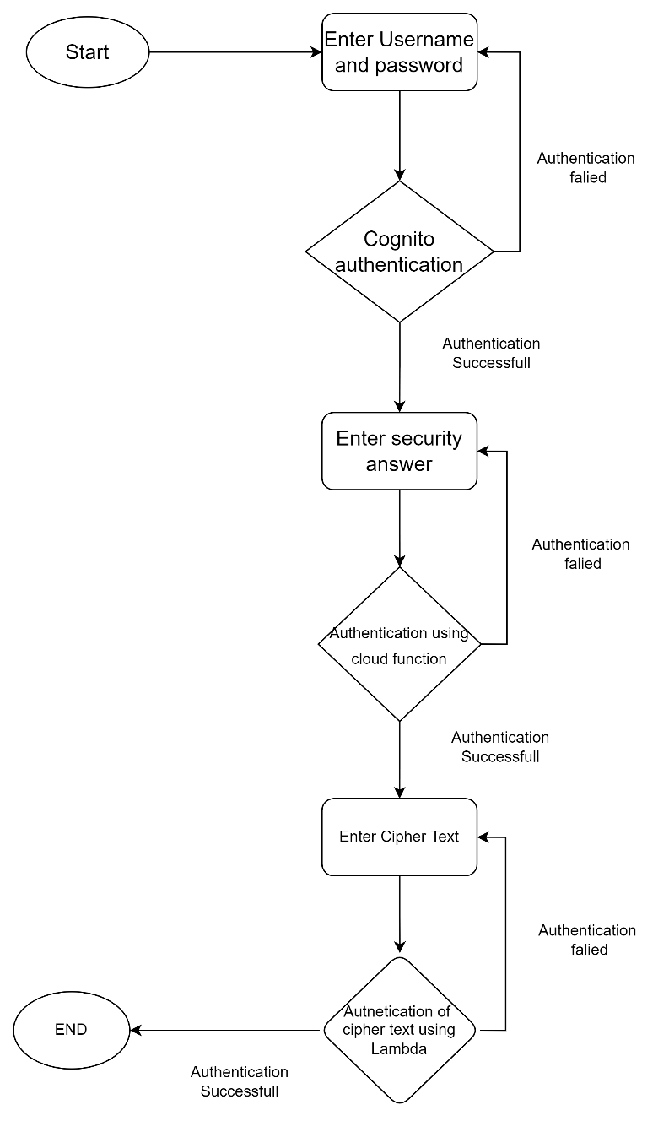

Figure 4 Flowchart of the Login

- Code snippet responsible for user registration

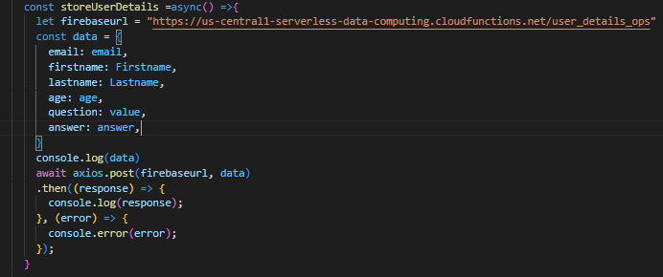

Figure 5 Code snippet for storing user details to Firestore via DynamoDB

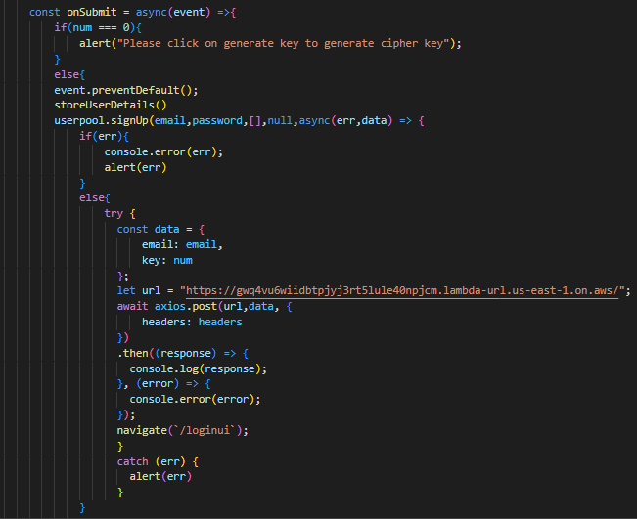

Figure 6 Code snippet for storing cipher key in DynamoDB via lambda

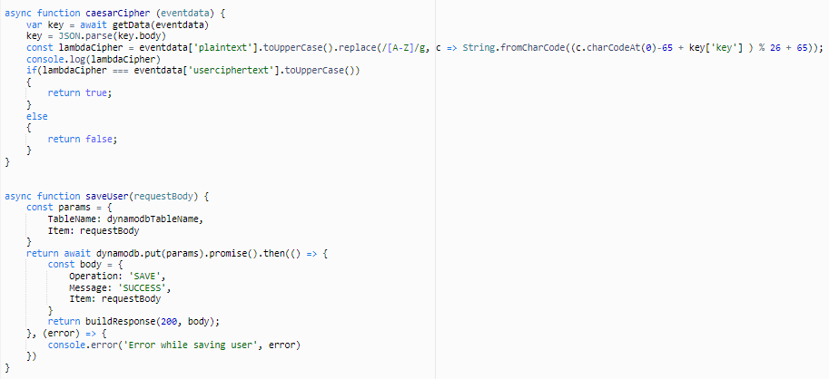

Figure 7 Code snippet for calculating Caesar cipher and to store cipher key in DynamoDb [10]

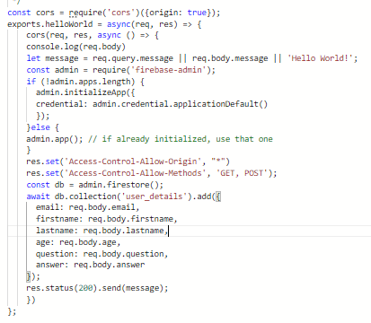

Figure 8 Code snippet for storing user details to Firestore via cloud function

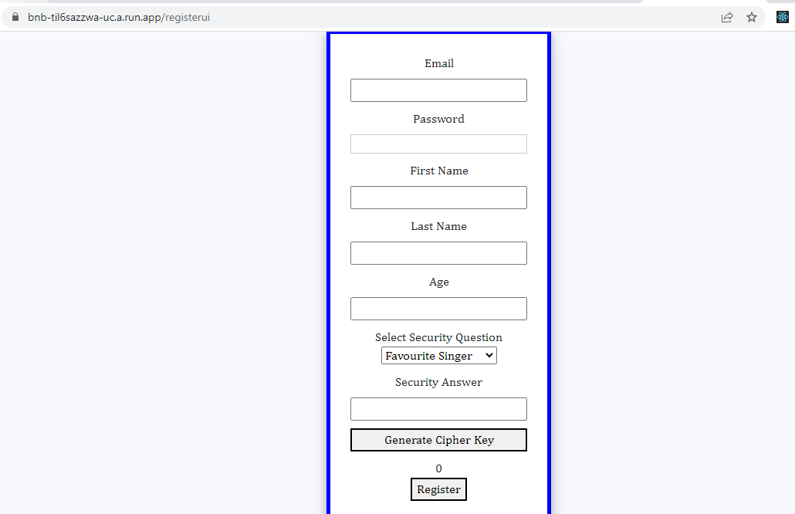

Figure 9 Registration UI

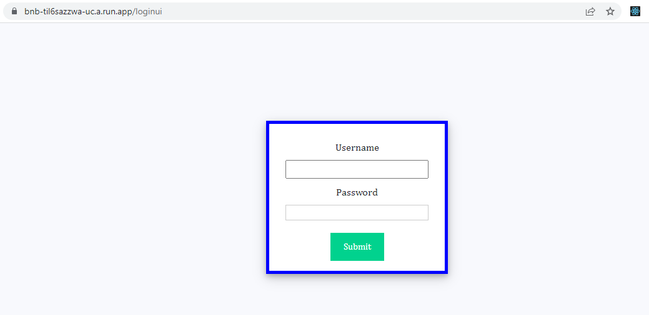

Figure 10 Login UI

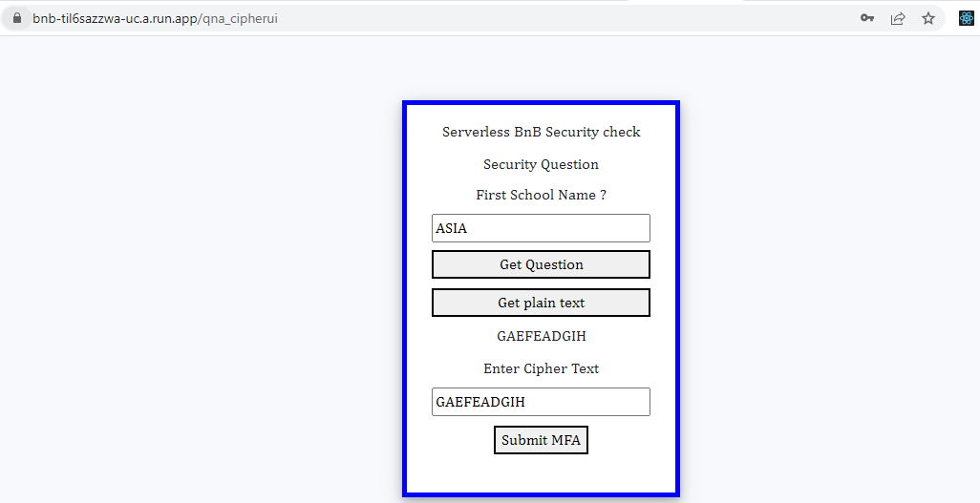

Figure 11 Q&A and cipher UI

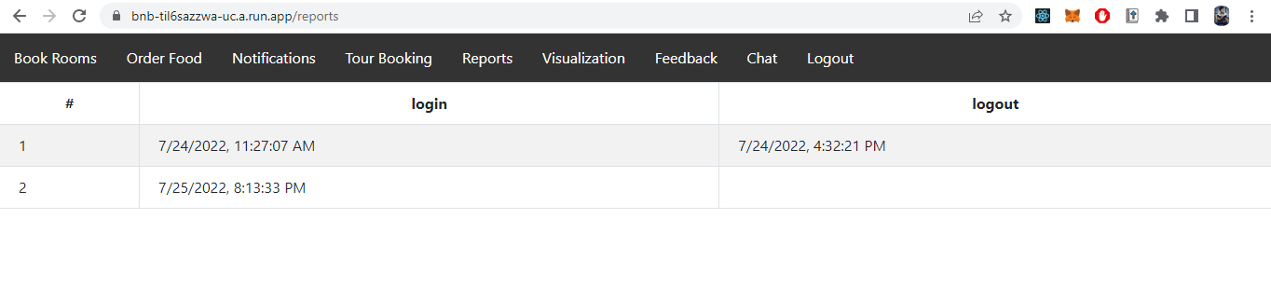

Figure 12 Report of user login statistics

**Testing of User Login and Authentication feature**

1. **Incorrect Password or Username**

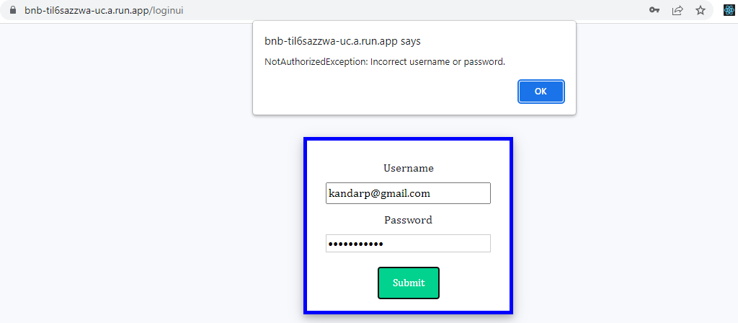

Figure 13 Testcase where password and username are incorrect

1. **Incorrect security answer**

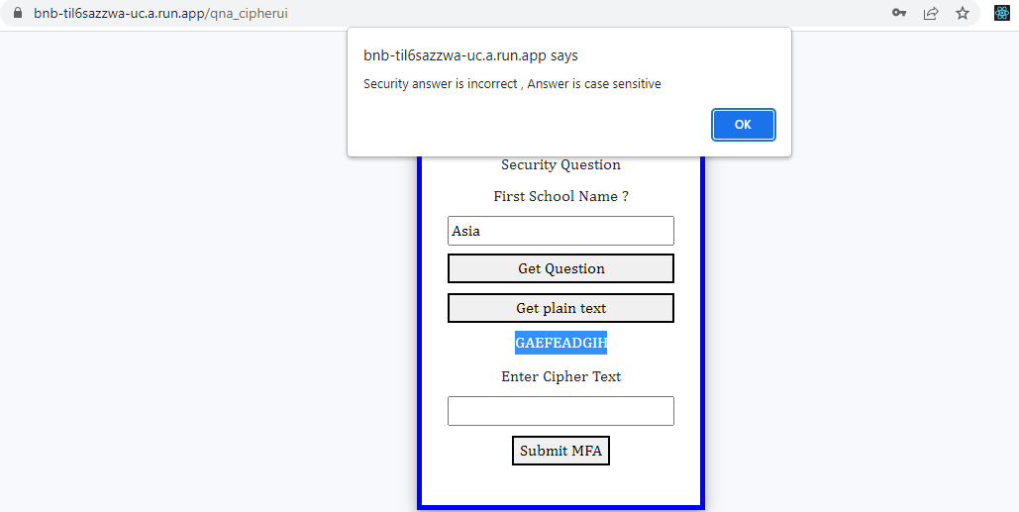

Figure 14 Testcase where security answer is incorrect

1. **Incorrect Caesar cipher**

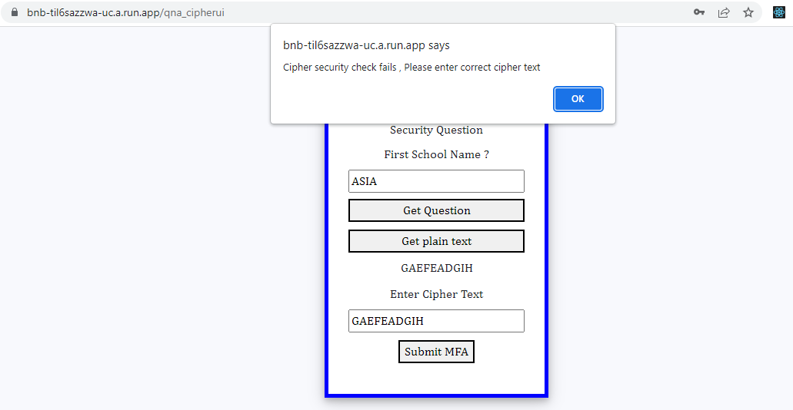

Figure 15 Testcase where Caesar cipher is incorrect

## **3.3 Online Support**

The Online Support module is developed using a combination of AWS Lex and AWS Lambda services of the AWS cloud provider along with GCP Cloud Functions and GCP Firestore services from the GCP cloud provider. A user sends the request to AWS Lex through a mediator API which is a post_text call. The post_text function is a function provided by the Boto3 library in Python. This function passes the text from frontend to our chatbot along with the session attributes object which holds the username of the logged in user. We do not allow users to proceed with room or tour booking or ordering food if they haven’t logged in, however, we allow users to view the menu or available options for tour or rooms.



Figure 16 Chatbot workflow

In the chatbot we have 3 flows: Order meals, book rooms and book tours.

**AWS Lambda Functions and Pseudocode**

**recognize_text_chatbot**

This function is like a mediator between our user interface and AWS Lex. The post text function of the boto3 library takes user input and sends it to AWS Lex bot and returns the output.

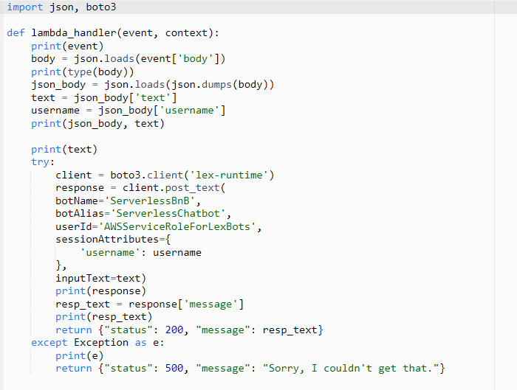

Figure 17 Call to Boto3 API Post Text

**OrderFoodLambda**

This function has 3 parts: get menu items, the main lambda handler and close a session.

**Get_menu_items**: This function calls an API which is hosted on GCP Cloud Function which will return a list of menu items to the user.

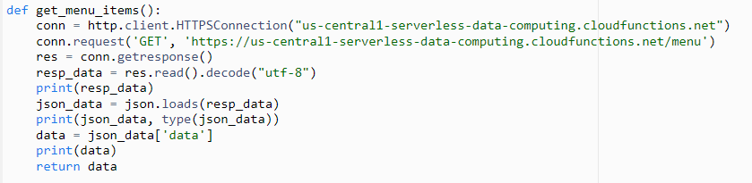

Figure 18 Get menu items function

**lambda_handler:** This function validates the retrieved slots and orders the selected food item. The food ordering API is hosted on GCP Cloud Function.

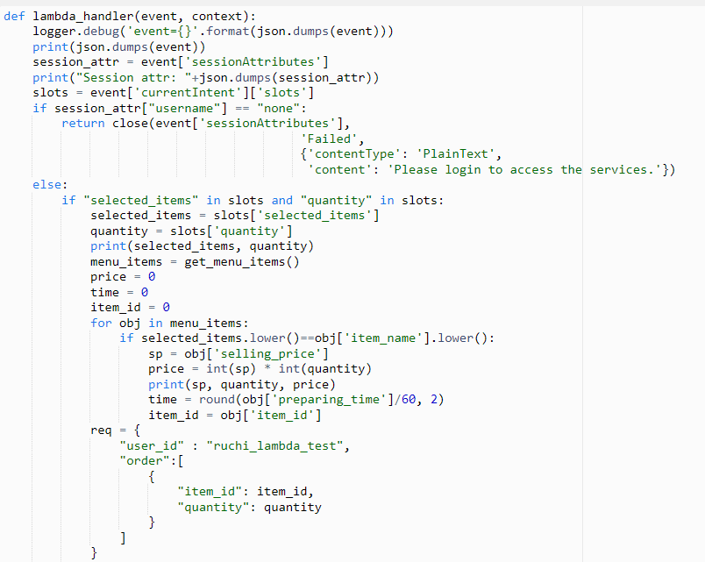

Figure 19 Order food part 1

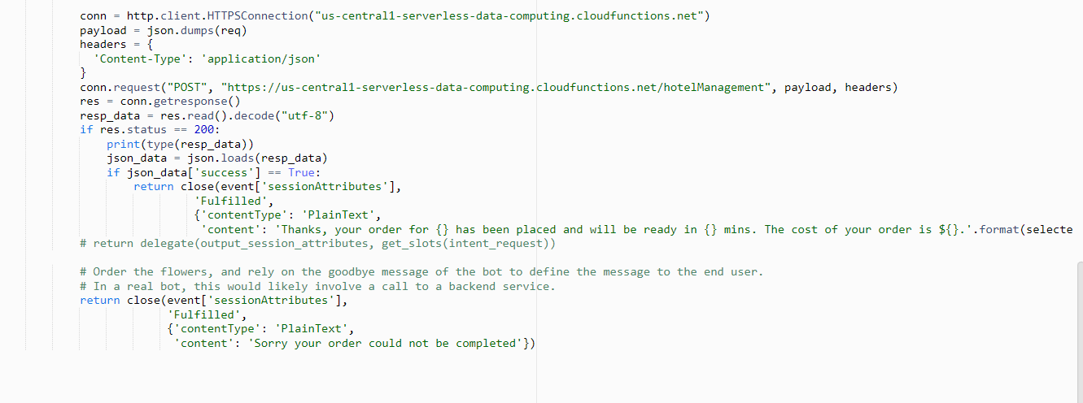

Figure 20 Order food part 2

**Close:** This function will close the session. This function is common across all Lambda Functions.

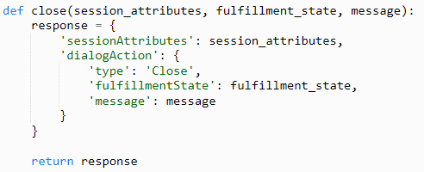

Figure 21 Close a session

**BookRoomLambda**

This function has 3 parts again: close, get_available_rooms and lambda_handler.

**Get_available_rooms**: This function calls the API hosted on GCP Cloud Function and returns the list of available rooms from where we retrieve the room details while booking one for the user.

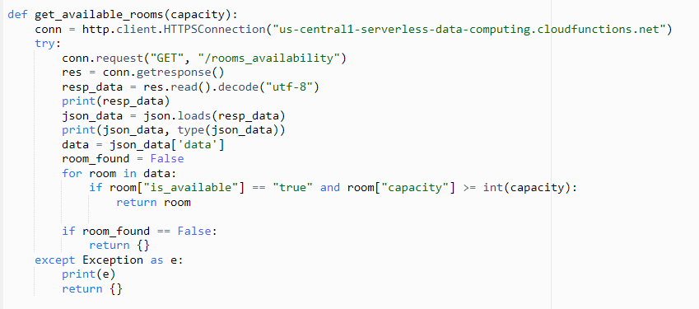

Figure 22 Get available rooms

**Lambda_handler:** This is the main function which validates all the slots retrieved from the user and calls the room booking API host on GCP Cloud Function.

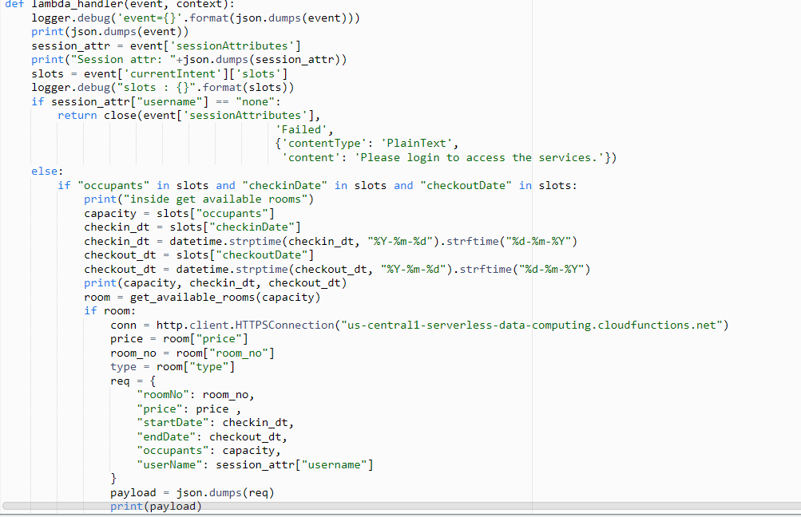

Figure 23 Book rooms part 1

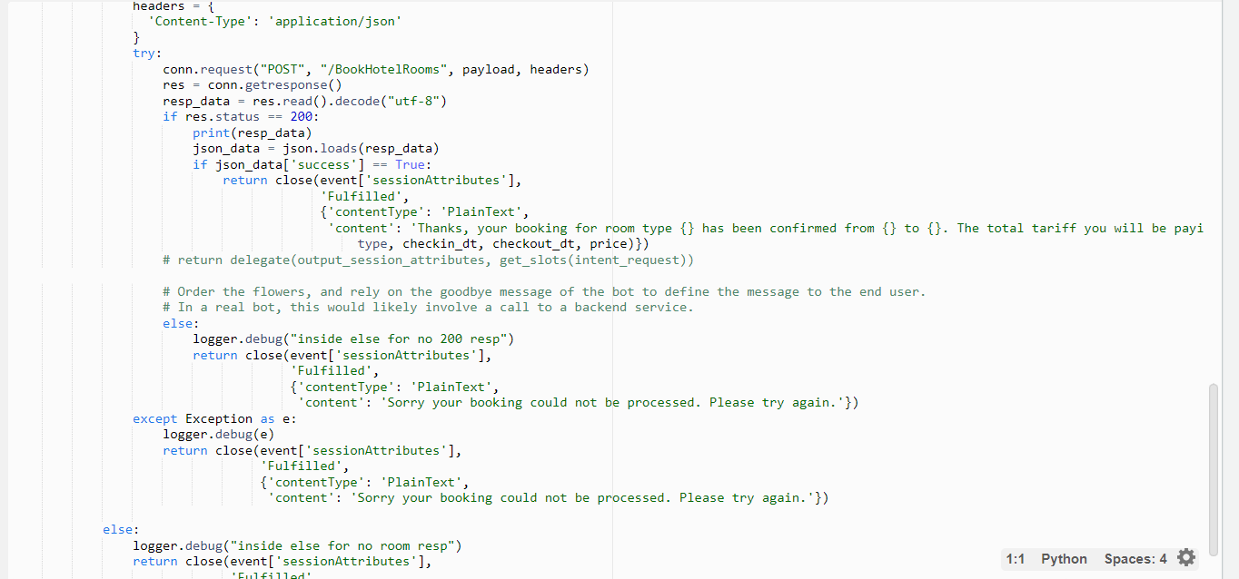

Figure 24 Book rooms part 2

**BookTours**

**Lambda_handler:**  This is the main function that validates user inputs and calls the tour booking API.

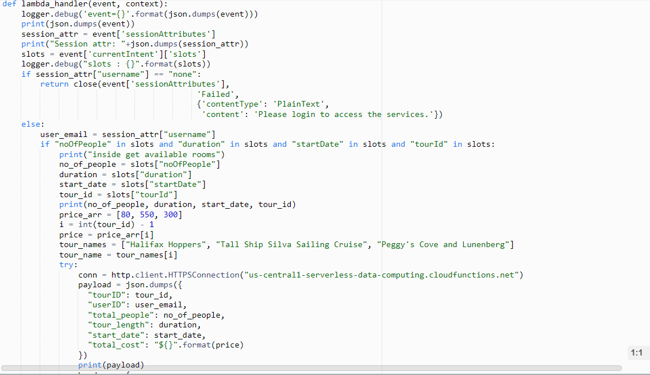

Figure 25 book Tours part 1

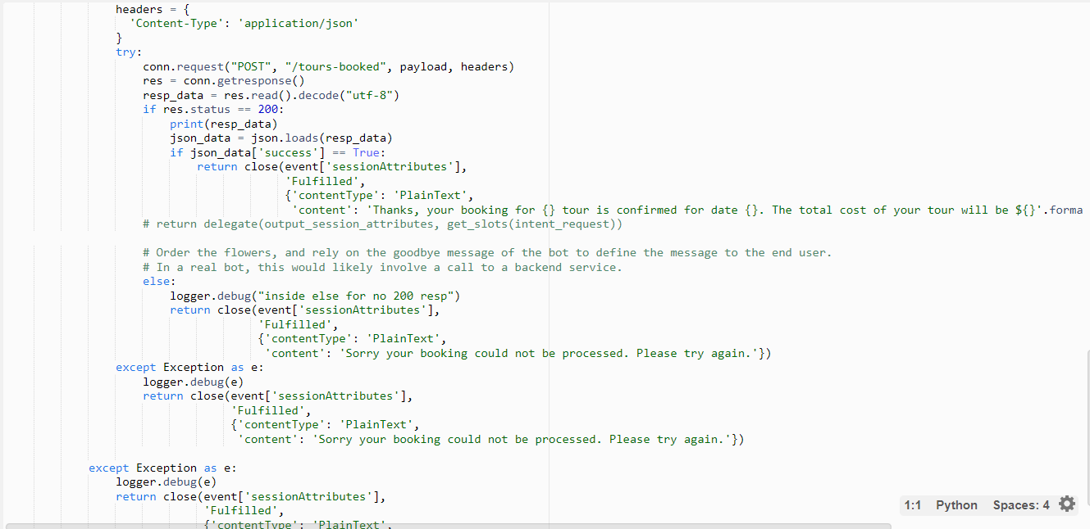

Figure 26 Book rooms part 2

The below figure illustrates the flow of activities performed by the online support feature.

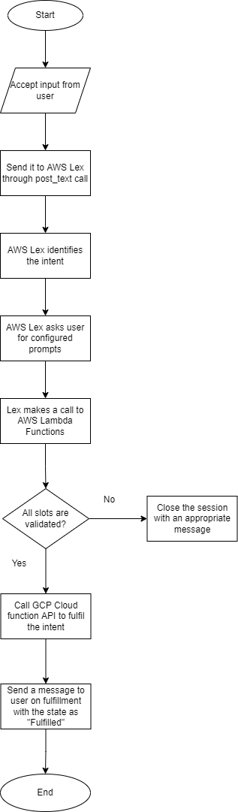

Figure 27 Chatbot Flowchart

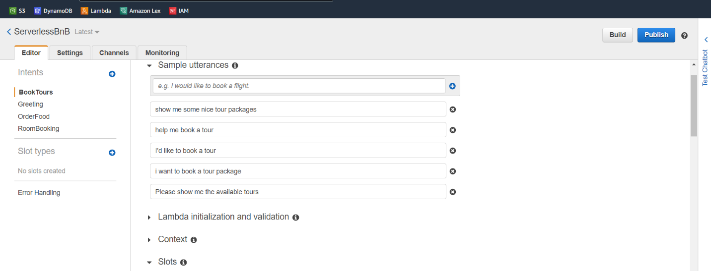

Figure 28 Book Tours Utterances

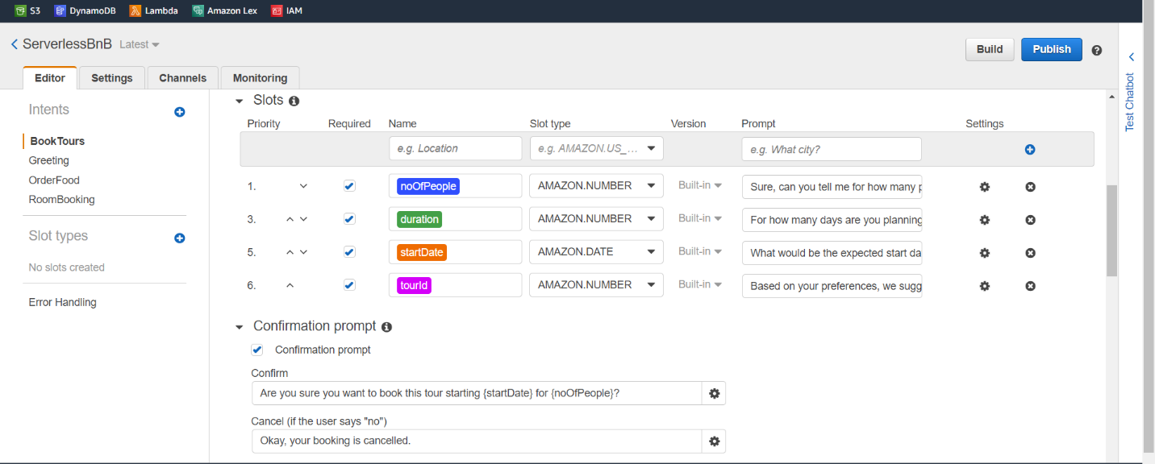

Figure 29 Book Tours Slots and Confirmation Prompt

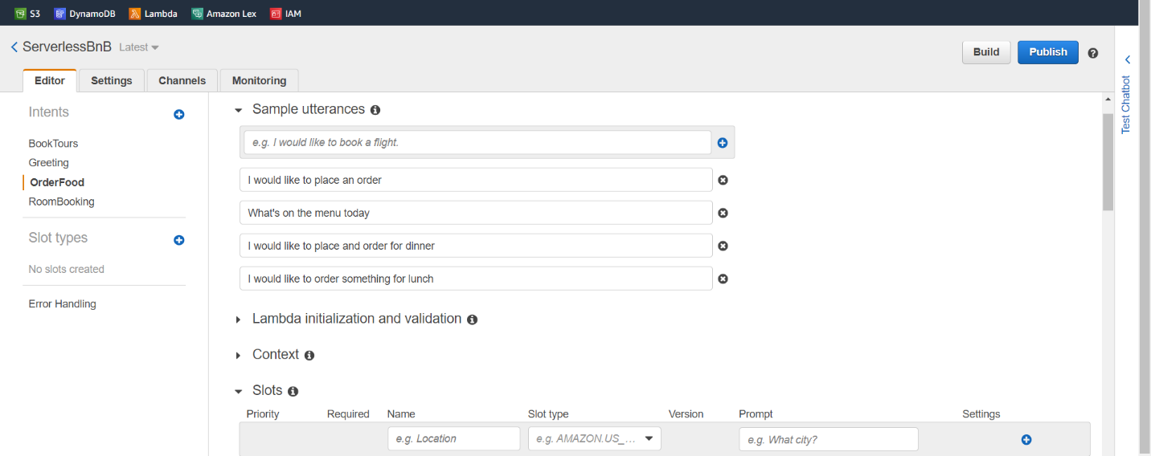

Figure 30 Order Food Utterances

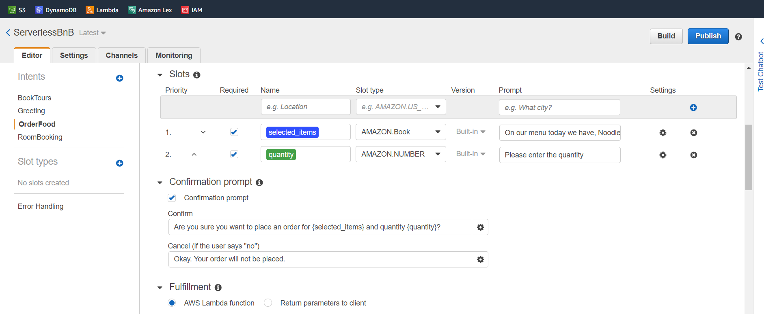

Figure 31 Order food slots and confirmation prompt

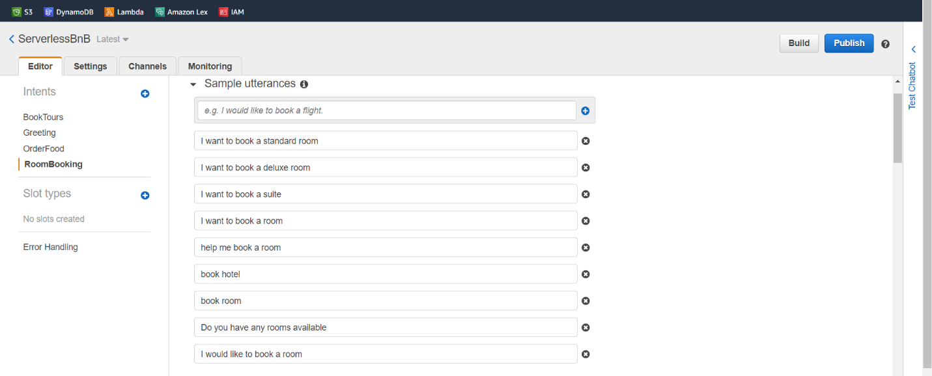

Figure 32 Room Booking Utterances

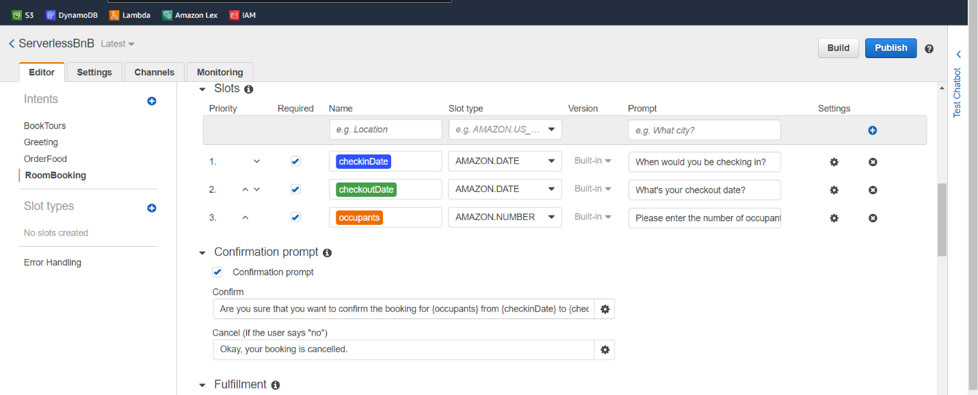

Figure 33 Room Booking slots and confirmation prompt

## **3.4 Message Passing**

The Message Passing module is built using Pub/Sub as a channel implemented in the Food Orders and the Tours Module. Let’s start with the food ordering module implementation.

The food ordering module allows users to order their favorite dishes for breakfast, lunch or dinner based on the food availability for that day. An unauthenticated user can also check for menu items, add items to cart, However, they will not be able to order food unless logged in.

Starting with the inventory, I have used cloud scheduler from GCP which will run a scheduled cron job (on 12:00 every day) which will update the inventory with the quantity of items available the next day. When the user clicks on menu, it will make a cloud function call which will fetch the menu items with their quantity from firestore. When the user clicks on order now, it will call a cloud function (Hotel Management) with the user and order details. The cloud function (Hotel Management) will publish a message in the queue and the queue is subscribed by a cloud function (Kitchen Service) which will parse the order details, calculate the preparing time for notifications and store it in firestore for invoice generation. When the user clicks on notifications, there will be an order with a status of PREPARING, which will later change to READY as soon as the order is ready to deliver. There will be an option to download invoice which will generate a PDF with order details and total amount.

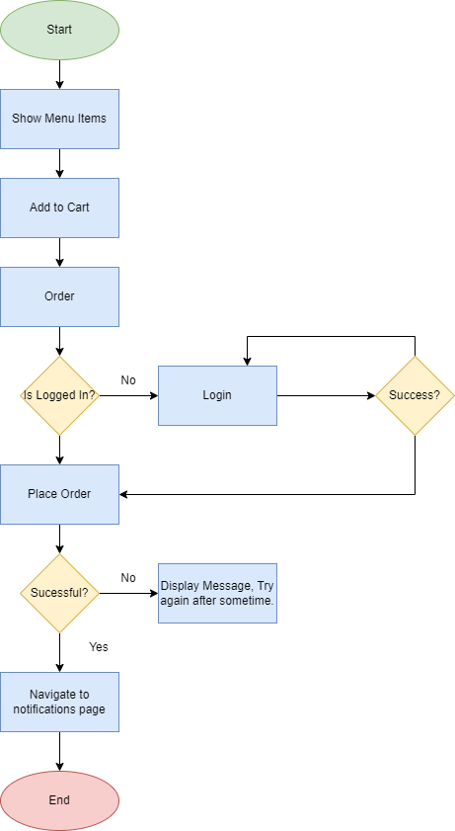

Figure 34 Flow Chart of Food Ordering

Let’s now go through the flow to retrieve the menu items from firestore [14] using cloud function.

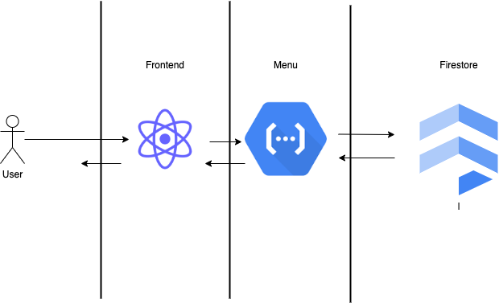

Figure 35 Retrieving Menu Items

The message passing module implementation which contains a hotel management cloud function, pub/sub followed by the kitchen microservice which will store items to the database.

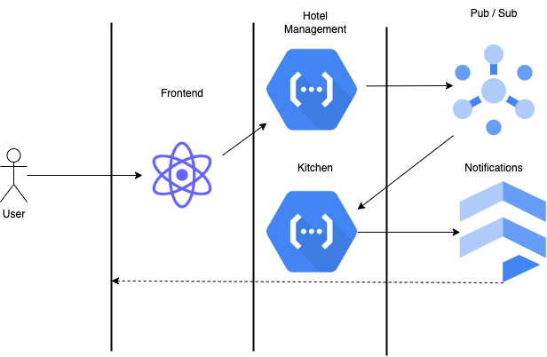

Figure 36 Message Passing Implementation

**Menu Retrieval**

A cloud function called menu is called which will make a firestore query to get items which have quantity greater than 2. For inventory management, we are running a scheduled cloud function using cloud scheduler [15] which will run at 12:00 to update the inventory.

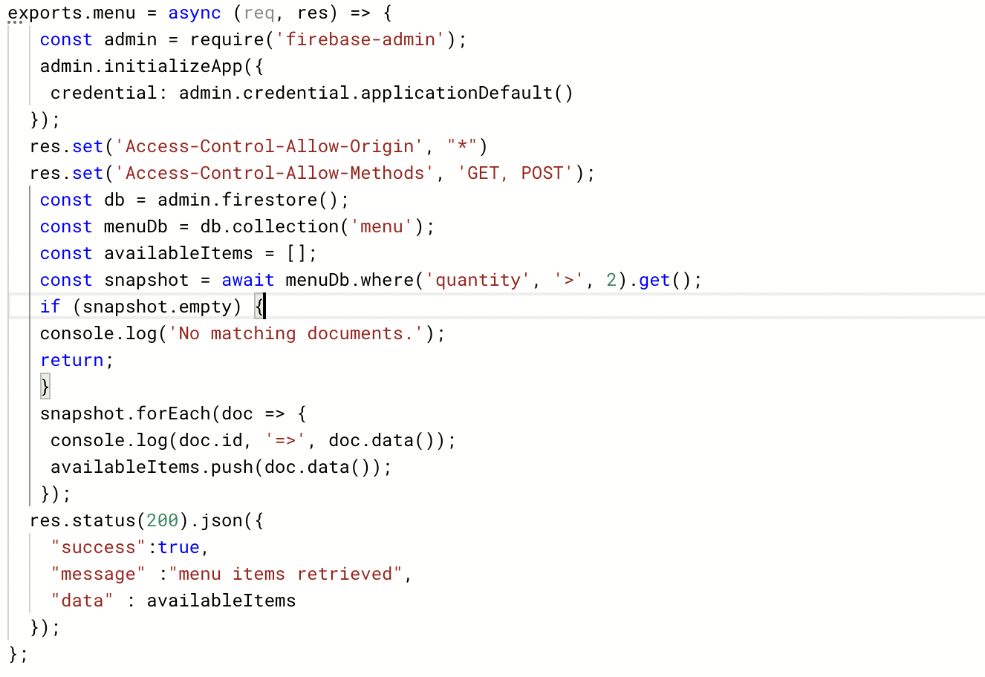

Figure 37 Available Items cloud function

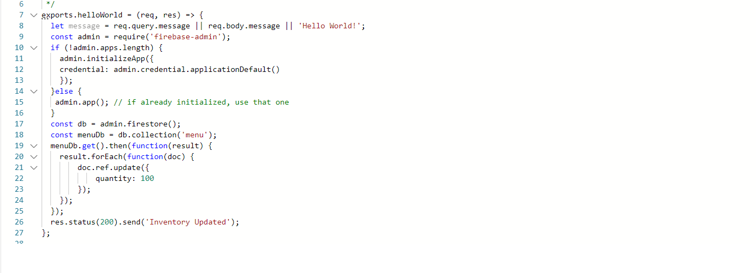

Figure 38 Inventory Updater

**Order Food**

As soon as the user clicks on order, there will be an http call made to the hotel management cloud function below, which does the input validation and publishes a message to the queue (pub/sub) [16], which will trigger the kitchen service for further processing.

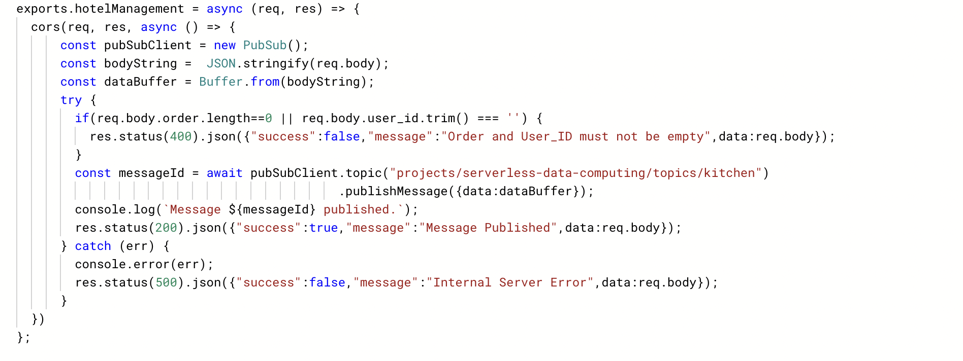

Figure 39 The hotel management cloud function

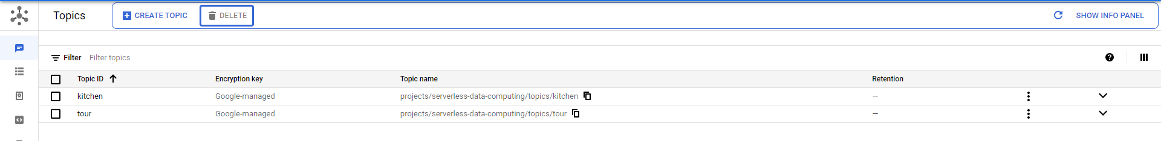

Figure 40 Pub/Sub topics

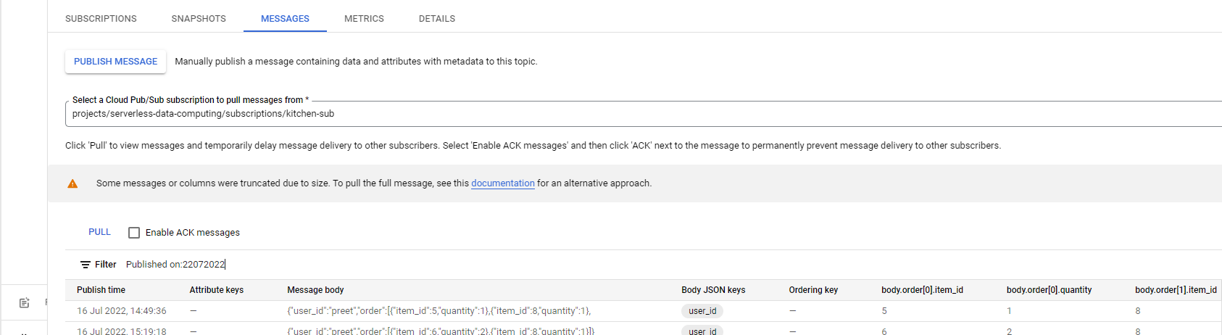

Figure 41 Pub/Sub Messages

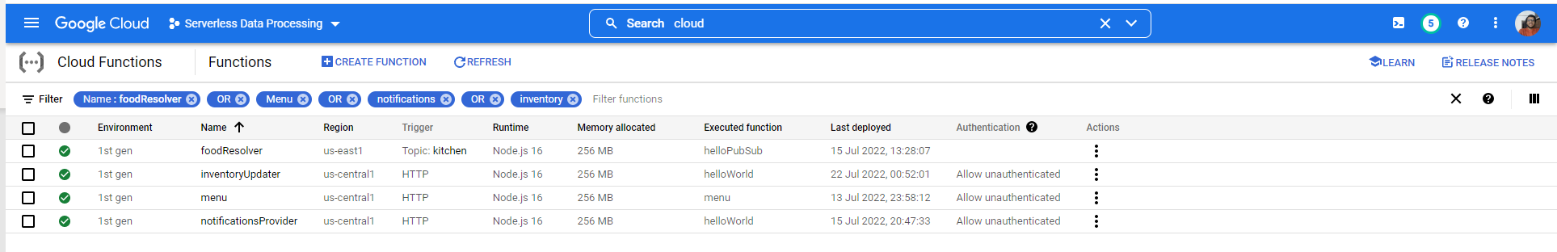

Figure 42 Cloud Functions as a part of Food Ordering Module

The hotel management function will publish the message and the below kitchen microservice will take care of preparing the order, performing all the computations, decrementing the quantity, and storing the information to firebase for notifications.

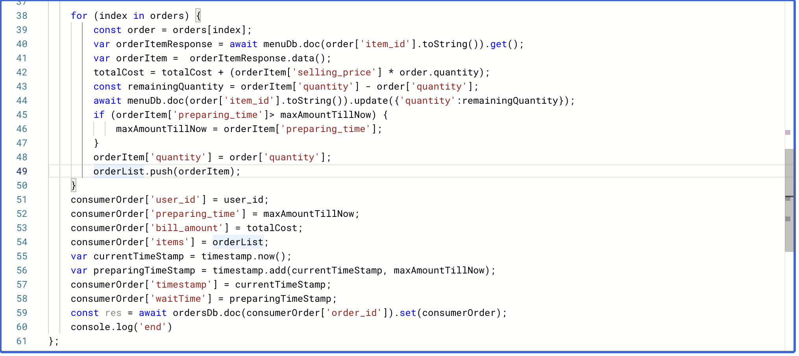

Figure 43 The Kitchen Service

Now, in the notifications page, we receive two notifications, one for an order placed on 21st of July, which is now READY, and the other one which we have placed on July 22nd (time of taking the screenshot) which is still in preparing stage and will be receiving a ready notification once the preparation time is passed.

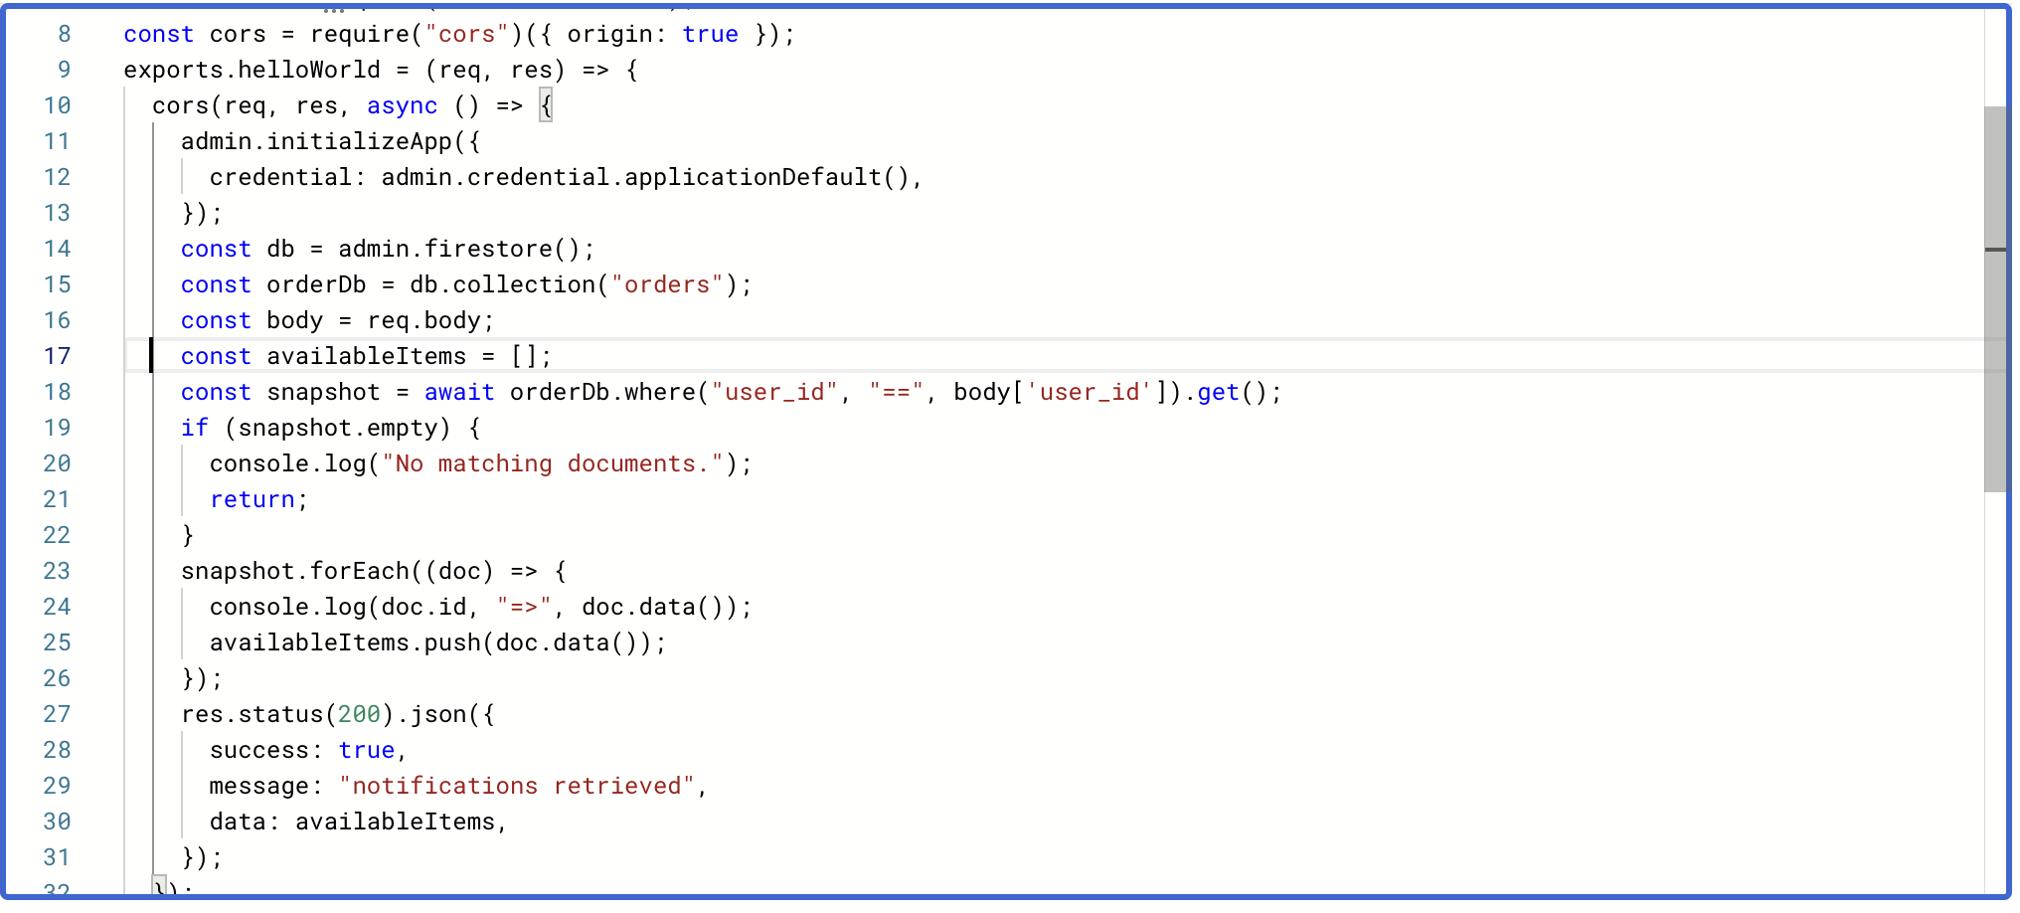

Figure 44 Notifications Provider

Let’s have a look at the firestore storage for menu and orders.

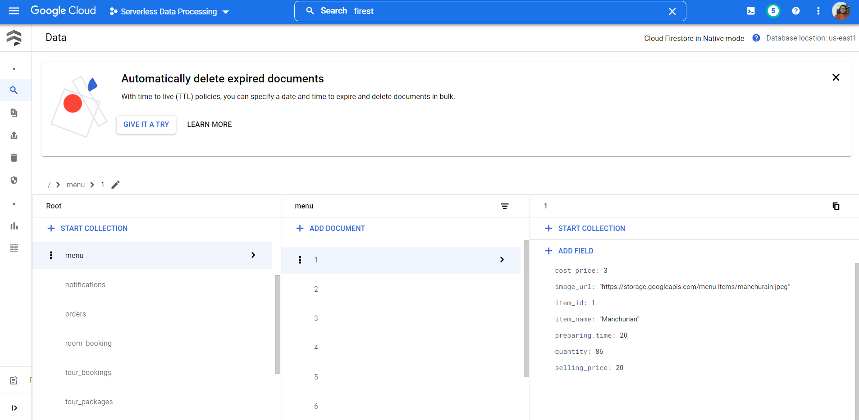

Figure 45 Menu Table Items describing about the menu information

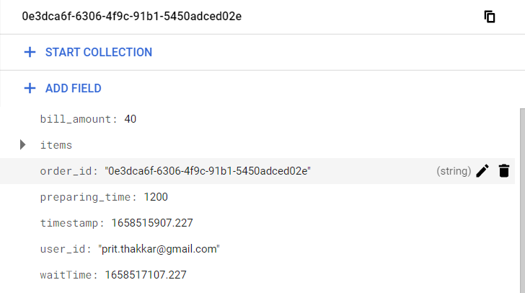

Figure 46 Order mentioning the bill amount, items, and necessary fields for notification

## **3.5 Room Reservations**

One of the primary features in this project is the reservation of rooms in the BnB facility. The cloud services used in this module are, Google Cloud Platform (GCP) Cloud Functions and Cloud Firestore. The room reservation module enables users to book rooms of their desired type, and size for a specific time interval. The attributes for each room are as follows:

1. Room Number
2. Room Type (Standard / Deluxe / Suite)
3. Price
4. Capacity (Number of Maximum Occupants)
5. Next Available Date
6. Current Availability

The module does not permit unauthenticated users to book or even view rooms and prompts them to login before redirecting them to the login page. When an authenticated user navigates to the “Book Room” page, the user can view a list of all rooms that are currently available for reservations. This list of rooms is displayed by sending a request to a Cloud Function which is triggered by HTTP requests. The cloud function will then retrieve data corresponding to rooms from Firestore where the current availability of rooms is “True”. Users then can make use of the filter panel located above the list of rooms, to filter rooms based on their desired Start Date, End Date, Room Type, Number of Adults and Number of Children. Accordingly, relevant rooms will then be rendered. Once users decided to reserve a room, they click on the “Book Now” button to reserve the room. Now, upon submitting a reservation request, another HTTP request is sent to a second Cloud Function which is also triggered by a HTTP request, with the details of the reservation. This Cloud function has two objectives. It firsts updates the current availability of the room, submitted in the reservation request, to “False” and updates the next availability date to the end date of the reservation. Next it stores the details of the reservation request in another Firestore Collection which contains data relevant to room reservations. Upon successful reservation users are alerted with a confirmation message and are navigated to the home page.

**Flowchart**

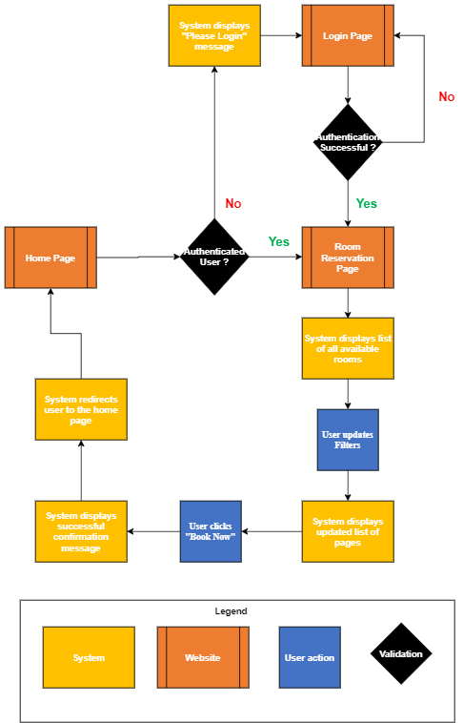

Figure 47 Room Reservation Flowchart [8]

Figure 47 represents the path taken by a user to view all available rooms and book a room. Please note that only authenticates users can book rooms through our application.

**Cloud Services Flowchart**

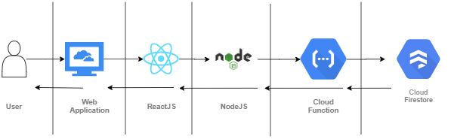

Figure 48 Retrieve Available Rooms & Record Room Reservation Service Flow chart

Figure 48 illustrates the cloud services utilized in this module. Asynchronous requests are sent from ReactJS to NodeJS and from NodeJS to the Cloud function. This might involve a delay in retrieving responses though this delay is typically insignificant.

## Code Blocks

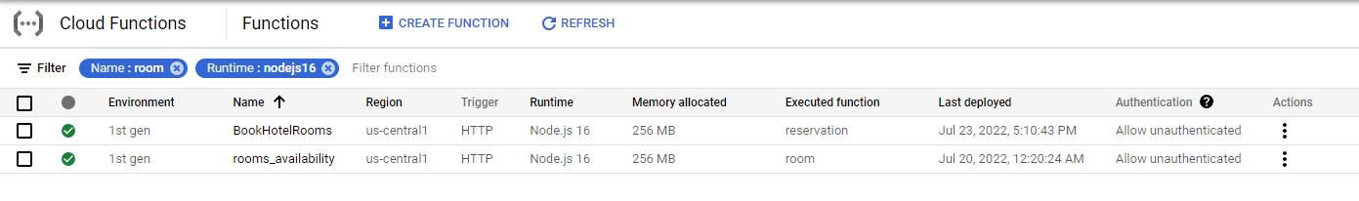

Figure 49 Cloud Functions for Room Reservation

1. **Cloud Function: Rooms Availability**

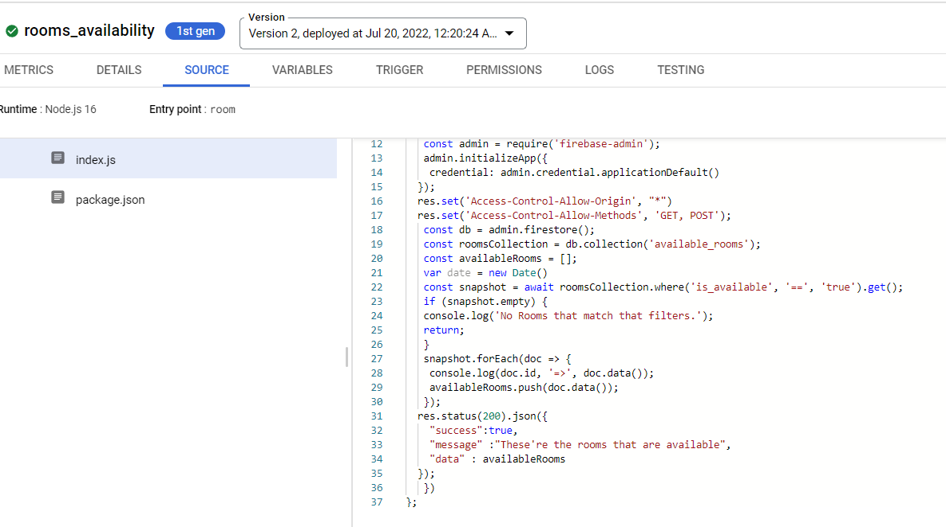

Figure 50 Cloud Function Source Code to Retrieve Available Rooms

Figure 50 represents the cloud function script to retrieve available rooms from Firestore where the current availability is True.

1. **Cloud Function: Book Hotel Rooms**

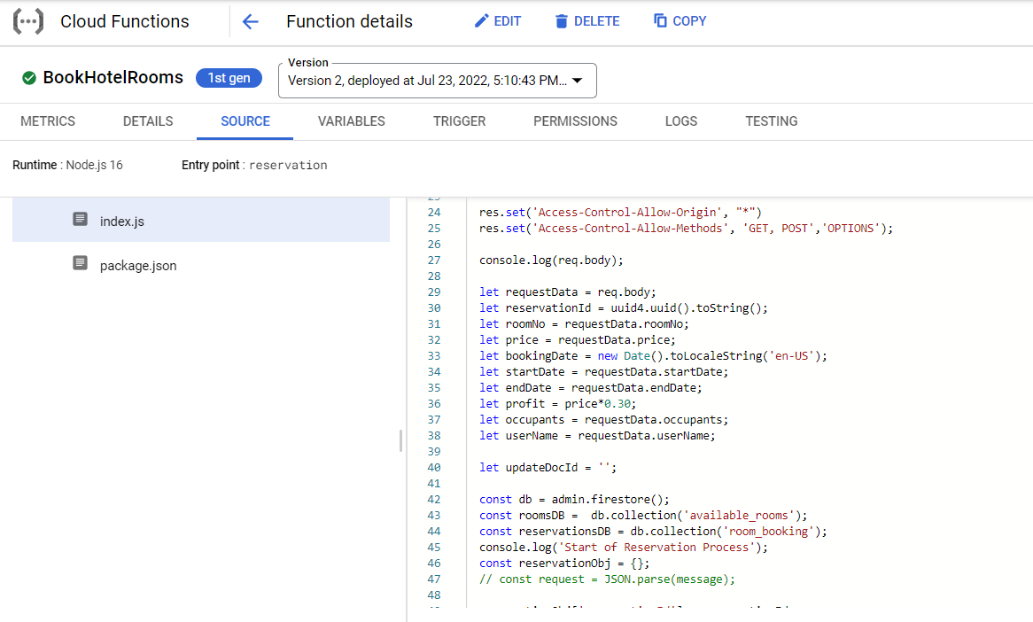

Figure 51 Source Code to store Reservation Request

Figure 51 represents the cloud function script to accept reservation requests and store them in an array of dictionaries.

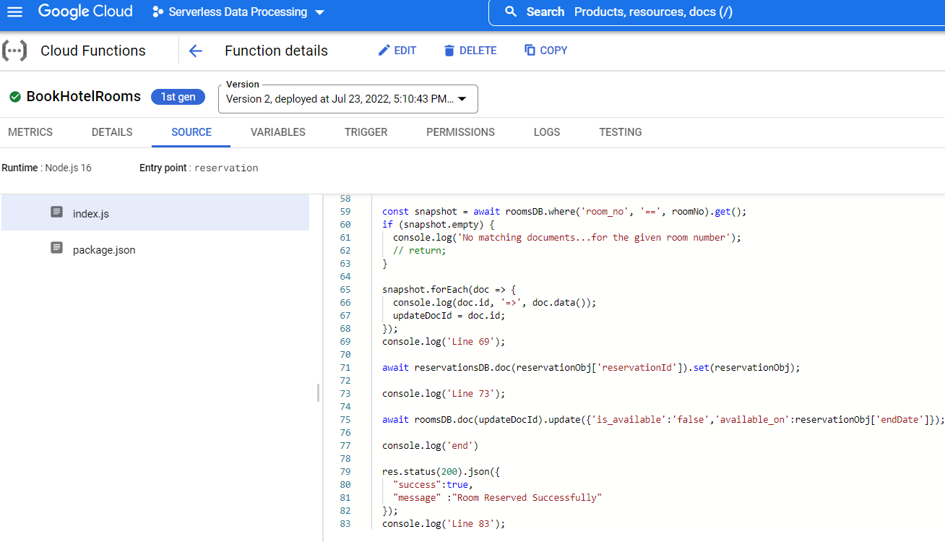

Figure 52 Cloud Function to update available rooms and record new reservation request

The above figure represents the cloud function script to update current availability and next available date of a reserved room before storing the reservation request in another firebase collection.

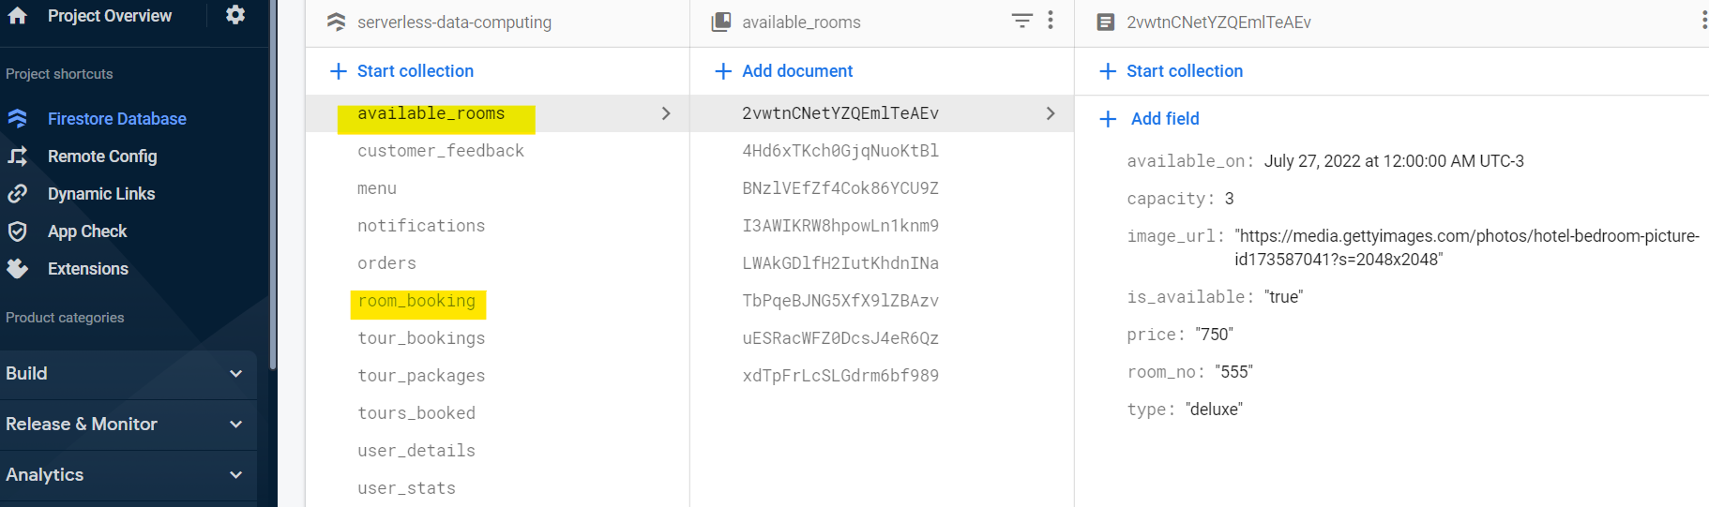

Figure 53 Firestore Collections

This figure represents the Firebase collections relevant to reserving rooms.

## **3.6 Machine Learning**

3.6.1 Recommending Tour packages

This module is used to recommend the tours packages to the customers. In this module the customers will search for the tours and packages. We will show them all the tours, but the order of the tours will be predicted by machine learning model. The cloud services used to create this model are GCP cloud function, GCP Vertex AI, and Google Firestore. Along with this the module will be using pub/sub module to pass messages.

To use this module the user should be signed in. If the user is not signed-in, then we will redirect him to the sign-in page. After the user logs in the webpage displays a specific set of input fields for the user. The user is required to fill these fields but even if the user does not fill the fields, we would still allow the user to search but the suggestions would not be accurate. Now, after the user clicks on the search button a cloud function is called tourBooking. There is a tourBooking cloud function that gets all the tours from the firestore database. Next, the function creates an instance of the search case and passes it to the Vertex AI model endpoint. The endpoint returns us the score of each tour. Now the tours will be rearranged into a list such that the tour in the descending order of scores. This will be passed as the response to the frontend. Once the front end receives this information it displays it on a table. Now the user can click on the Book tour button available on the UI in the row of each tour. After the button is clicked, we invoke another cloud function to book the tour called toursBooked. The tours Booked cloud function acts as the intermediate pub/sub and calls the subscribed cloud function which is storeTourBooking. This cloud function books the tour for the user. After this is done an alert will be displayed on the front-end telling the user the tour is booked. The flow chart and cloud flow diagrams are shown below.

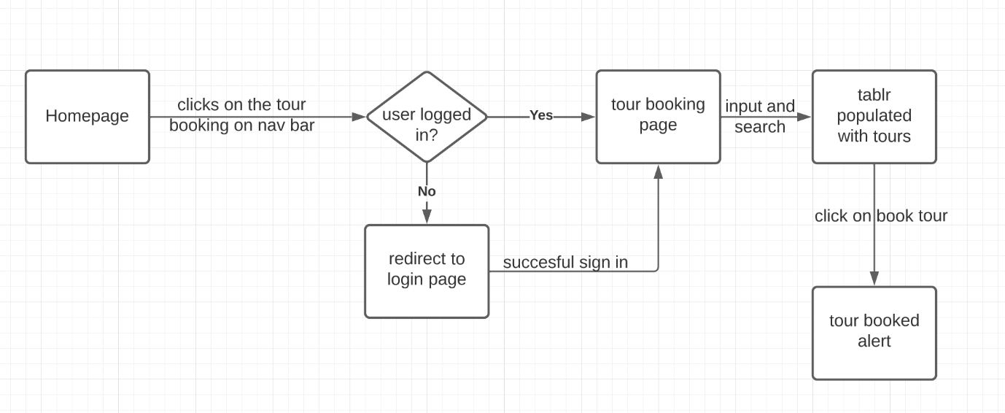

Figure 54 Flow chart of the tour booking [8].

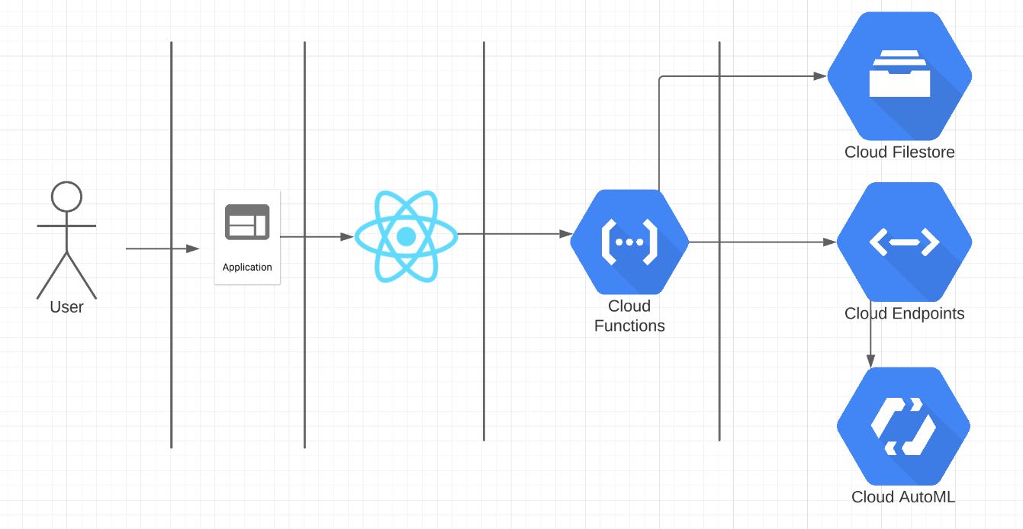

Figure 55 Search tours using prediction [8]

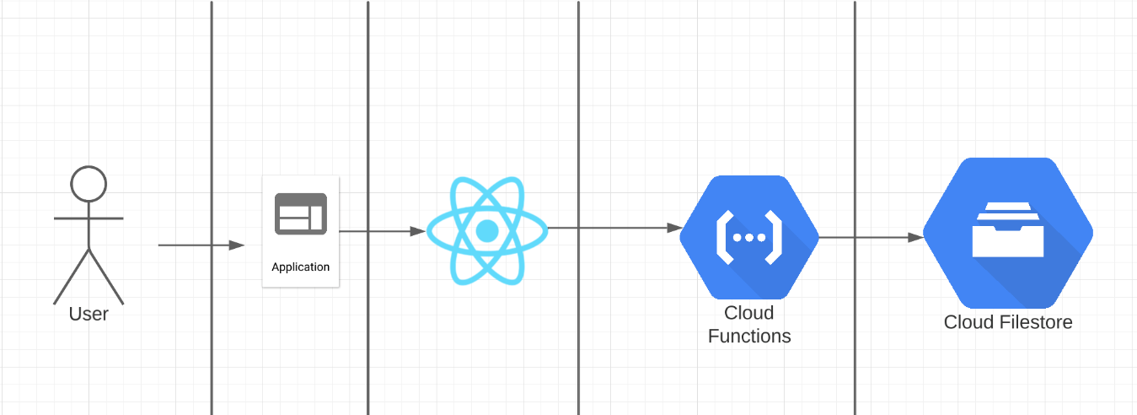

Figure 56 Book tour after selecting it [8]

3.6.2 Customer Feedback Sentiment Analysis

In the customer feedback sentiment analysis part of the machine learning module, we need to analyze customer feedbacks and identify their polarity and assign an appropriate sentiment score for the submitted feedback using GCP. To perform this task, I decided to use a service provided by Google Cloud Platform known as Google Cloud Natural Language API. In essence, Cloud Natural Language AI uses Google machine learning to derive insights by extracting, analyzing, and storing text from unstructured text [4]. Additionally, the Cloud Natural Language API includes technology for natural language understanding that may be used by developers to do sentiment analysis, text annotations, entity recognition and entity sentiment analysis [4].

When the user enters the feedback and clicks on the submit button, a cloud function will be triggered which will hit the analyzeSentiment end point of Natural Language API. This end point will analyze the submitted feedback text and try to identify the emotional opinion to predict if the text is positive, negative, or neutral [4]. The first value returned by this method is the score, which is a number between -1.0 and 1.0 that indicates how positive or negative the text is. Here, -1.0 indicates strongly negative and 1.0 indicates strongly positive. The second parameter is magnitude, which is a number between 0 and infinity that indicates the strength of the feedback's sentiment, regardless it is positive or negative [4]. For our project, based on Google Cloud Natural Language documentation and by performing various tests by randomly submitting feedbacks and analyzing the returned sentiment scores of feedbacks, I decided to identify all the feedbacks with sentiment score greater than 0.25 as positive, less than -0.25 as negative, and any value between -0.25 and 0.25 as neutral. Lastly, after performing sentiment analysis, this cloud function will store all the data in ‘customer_feedback’ collection of Google Cloud Firestore.

Besides this, the user has an option to view all customer feedbacks. For this the customer needs to click on ‘VIEW ALL FEEDBACKS’ button which will trigger a cloud function. This cloud function will fetch all feedbacks from ‘customer_feedback’ collection and the users can view all the customer feedback on the screen.

The flow chart for customer feedback sentiment analysis looks like below:

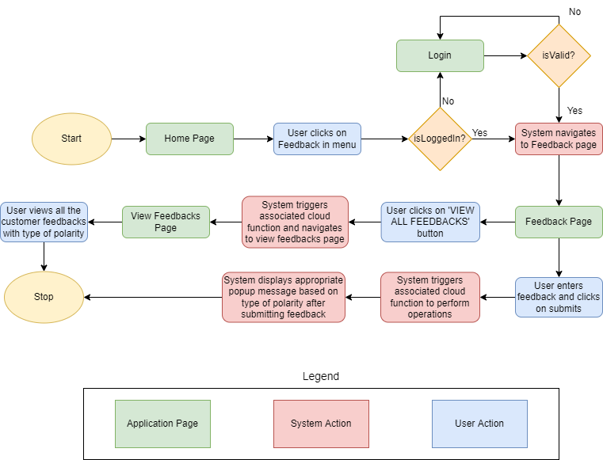

Figure 57 Customer Feedback Sentiment Analysis flow chart [8]

The cloud services flow chart for customer feedback sentiment analysis:

The cloud service flow chart for first Cloud Function responsible to perform feedback sentiment analysis and store the results in Cloud Firestore looks like below:

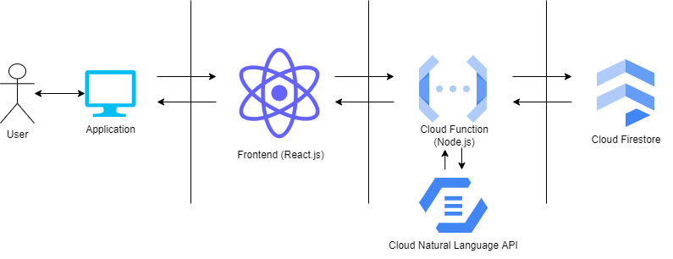

Figure 58 Perform sentiment analysis and store data in Cloud Firestore cloud service flow chart [8]

The cloud service flow chart for second Cloud Function responsible to fetch all feedback data from Cloud Firestore looks like below:

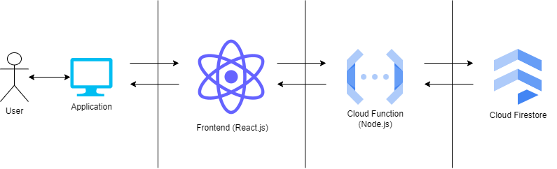

Figure 59 Perform sentiment analysis and store data in Cloud Firestore cloud service flow chart [8]

The below figures represent the cloud function responsible to perform sentiment analysis and store the results in ‘customer_feedback’ collection in Cloud Firestore.

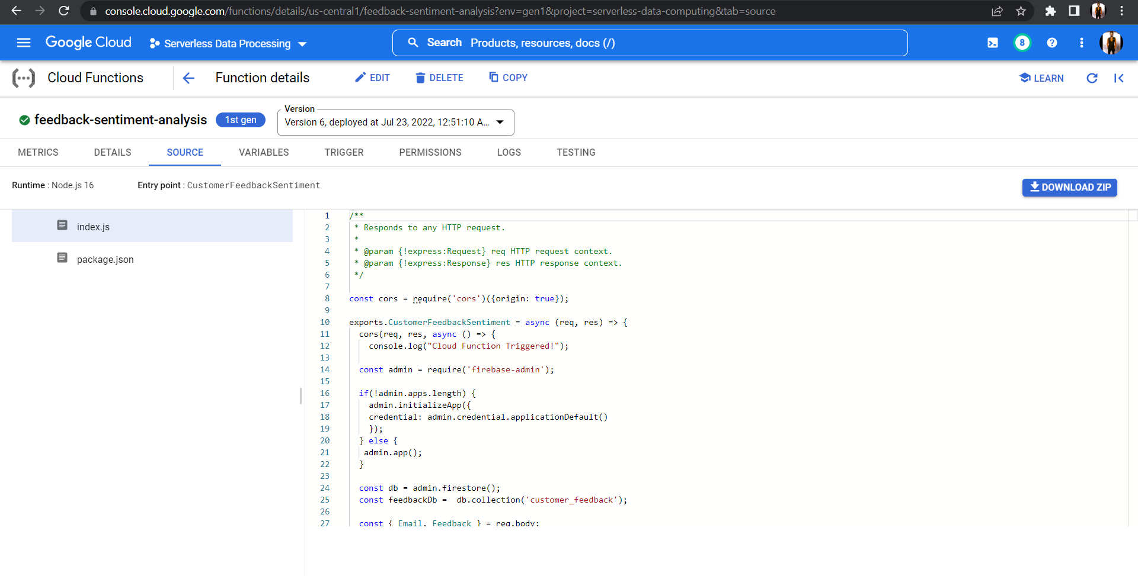

Figure 60 feedback-sentiment-analysis cloud function responsible to perform sentiment analysis and store the results in google cloud firestore

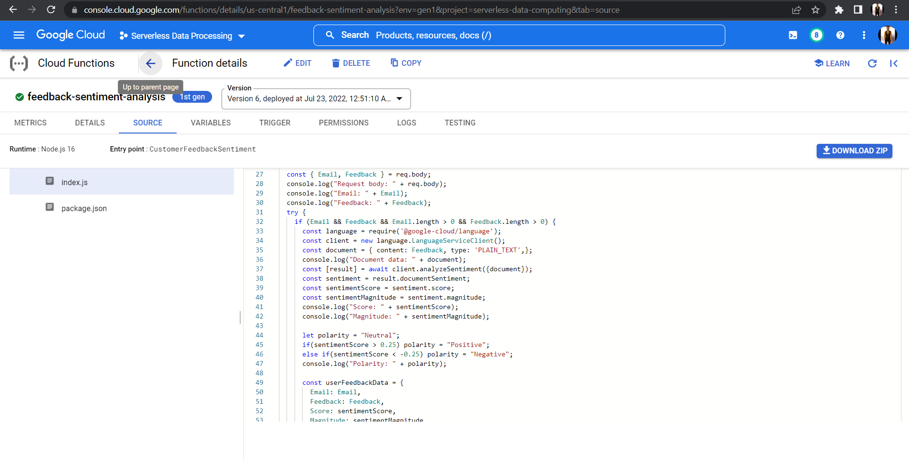

Figure 61 feedback-sentiment-analysis cloud function responsible to perform sentiment analysis and store the results in google cloud firestore

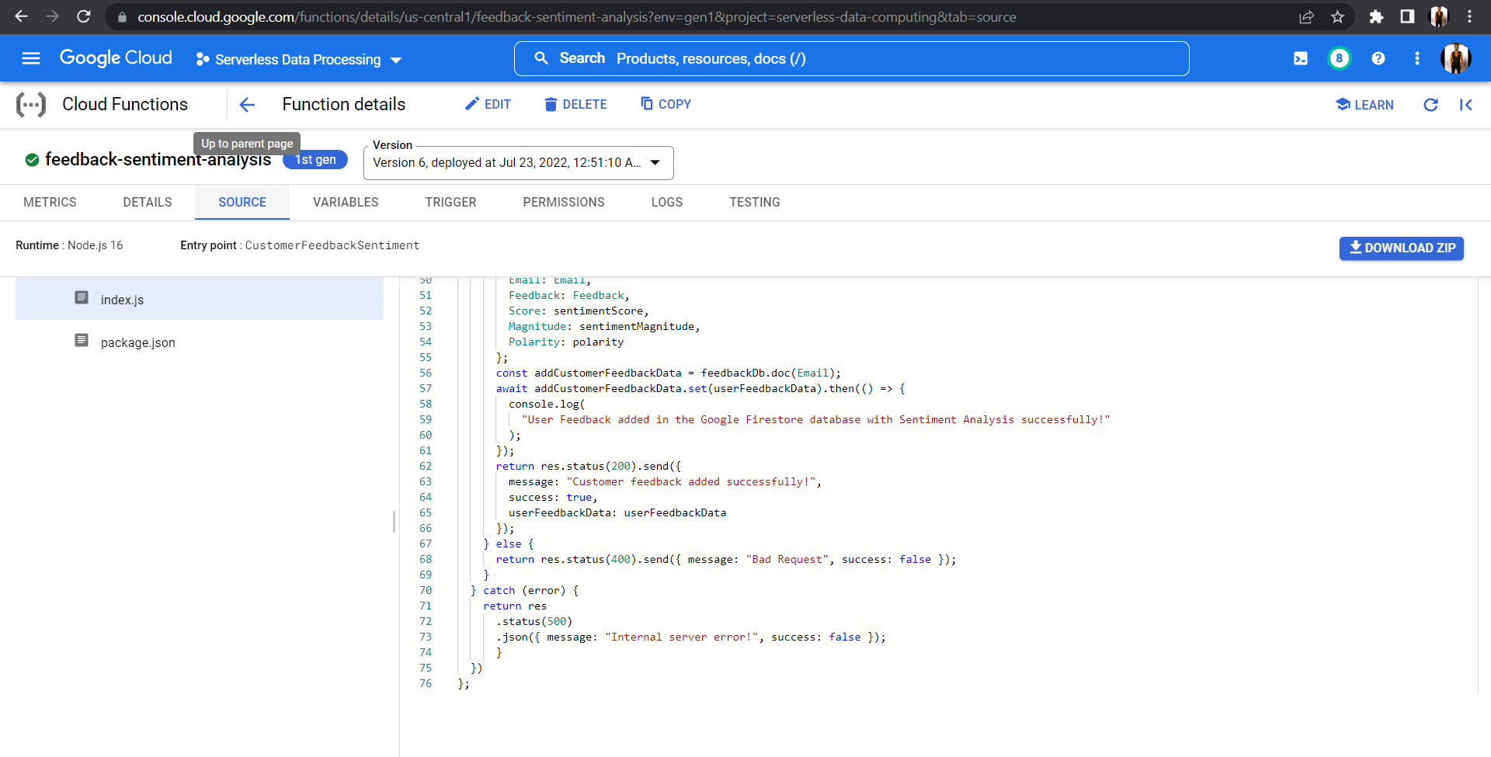

Figure 62 feedback-sentiment-analysis cloud function responsible to perform sentiment analysis and store the results in google cloud firestore

Now, the cloud function responsible to fetch all customer feedbacks with polarity from ‘customer_feedback’ collection in Cloud Firestore looks as shown below.

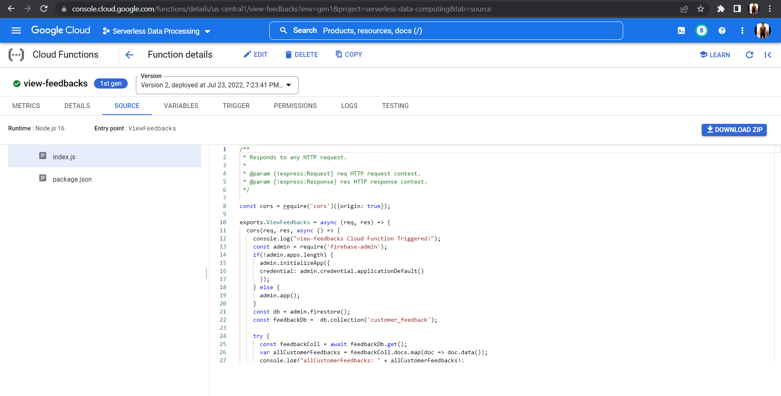

Figure 63 view-feedbacks cloud functions code responsible to retrieve all feedbacks from cloud firestore

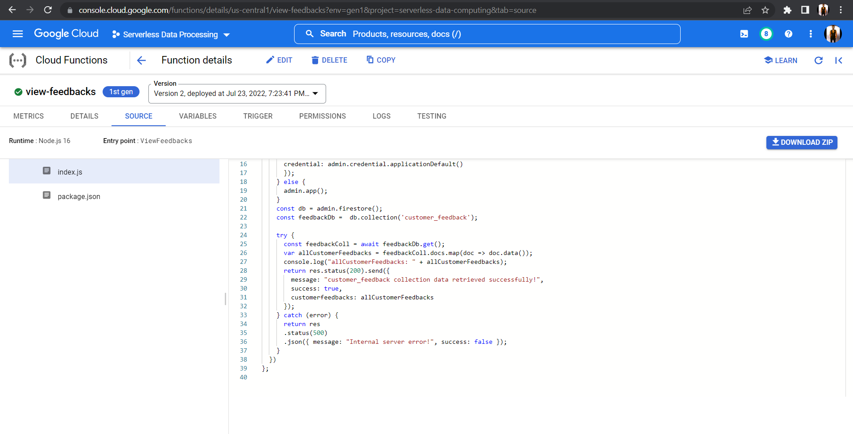

Figure 64 view-feedbacks cloud functions code responsible to retrieve all feedbacks from cloud firestore

## **3.7 Web Application and Hosting**

The frontend of Serverless B&B is built using React.js and as the aim of this project is to develop a serverless web application, we have deployed the web application on Google Cloud Run by an image deployment methodology, wherein we containerize the application, push the image to Google’s Artifact Registry and deploy it to Cloud Run by providing the service name and region.

Then, we must define the NGINX configuration settings which will be used to define on which port will the application run, and some other configuration which will make our react.js code working on cloud run [13].

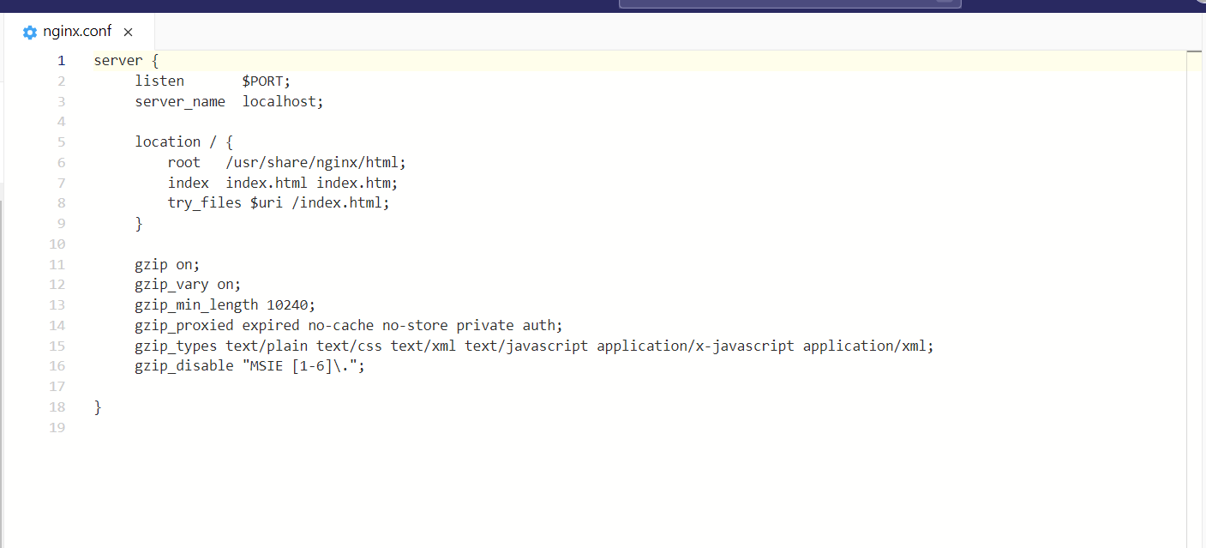

Figure 65 NGINX configuration [13]

The next step now is to build a docker image by using a Dockerfile which will build the executable container image to deploy it later on CloudFront [13].

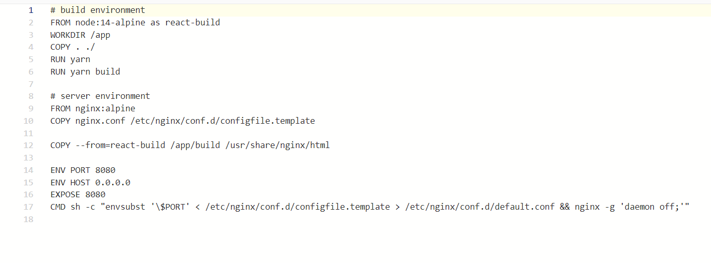

Figure 66 Dockerfile [13]

Now comes the build and deploy part, for that, we need to install the gcloud cli on our local machine and configure it with the project we are working on to be able to publish the image to google artifact registry, which will be later used by Cloud Run to deploy the application [13].

--

gcloud builds submit --tag gcr.io/[YOUR_PROJECT_ID]/cra-cloud-run

--

The above command will submit the code and a container image will be built using the Cloud Build API, after the image has been successfully created, we will have to deploy the image on Cloud Run.

--

gcloud run deploy --image gcr.io/[YOUR_PROJECT_ID]/cra-cloud-run --platform managed

--

The above command will deploy the existing built image from Google Artifact Registry and deploy it to cloud run. Before deploying, it will ask for the service name (here we have called it bnb) and region (we have used us-central1). After providing the required information, cloud run will route traffic and make the web application available to fulfill the new requests.

## **3.8 Report Generation**

- For report generation module, Firestore has been used to store the Login and Logout timestamps of the user. Whenever a user successfully logs in to the application, the time =stamp will be stored in database and whenever the user logs out of the system that time stamp will be stored in firestore as well. Now when the user clicks on report, they will be able to see a report of their past login and logout time stamps.



Figure 67 User login and logout timestamp report

## **3.9 Visualization**

The visualization module is responsible for rendering charts which represent various forms of data in intuitive formats. Users can utilize the visualizations to extract easy-to-understand insights and perform informed decision-making. The cloud services used in this module are, Google Cloud Platform (GCP) BigQuery, Google Data Studio [9] and Cloud Firestore.

The module does not permit unauthenticated users to view visualizations and prompts them to login before redirecting them to the login page. When an authenticated user navigates to the “Visualizations” page, the user can view visualizations from Google Data Studio embedded into the page through the use of “iframes”. Users have access to three types of visualizations in this page. The first visualization corresponds to the top 5 popular food items in the BnB’s restaurant based on order quantities. Users can utilize this chart to determine what they can have for their next meal. The second visualization is a table which corresponds to all room reservations for the current user who is logged in. The third visualization is a table which corresponds to all tour reservations initiated by the current user. Please note that the last two tables are unique to each user who is logged in. This module is implemented by streaming data from Cloud Firestore to GCP BigQuery and subsequently creating views by querying the JSON data. These views are then imported into Google Data Studio where the relevant dimensions (attribute columns) and metrics (values) are extracted from the views and rendered through visualizations.

**Flowchart**

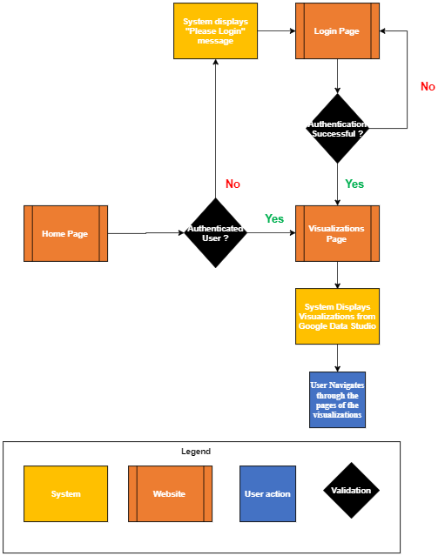

Figure 68 Navigating to the Visualizations page Flowchart

The above figure describes the path taken by a user to view visualizations in the web application.

**Cloud Services Flowchart**

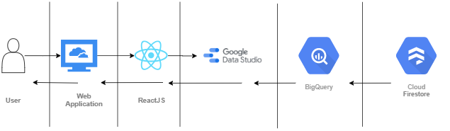

Figure 69 Cloud Service Flow for the visualization module [9]

This figure represents the cloud service pipeline that is established to render data to users in the web application. For Room and Tour reservations, data filtering based on current user is performed through the establishment of an access control mechanism which filters data based upon the email address of the current user.

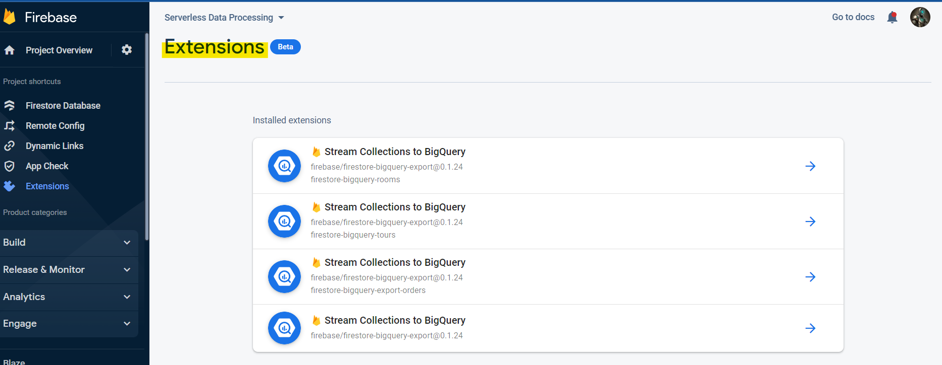

Figure 70 Firestore Extension to Stream Data to BigQuery

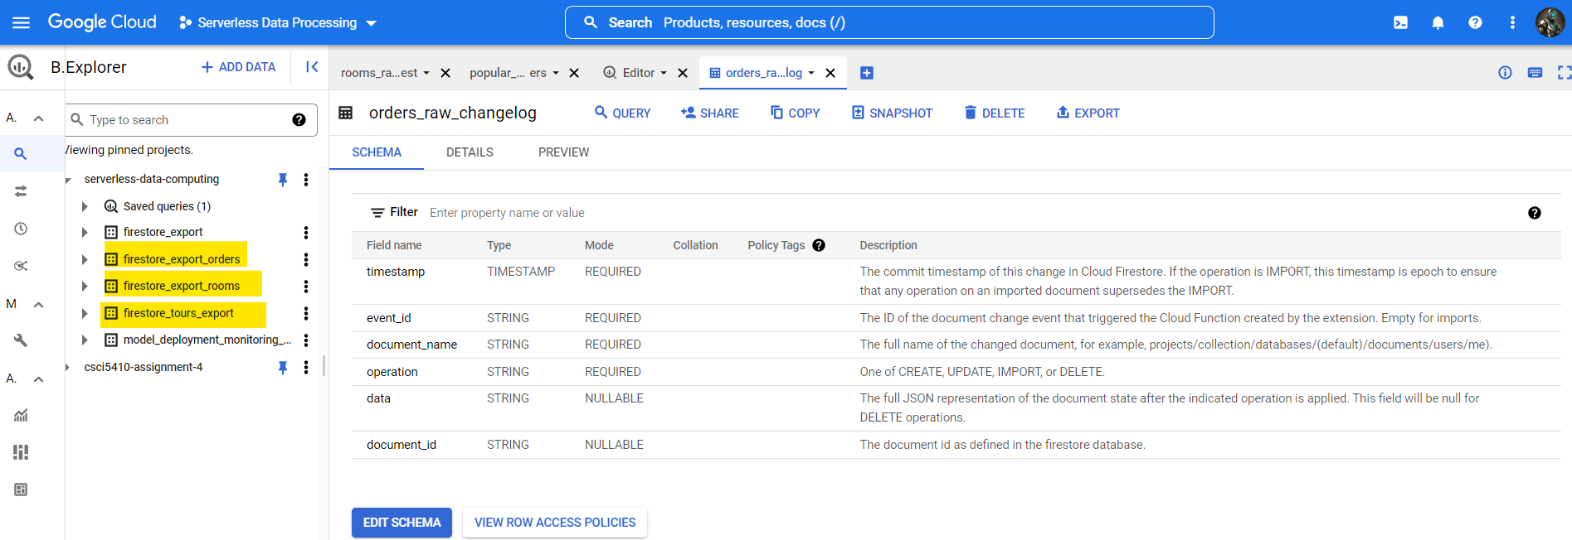

Figure 71 BigQuery Views that are imported into Google Data Studio

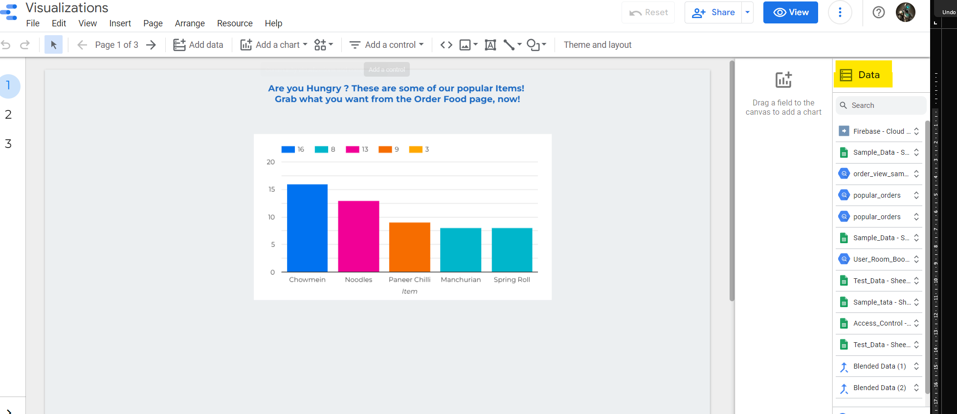

Figure 72 Data Imports in Google Data Studio

# Testing (UI Screenshots)

## **4.1 Online Support**

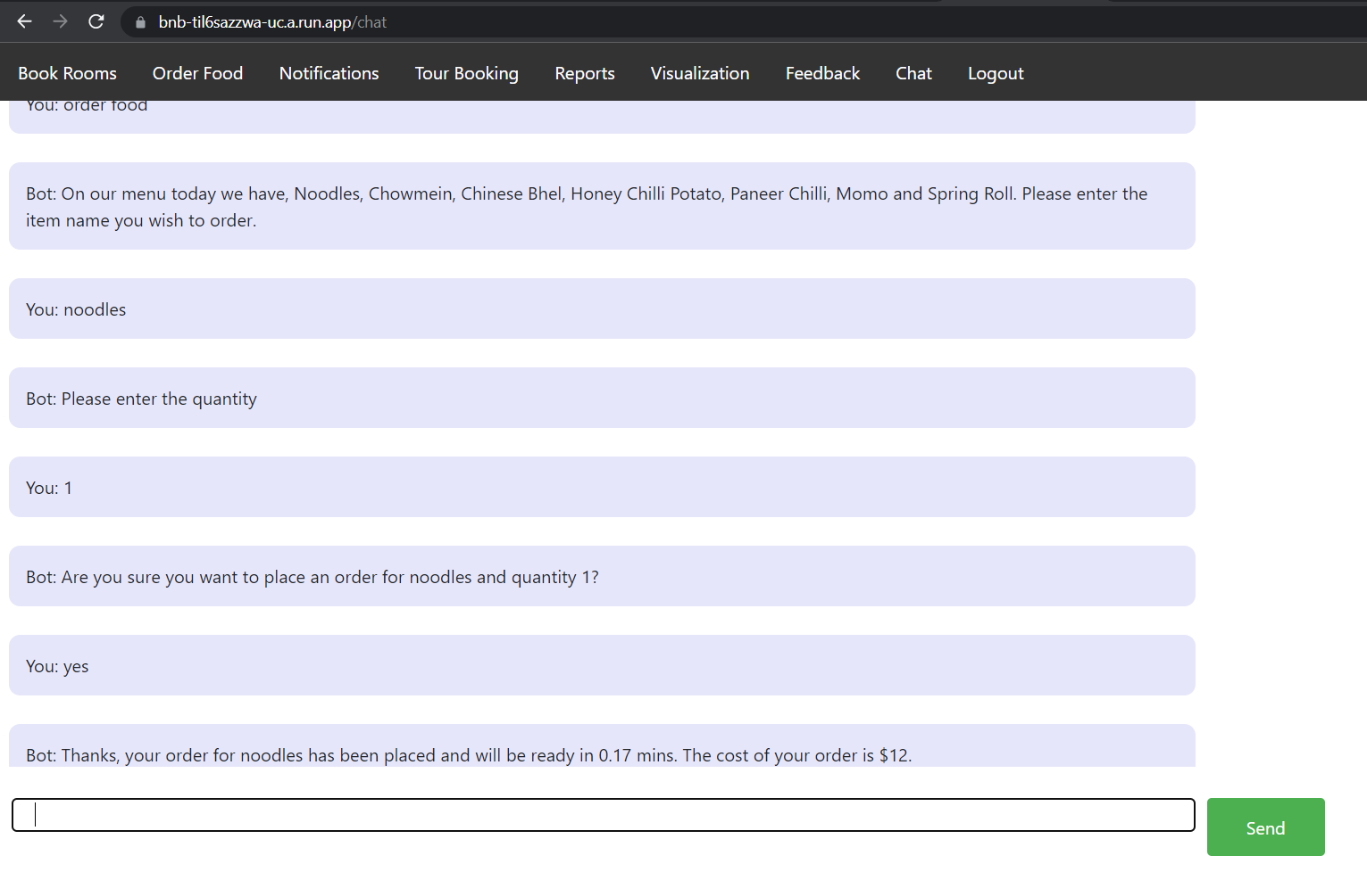

Figure 73 Order food from chatbot

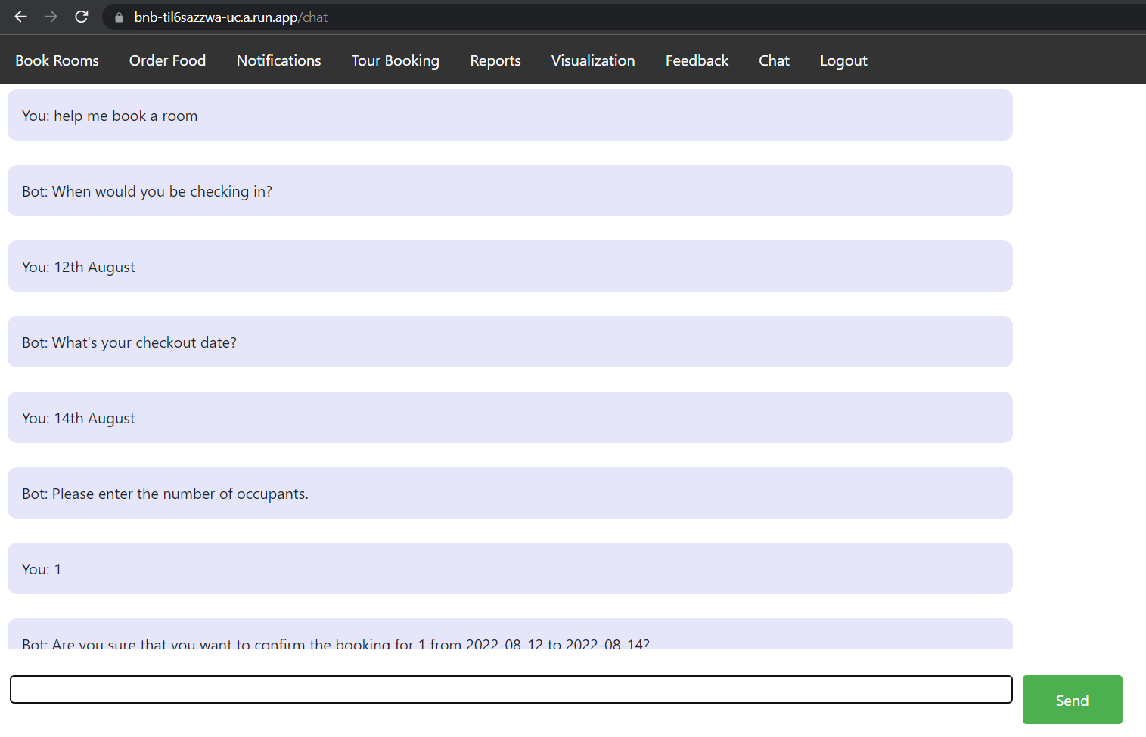

Figure 74 Book a room part 1

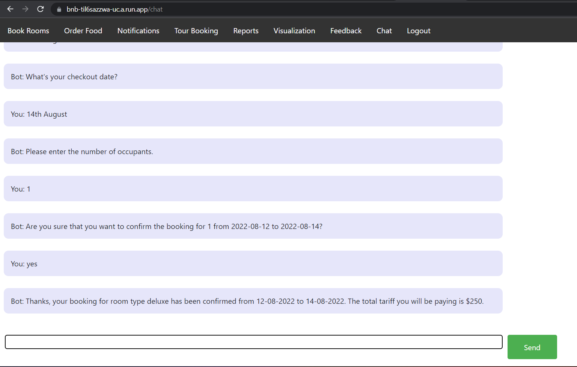

Figure 75 Book a room part 2

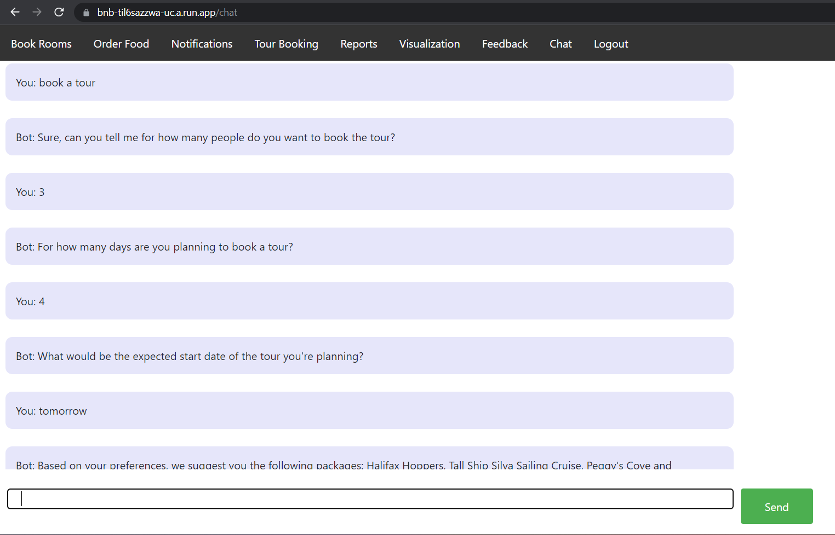

Figure 76 Book a tour part 1

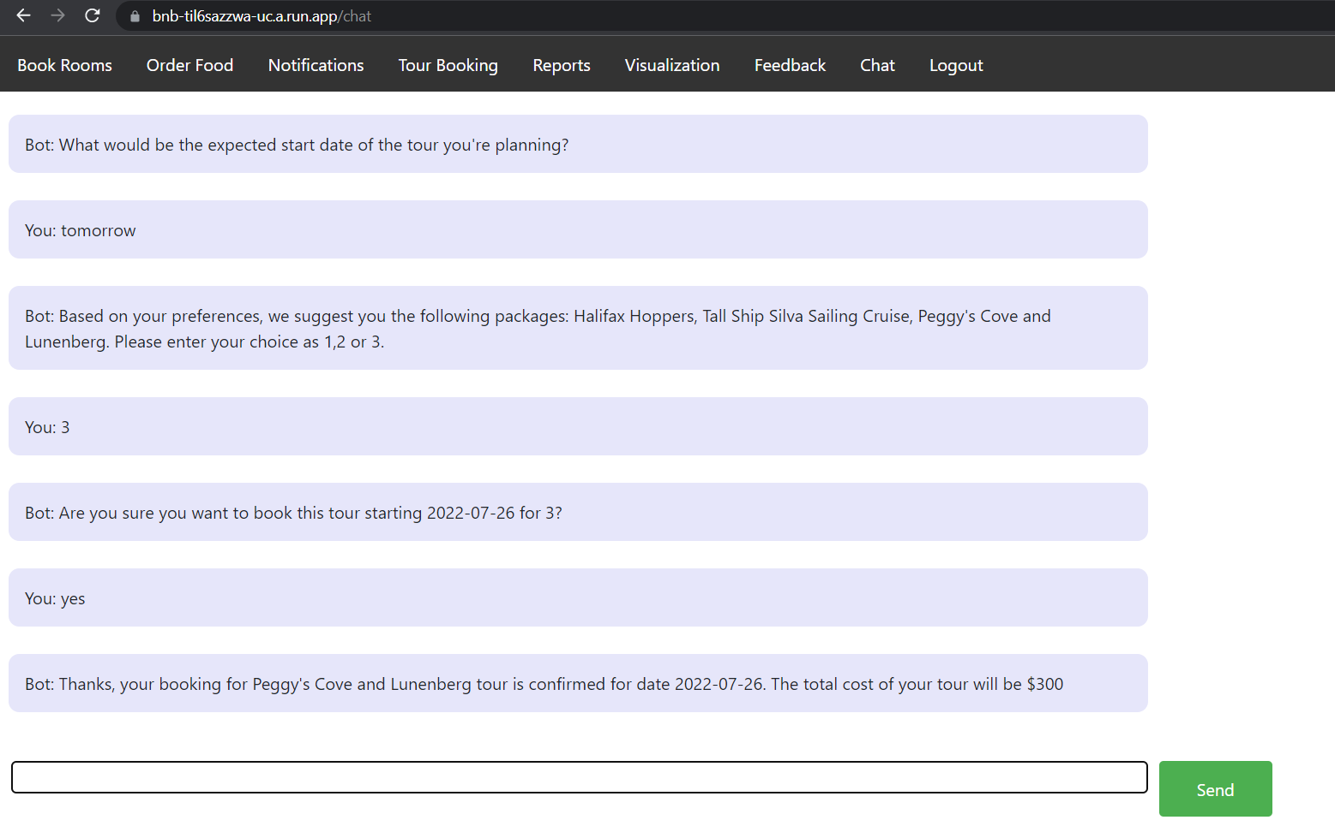

Figure 77 Book a tour part 2

## **4.2 Message Passing**

**Food Orders**

The food orders UI consists of two pages, order food and notifications

### Menu page (available for authenticated and unauthenticated users)

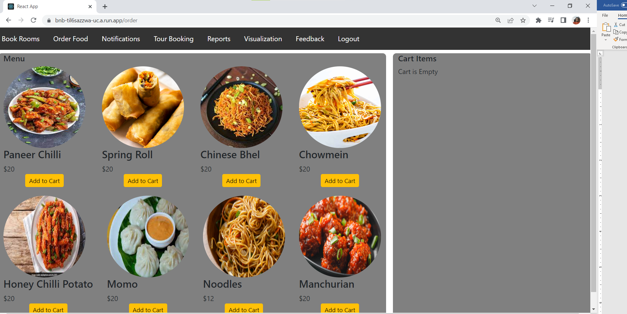

Figure 78 Menu Page for adding items to cart

### Cart Items page where the user can check the items, add or remove them and place an order.

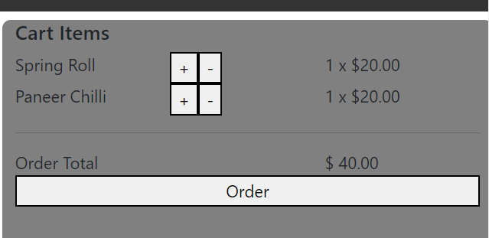

Figure 79 Cart Items

### Response for unauthenticated user while trying to place an order

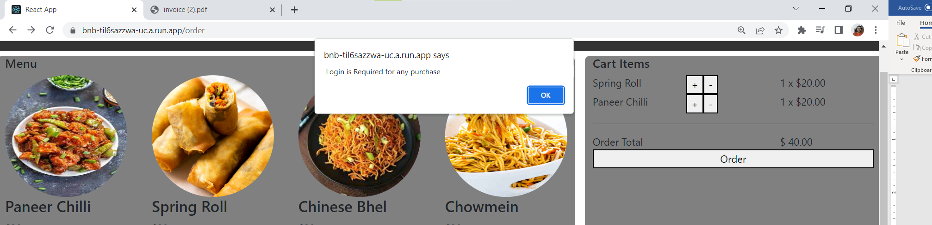

Figure 80 Unauthenticated user

### Redirect to the notifications page once the order has been placed successfully.

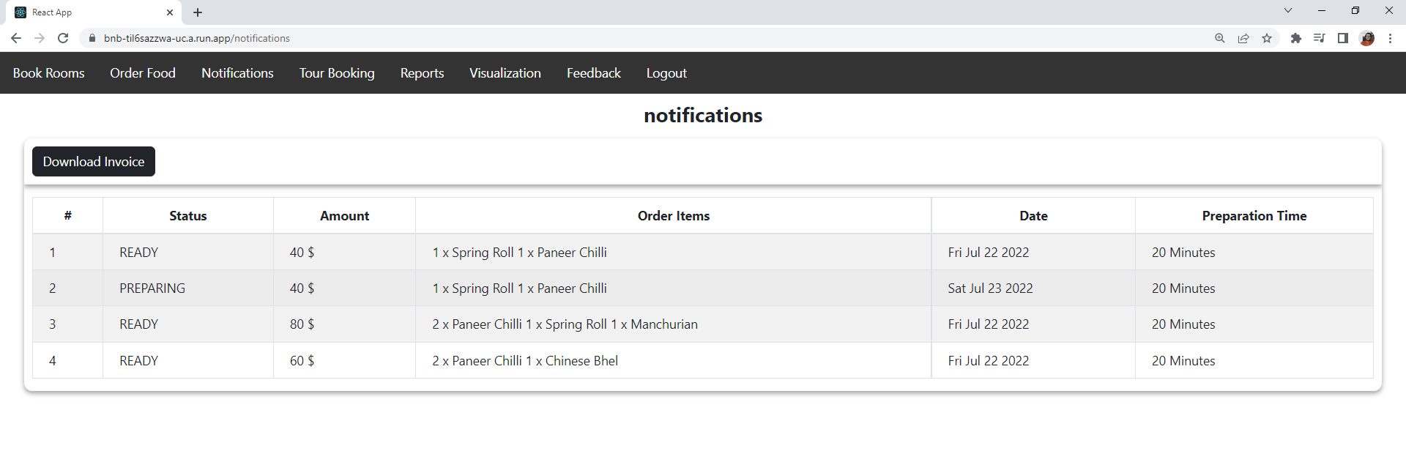

Figure 81 Notifications for authenticated users

### Error when an unauthenticated user tries to visit the navigations page

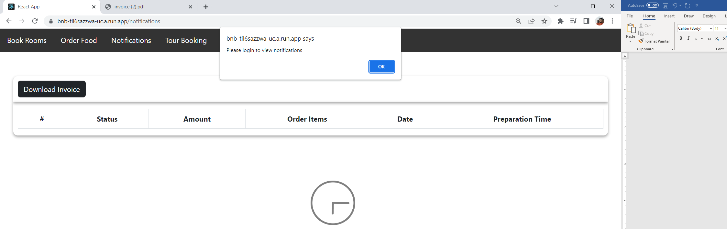

Figure 82 Notification error for unauthenticated users

### Generated downloadable pdf when an authenticated user clicks on Download Invoice.

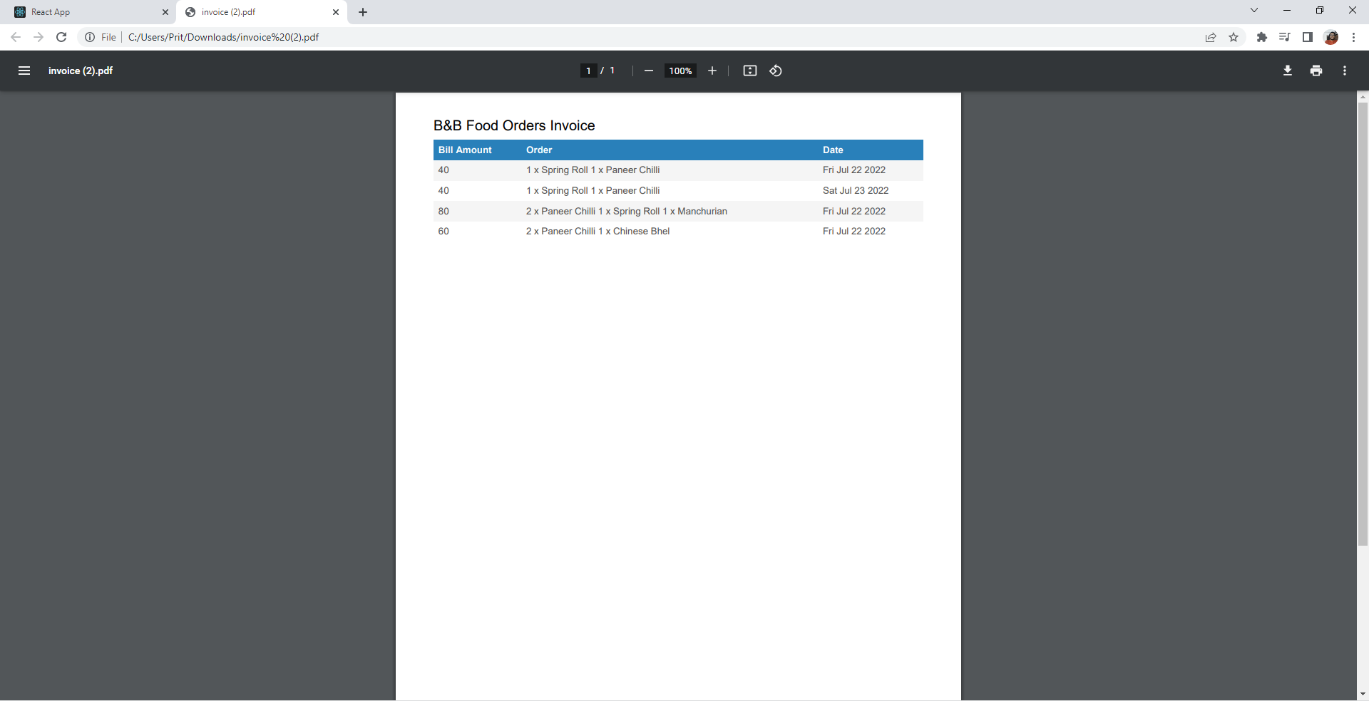

Figure 83 PDF invoice when user clicks on "Download Invoice"

## **4.3 Room Reservation**

1. Let us simulate a scenario where an unauthenticated user attempts to navigate to the room reservation page.

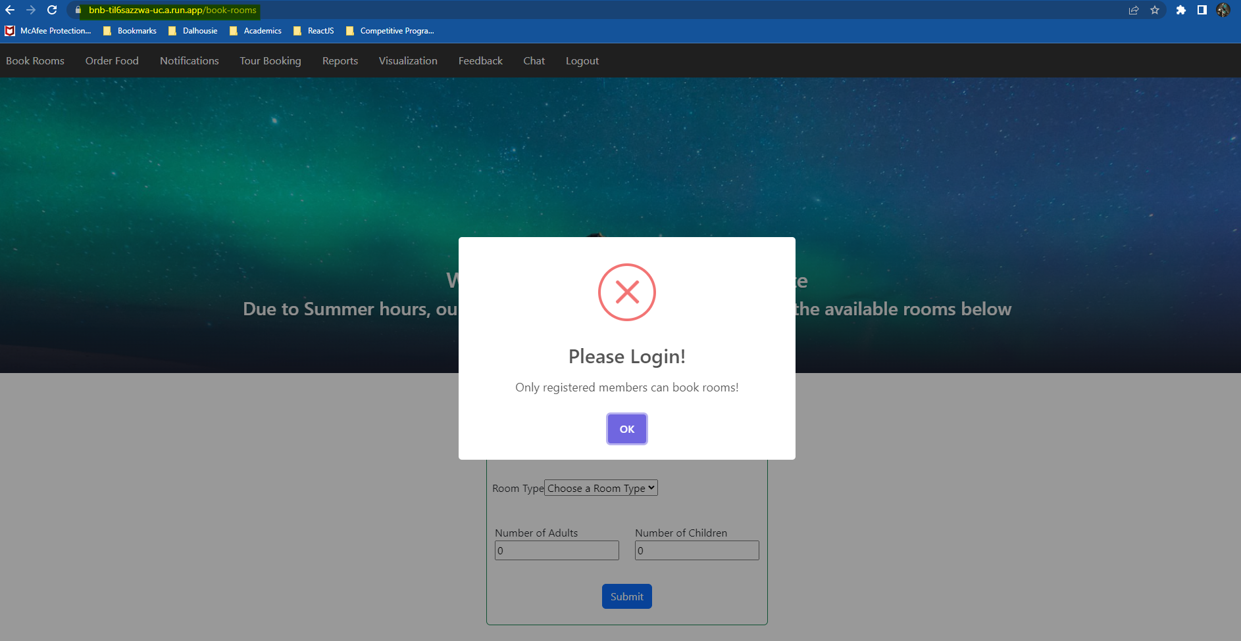

Figure 84 Simulation of an unauthenticated user accessing the room reservation page

1. Sign into the application

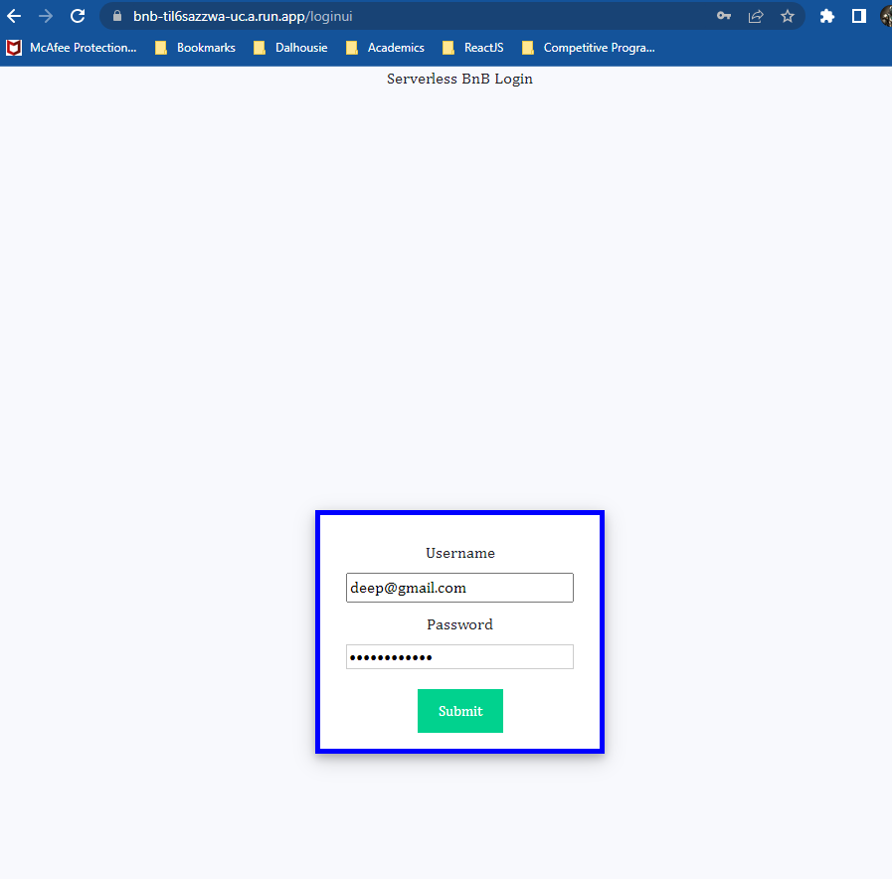

Figure 85 Input Username and Password

1. Verification through Multifactor Authentication

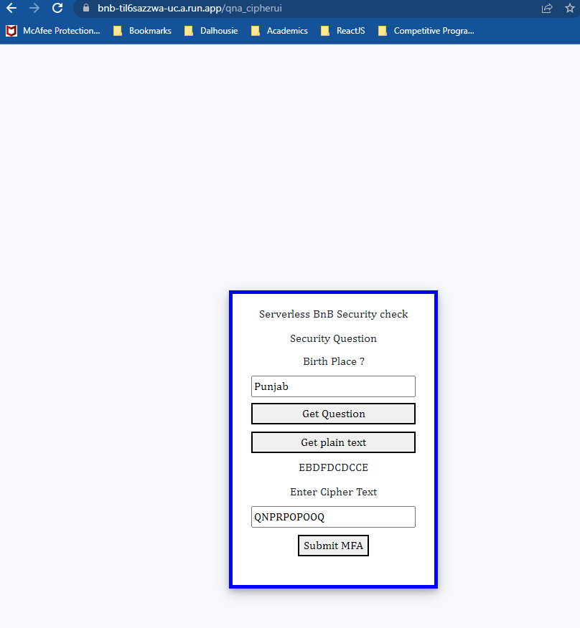

Figure 86 Multifactor Authentication

1. Reservation Page for Authenticated user

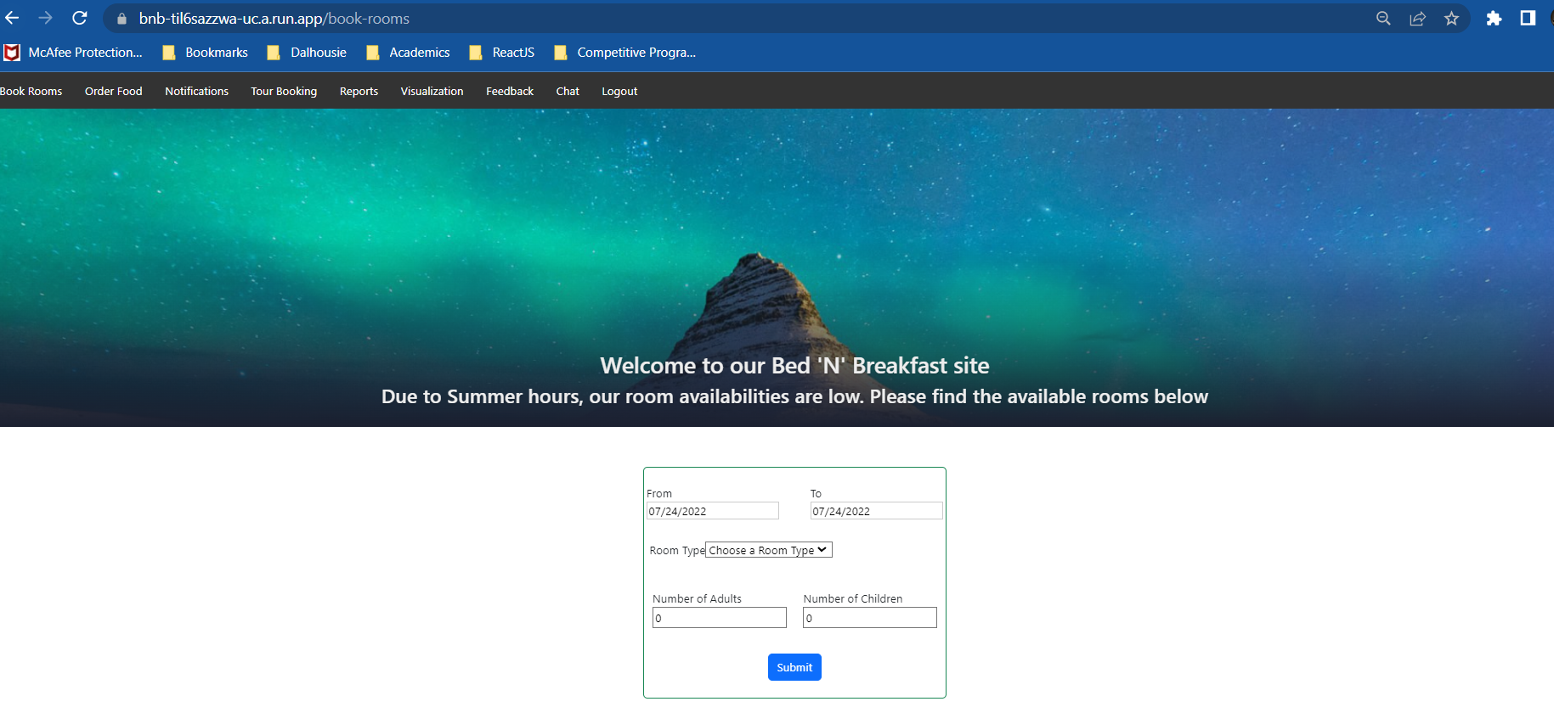

Figure 87 Room reservation page

1. List of Available Rooms

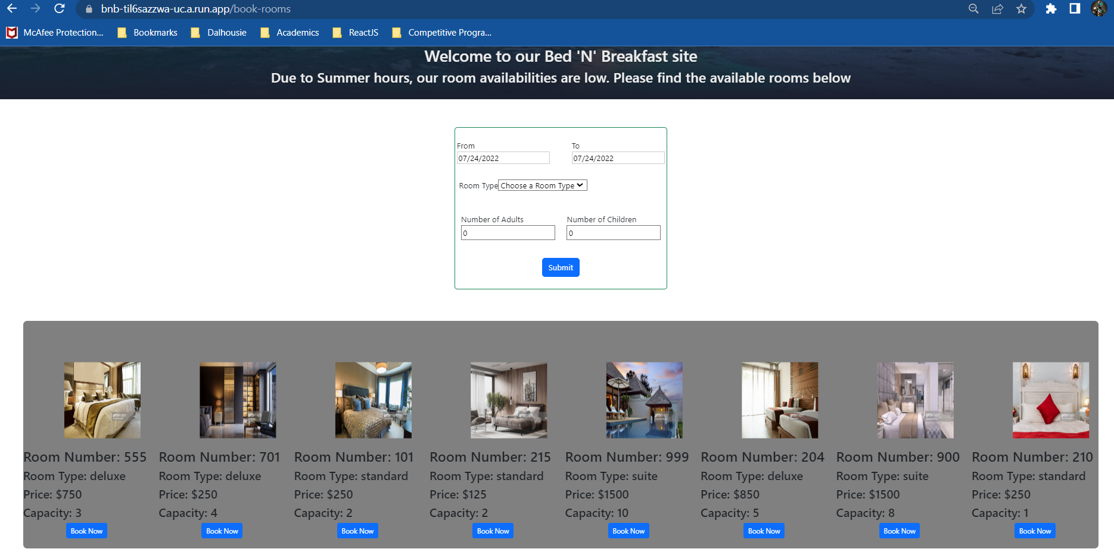

Figure 88 Listing all available rooms in the page

1. Filtering the list of available rooms

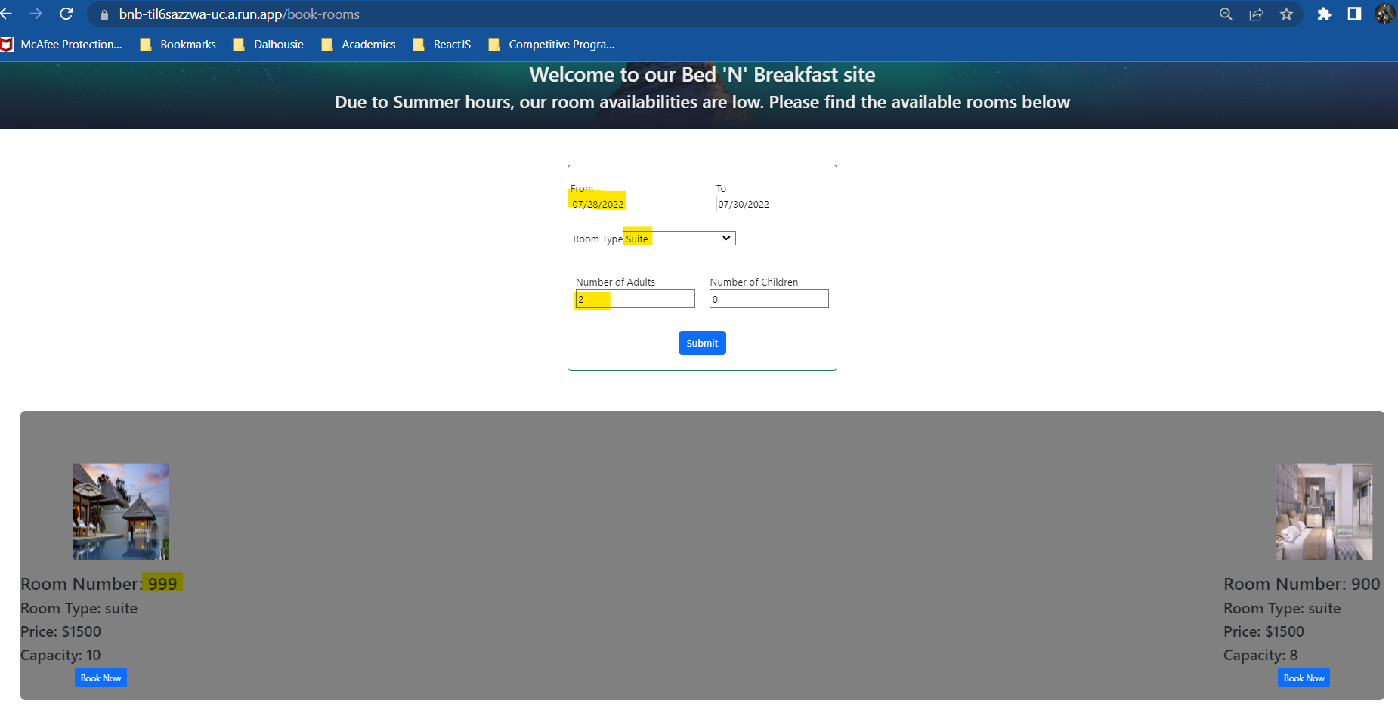

Figure 89 Filtering rooms based on preferences and dates

1. Booking a room

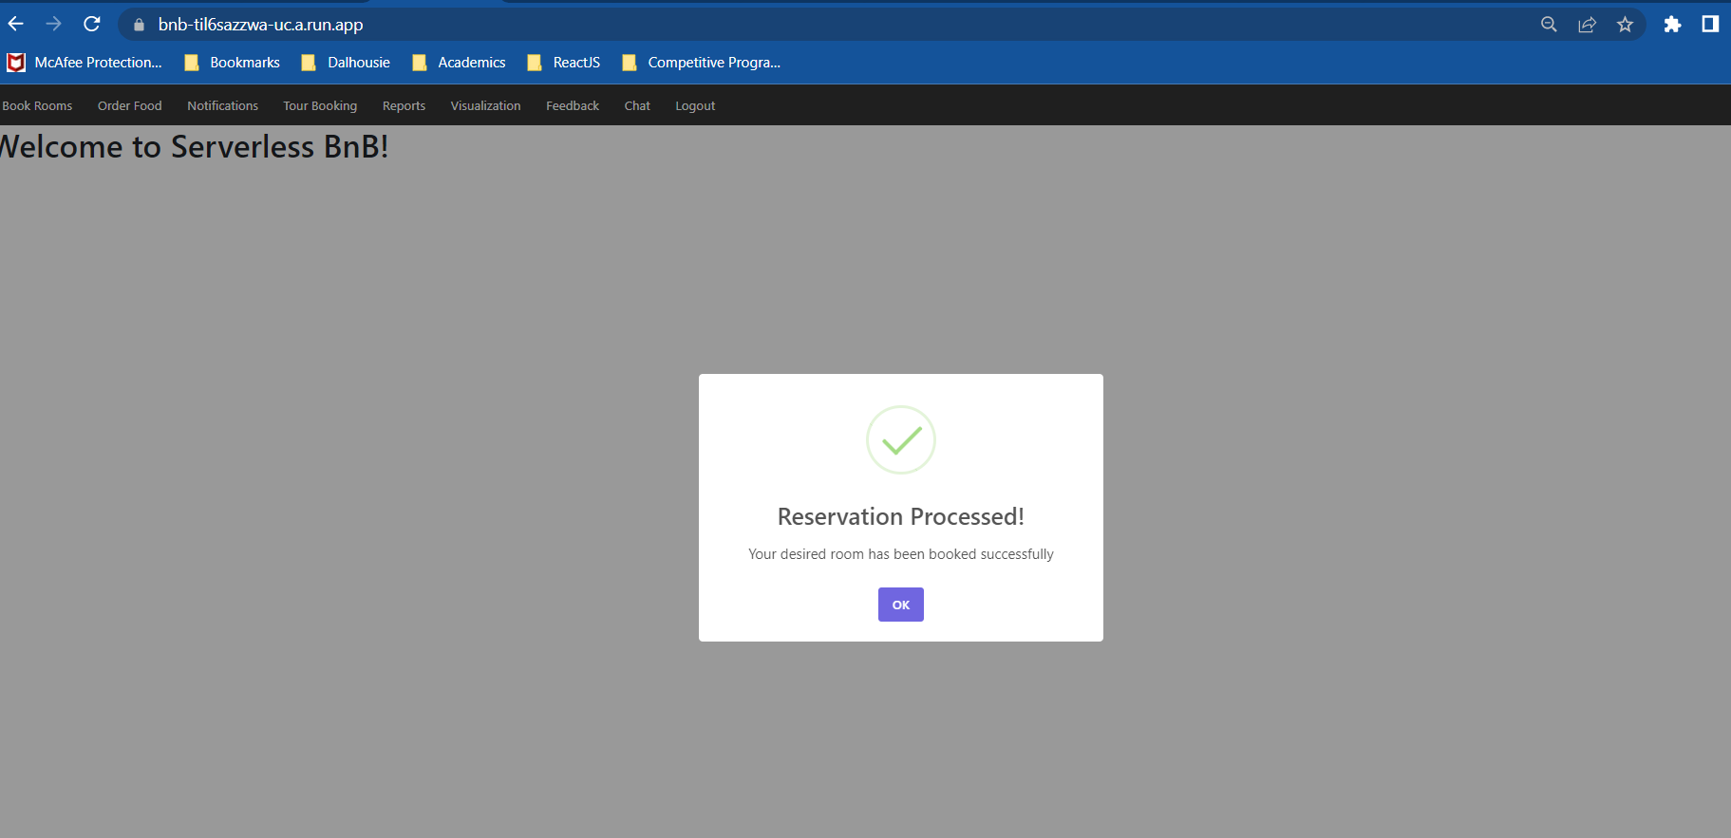

Figure 90 Room Reservation Confirmation

1. Validating Reservation Request in the User Interface

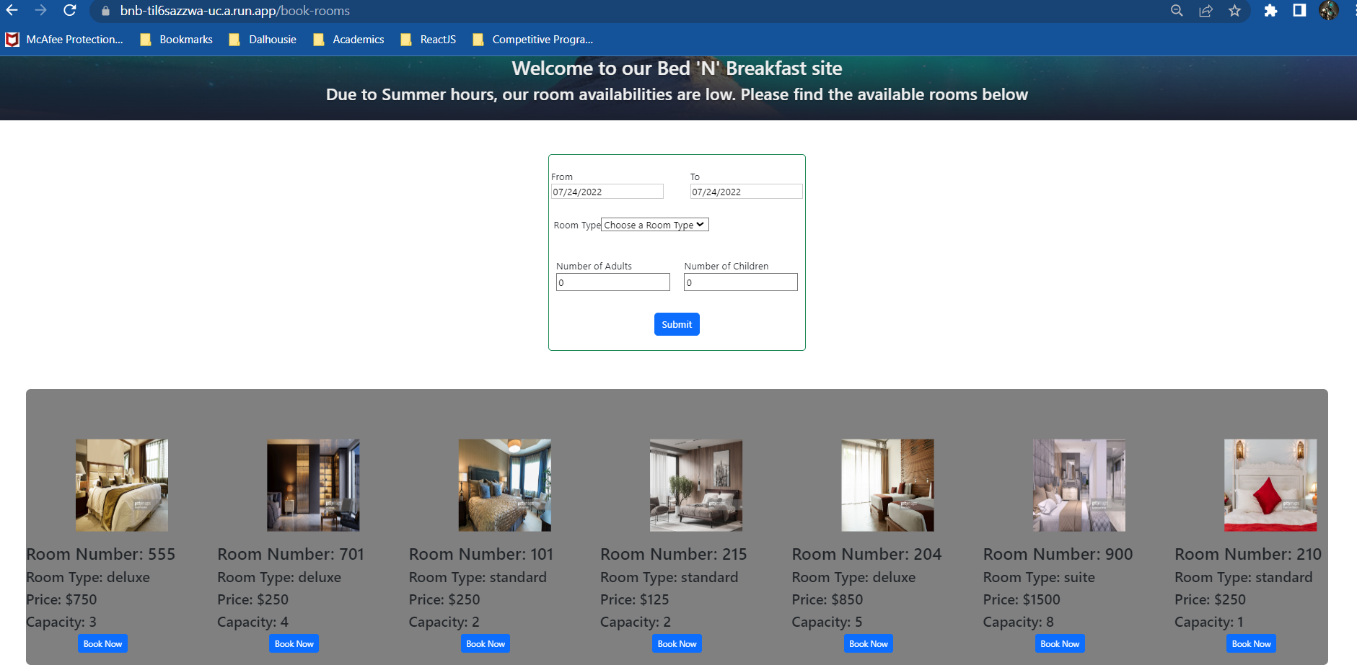

Figure 91 Romm- 999 is no longer available for reservation

From the above figure we can observe that Room – 999, which was booked in the previous step, is no longer available for reservations.

1. Validating Reservation Request in Cloud Firestore

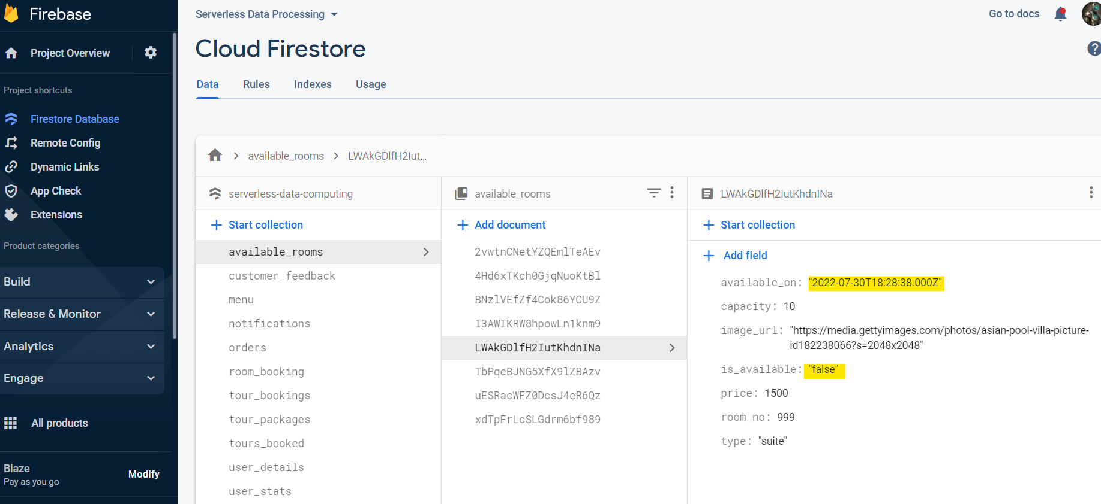

Figure 92 Updated current availability and next availability date in Firestore

We can observe that the current availability is set to false and that the next available date is set to the end date of the current reservation.

## **4.4 Machine Learning**

4.4.1 Recommending Tour Packages

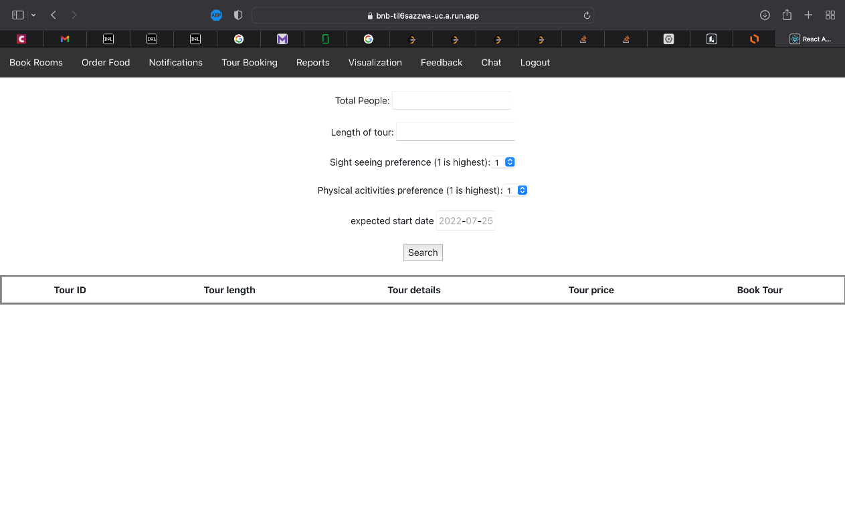

Figure 93 Tour booking page

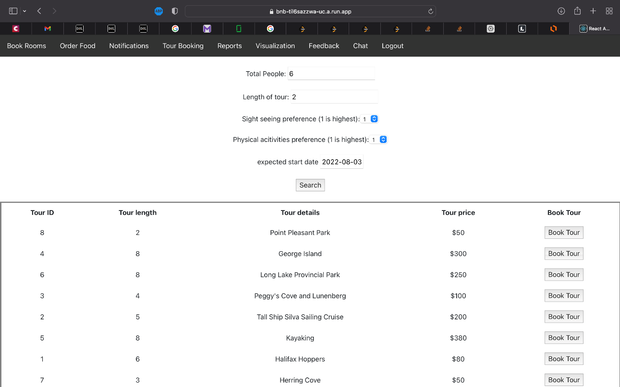

Figure 94 Search results of tours

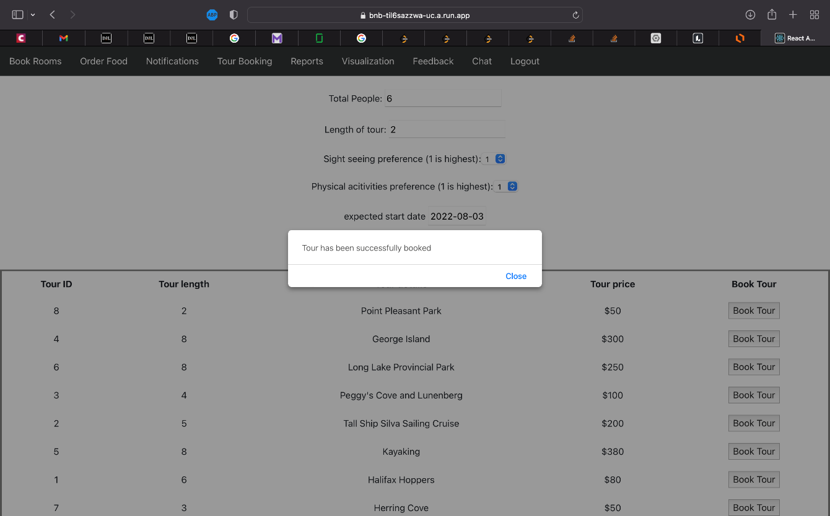

Figure 95 Alert after tour is booked

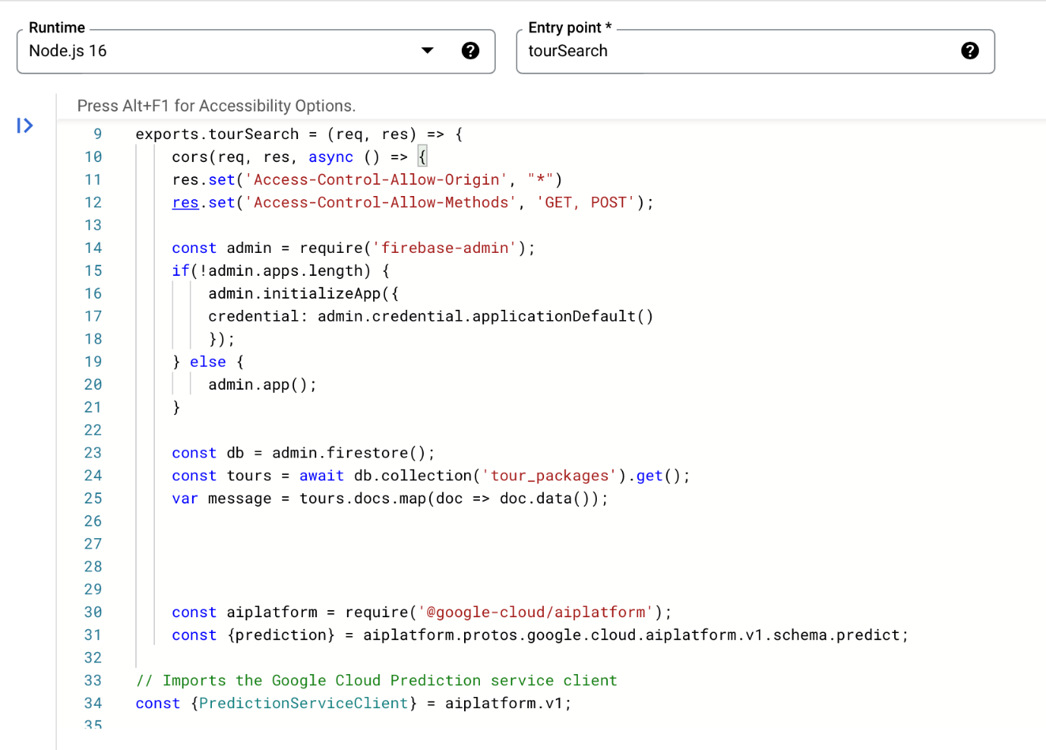

Figure 96 tourBooking cloud function code snippet

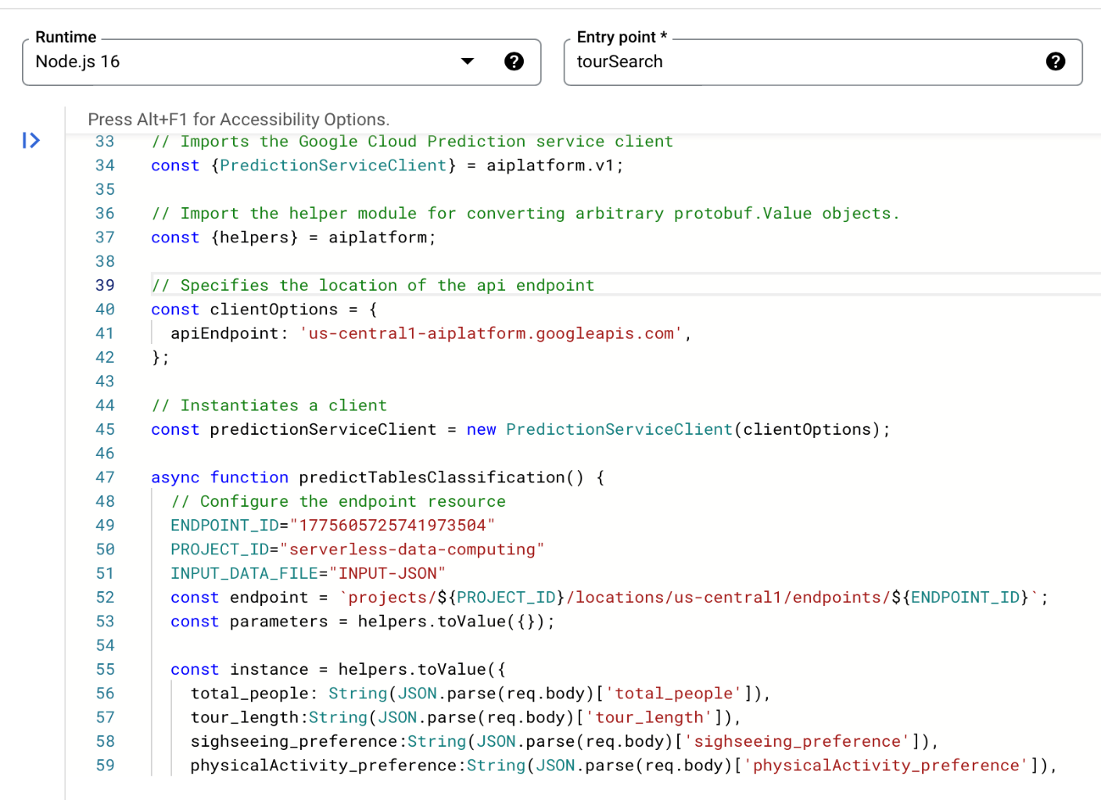

Figure 97 tourBooking cloud function code snippet

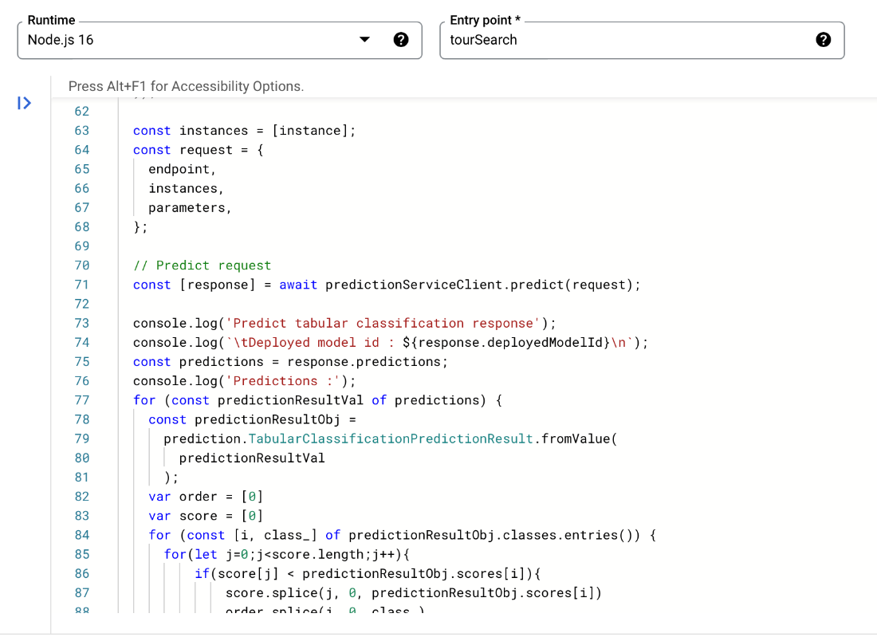

Figure 98 tourBooking cloud function code snippet

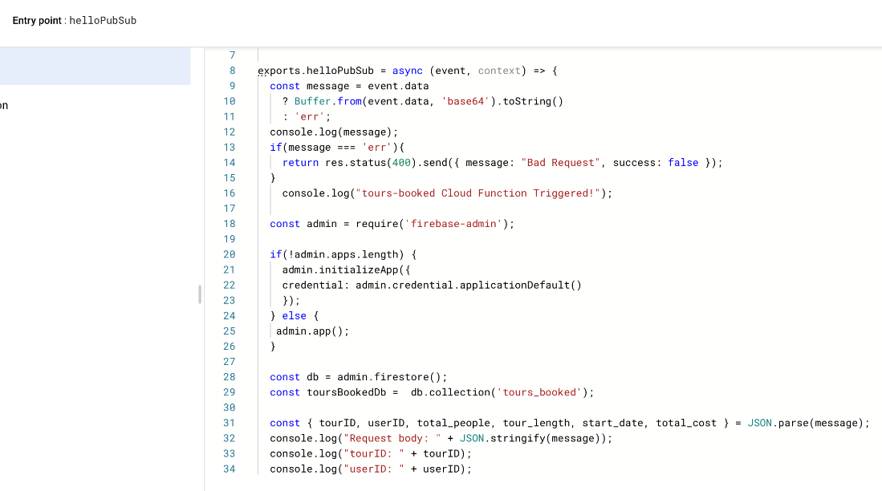

Figure 99 storeTourBooking cloud function code snippet

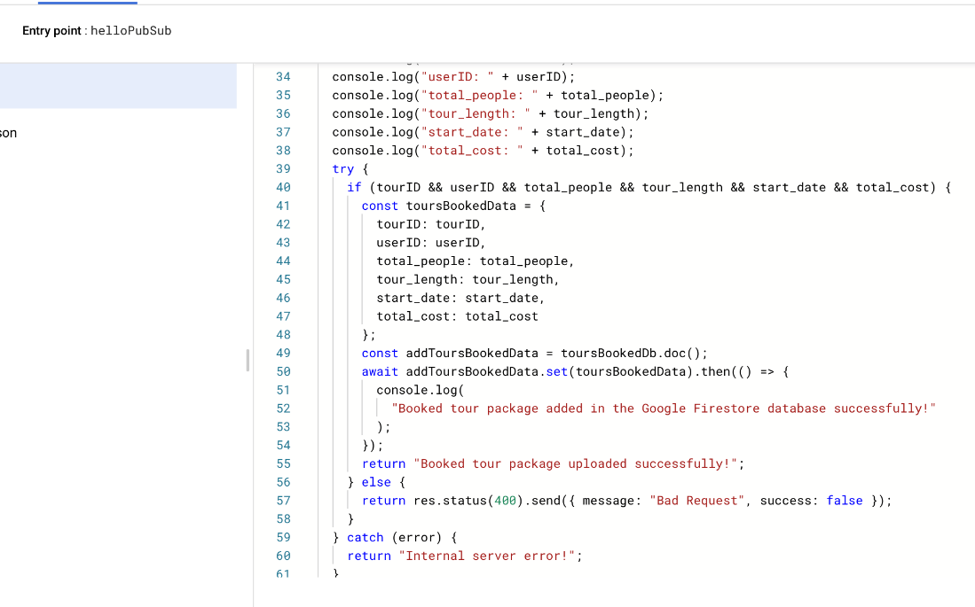

Figure 100 storeTourBooking cloud function code snippet

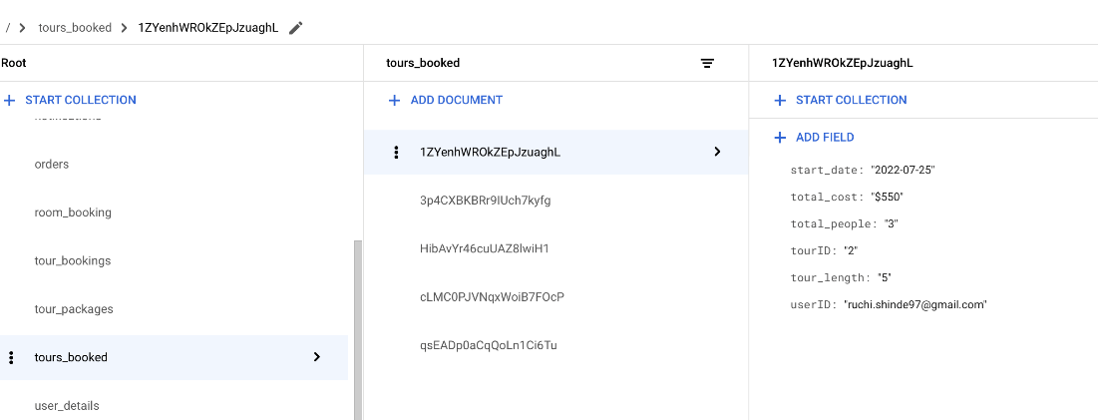

Figure 101 Firestore DB collection representing the booked tours

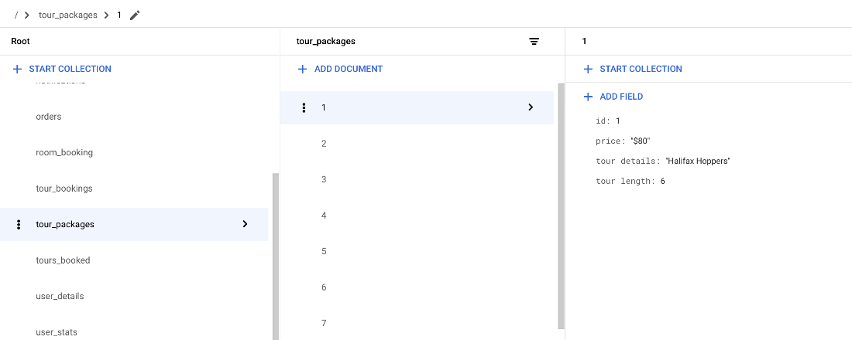

Figure 102 Firestore DB collection representing the available tour packages

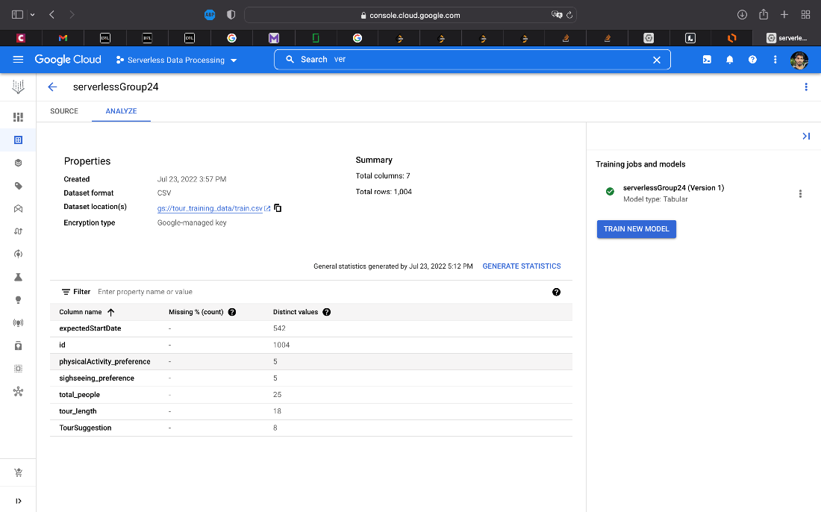

Figure 103 Training data set used to train tour predictions machine learning model

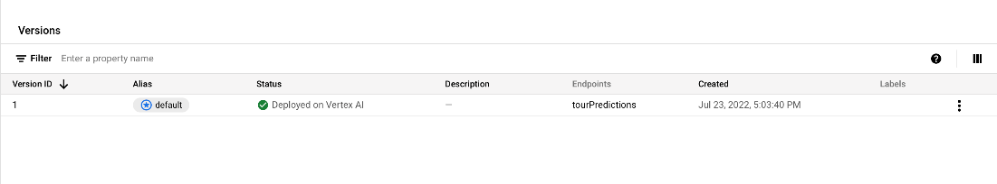

Figure 104 Machine learning model used to predict tours

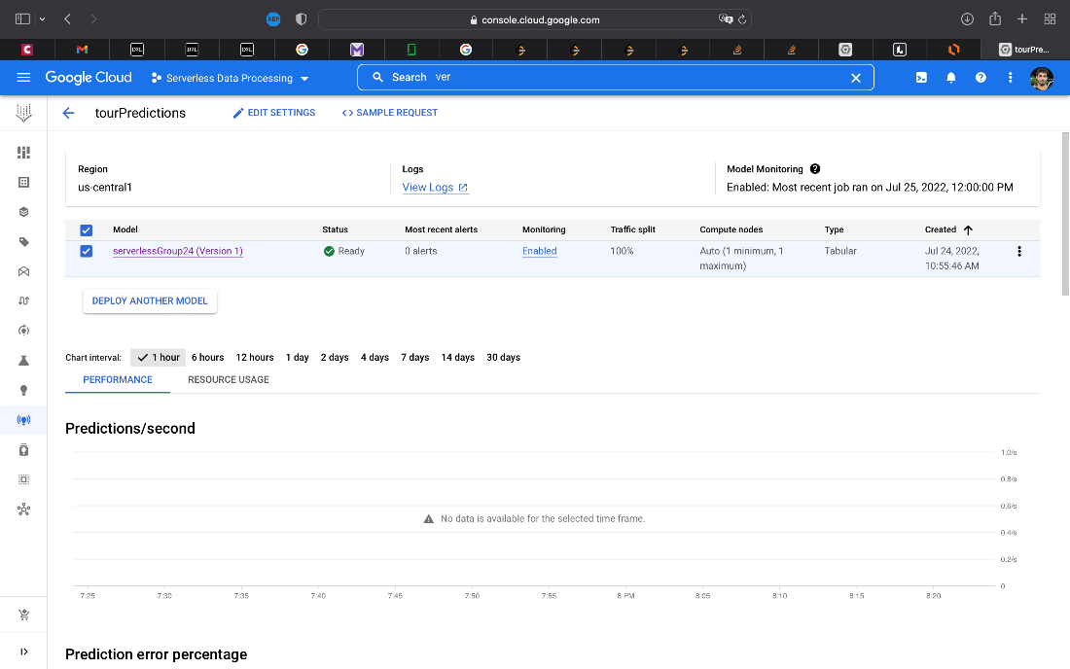

Figure 105 Machine learning model endpoint

4.4.2 Customer Feedback Sentiment Analysis

1. Unauthorized user tries to access the Feedback page

Firstly, when an unauthorized user attempts to navigate to the Feedback page then the user will be redirected to the login page.

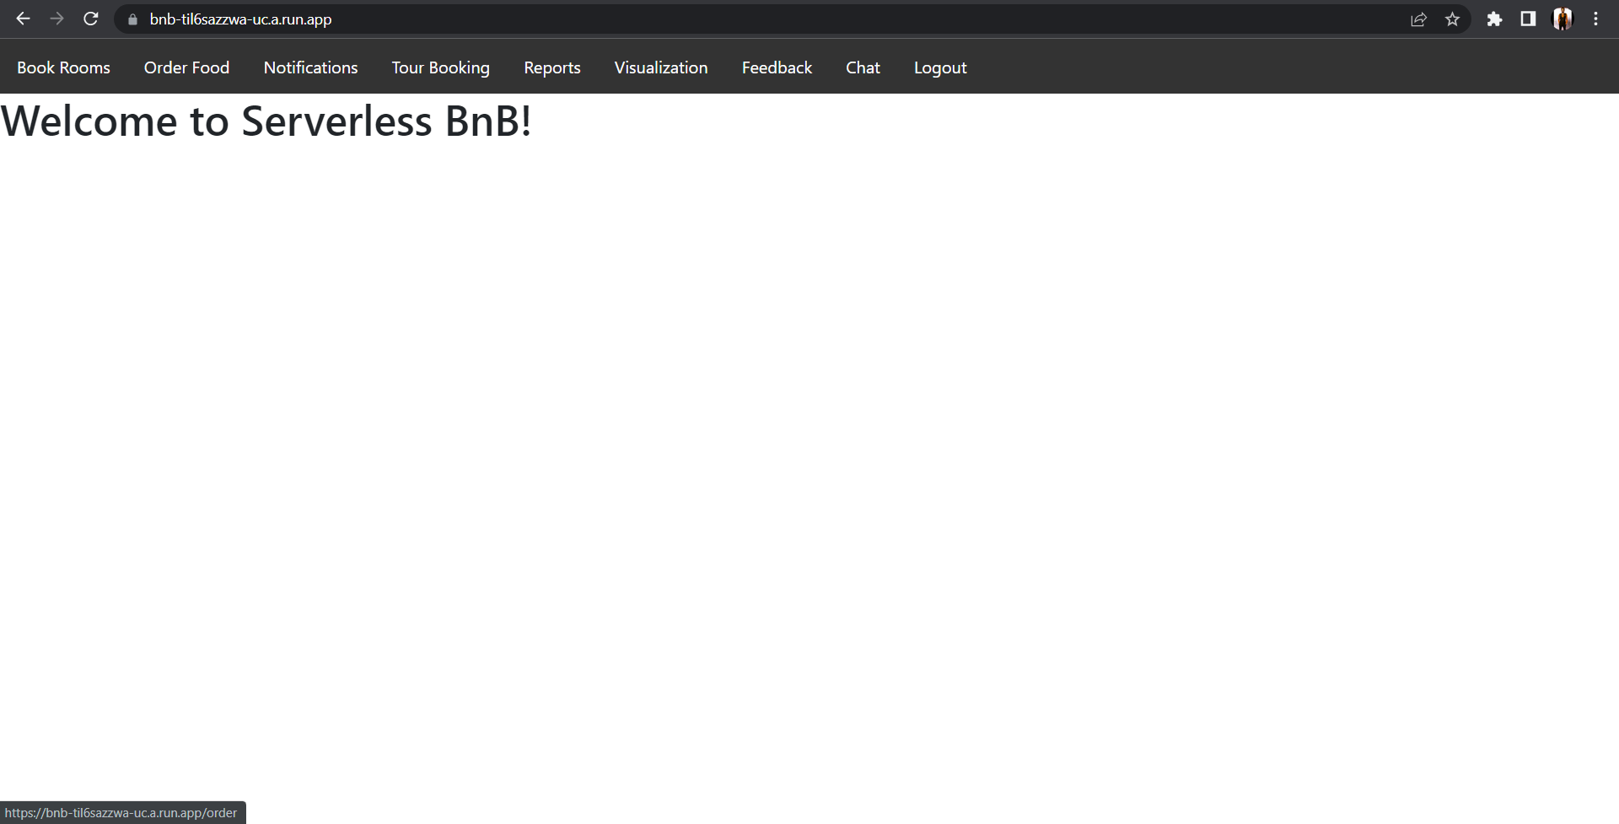

Figure 106 Figure displaying the Serverless BnB landing/home page

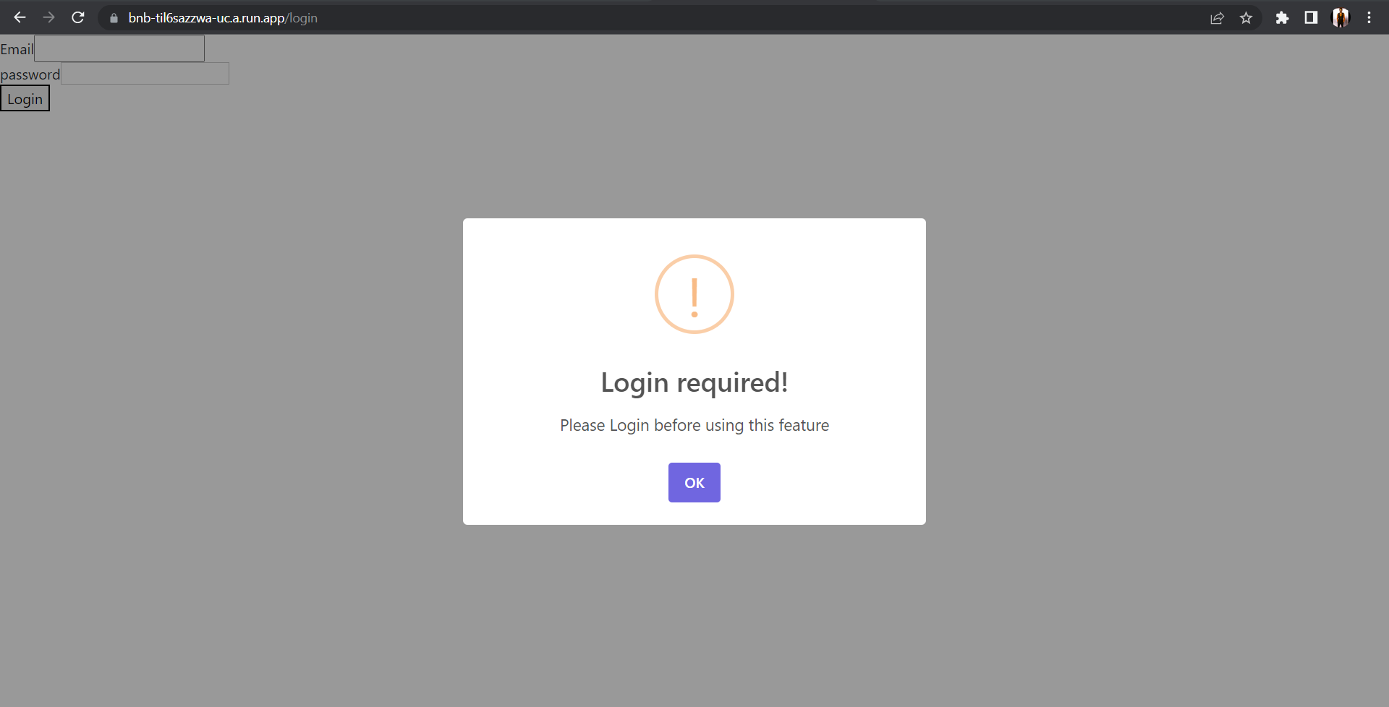

Figure 107 User gets redirected to Login page and a popup message shows up when an unauthorized user tries to access Feedback page

1. Customer Feedback homepage

The Customer Feedback page looks like below:

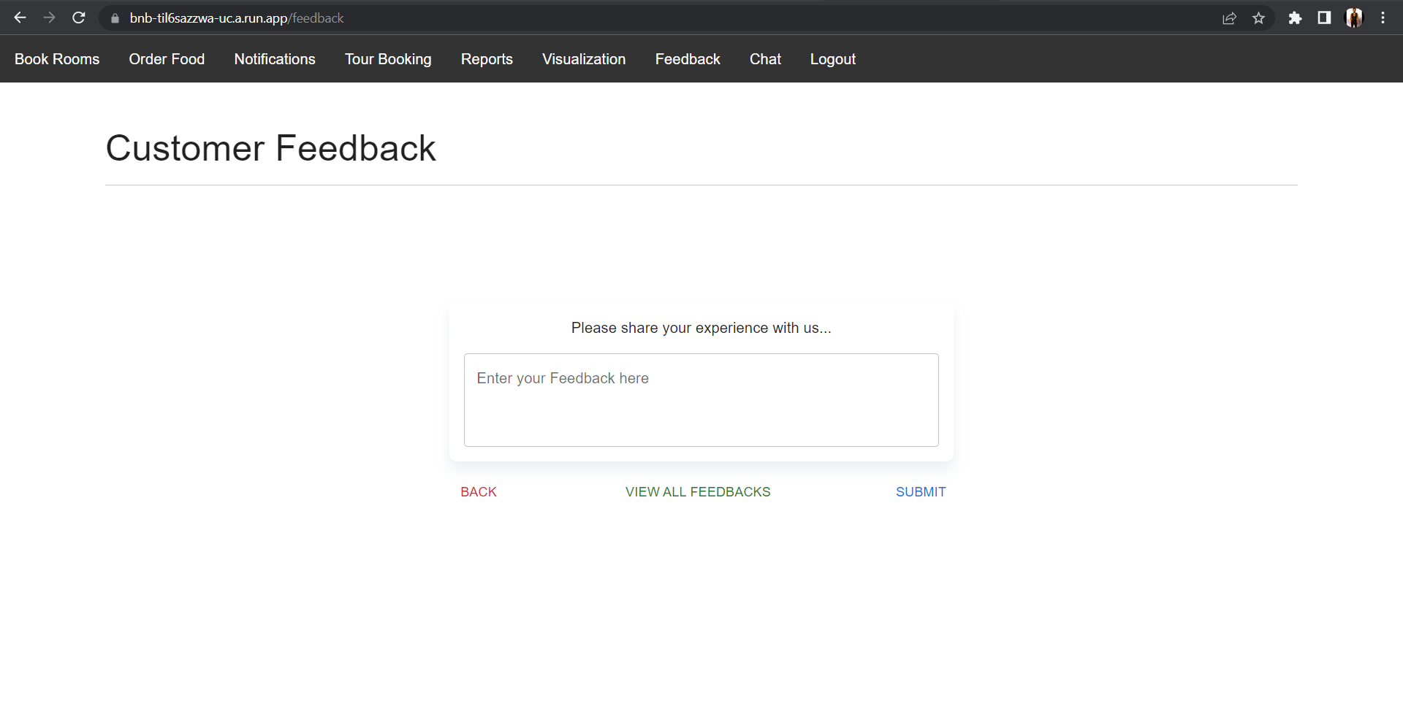

Figure 108 Screenshot displaying the Customer Feedback page

1. Validation handling in Customer Feedback

If a user tries to submit feedback without entering any text, then an error message will pop up.

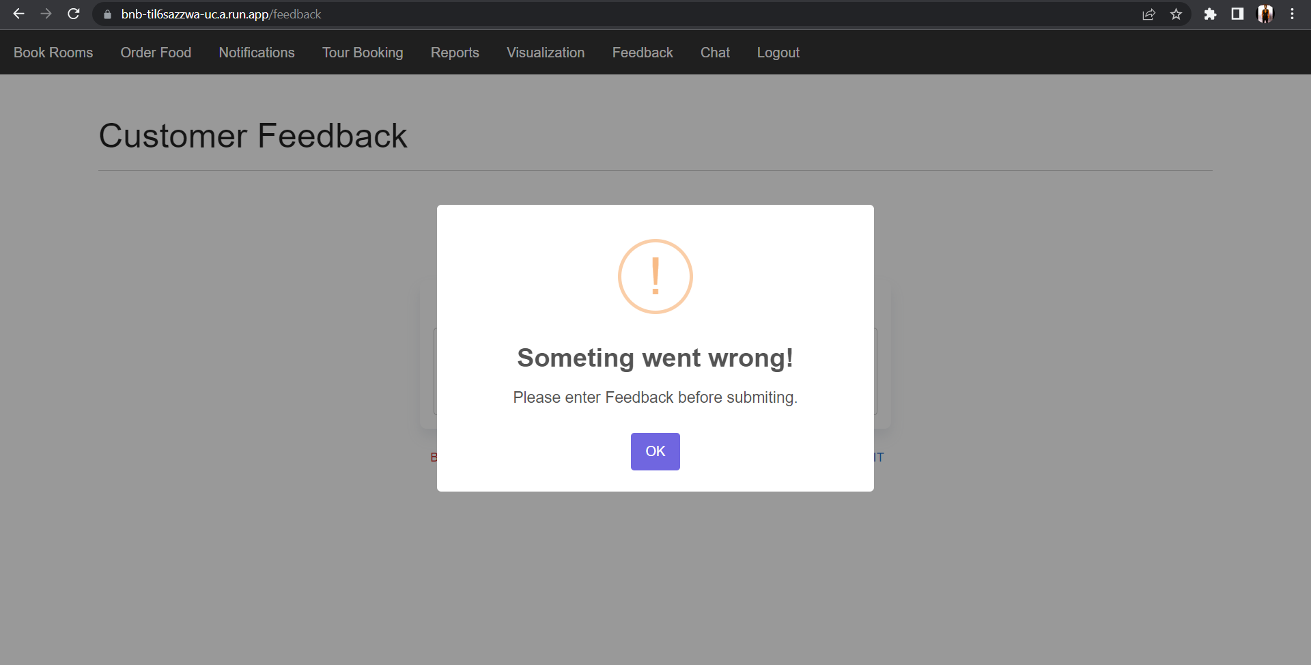

Figure 109 Screenshot displaying validation handling when user tries to submit feedback without entering any text.

1. Submitting positive feedback

When a user submits feedback then the associated cloud function will be triggered, and it will perform sentiment analysis on the text to assign an appropriate sentiment score using Cloud Natural Language API. The below figures show what happens when a user submits positive feedback.

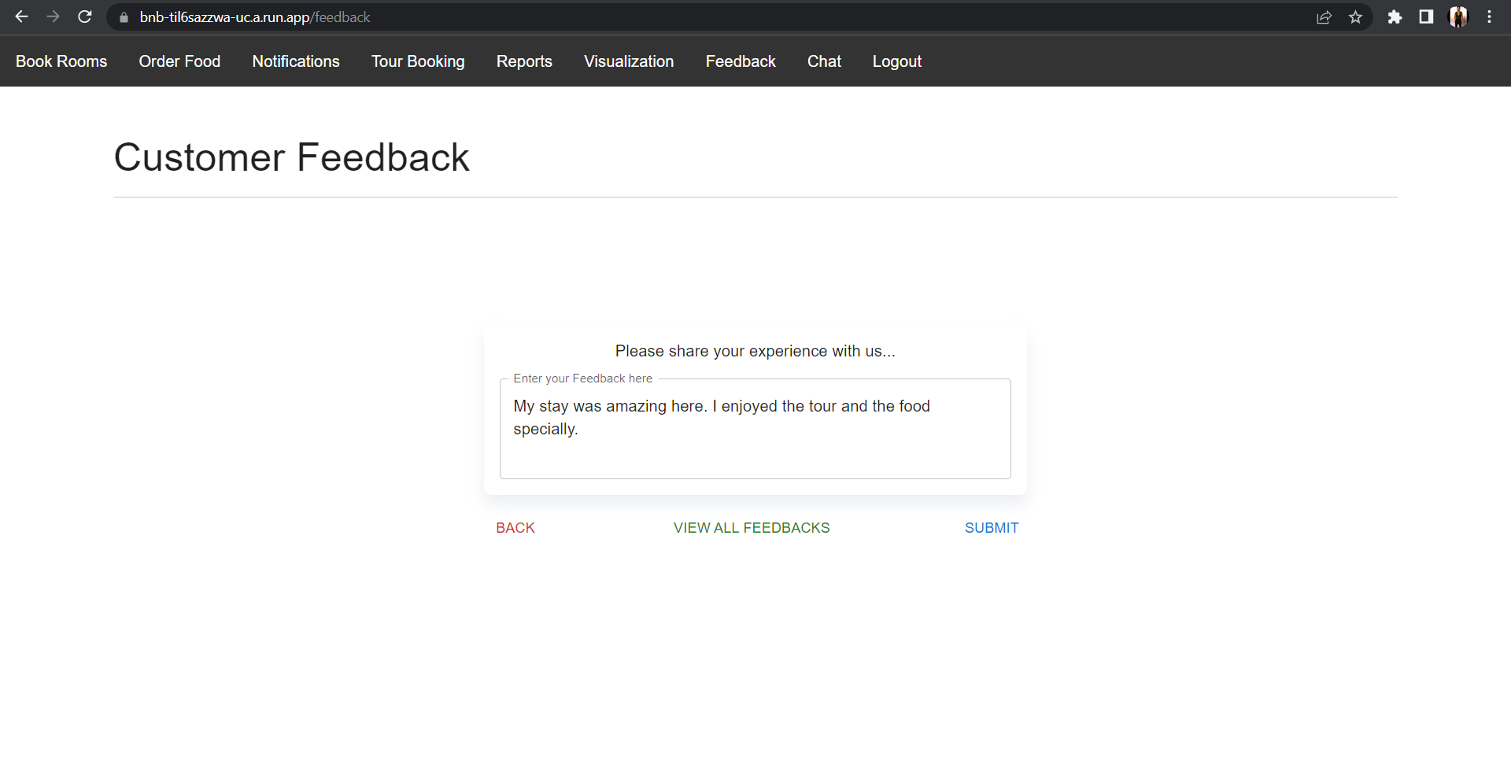

Figure 110 Screenshot displaying a test case where user enters a positive feedback

When feedback is submitted, an appropriate popup message will be displayed based on the polarity. As the submitted feedback in this case is positive the below message will popup.

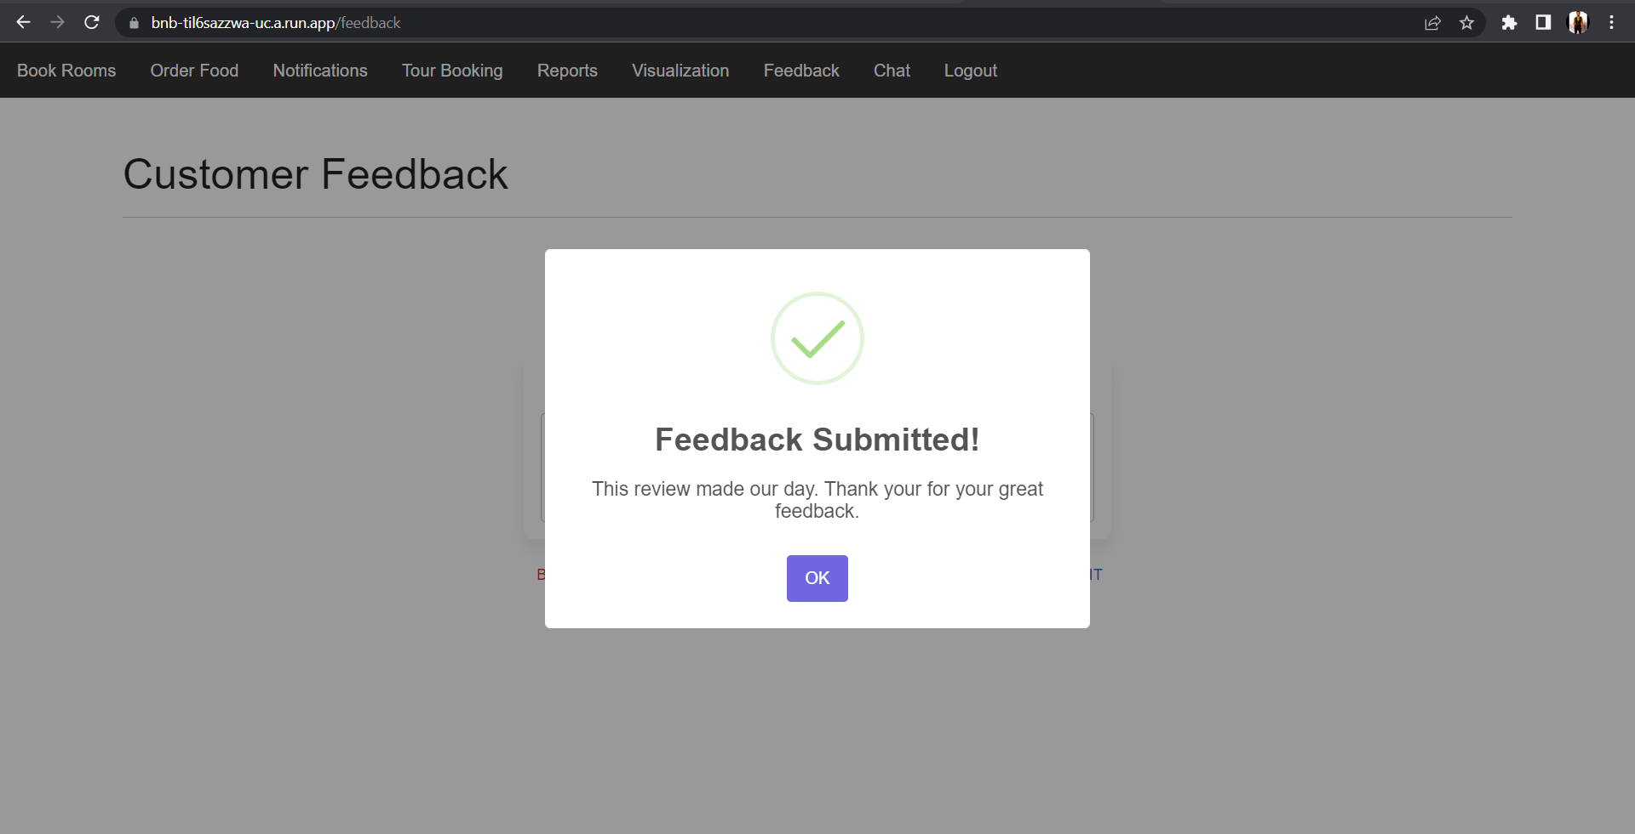

Figure 111 Screenshot displaying the appropriate popup message based on the identified polarity of the submitted feedback

After the associated cloud function is triggered and sentiment analysis is performed, the user email, feedback, score, magnitude, and polarity of the feedback will be stored in the ‘customer_feedback’ collection in cloud Firestore. The below given figure displays the stored feedback with positive polarity as the submitted feedback was positive.

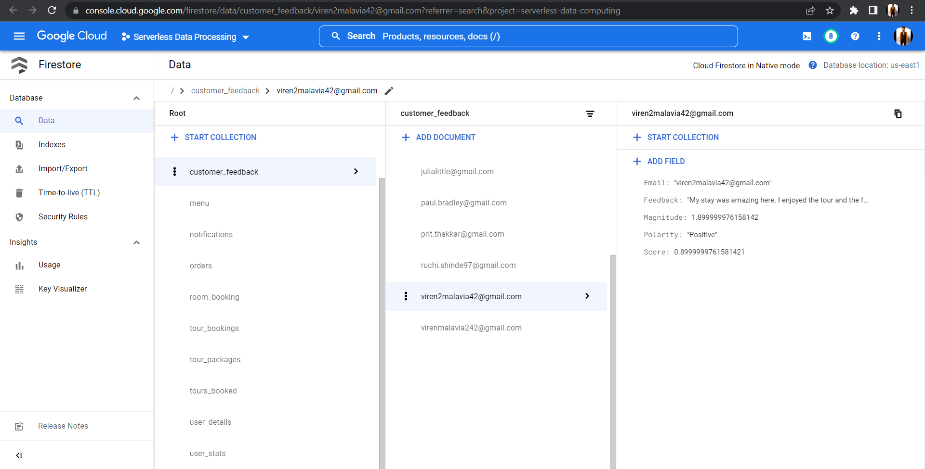

Figure 112 Screenshot displaying the submitted feedback on cloud Firestore with the user’s email, feedback, magnitude, identified polarity and sentiment score

1. Submitting negative feedback

The associated cloud function will be triggered on submitting the feedback, and it will perform sentiment analysis on the text to assign an appropriate sentiment score using Cloud Natural Language API. The below figures show what happens when a user submits negative feedback.

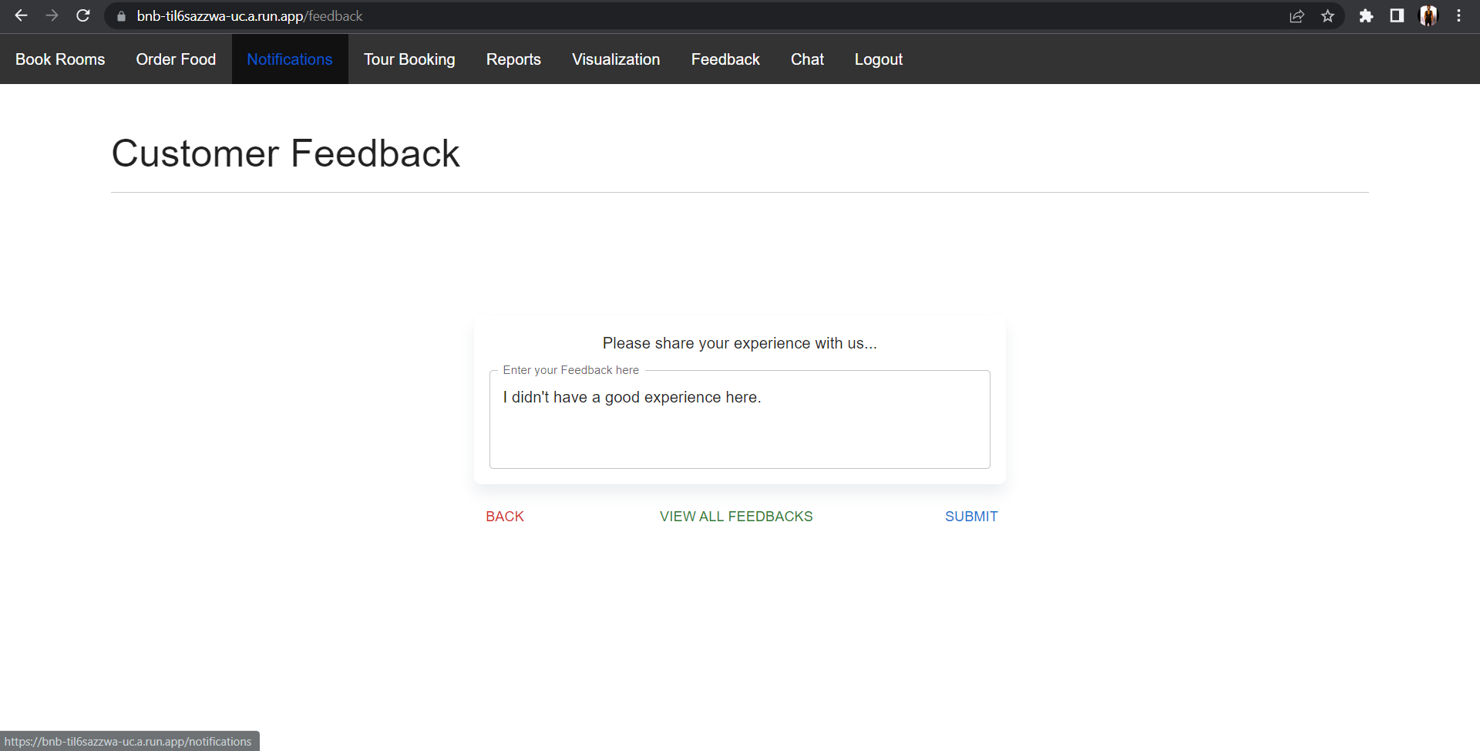

Figure 113 Screenshot displaying a test case where user enters a negative feedback

When feedback is submitted, an appropriate popup message will be displayed based on the polarity. As the submitted feedback in this case is negative the below message will popup.

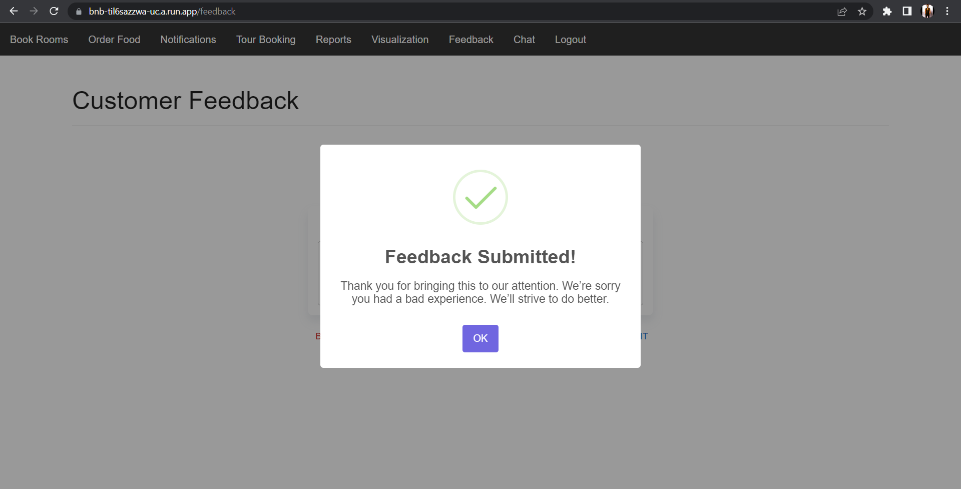

Figure 114 Screenshot displaying the appropriate popup message based on the identified polarity of the submitted feedback

The associated cloud function will perform sentiment analysis and store the user’s email, feedback, score, magnitude, and polarity of the feedback in the ‘customer_feedback’ collection in cloud Firestore. The below given figure displays the stored feedback with negative polarity as the submitted feedback was negative.

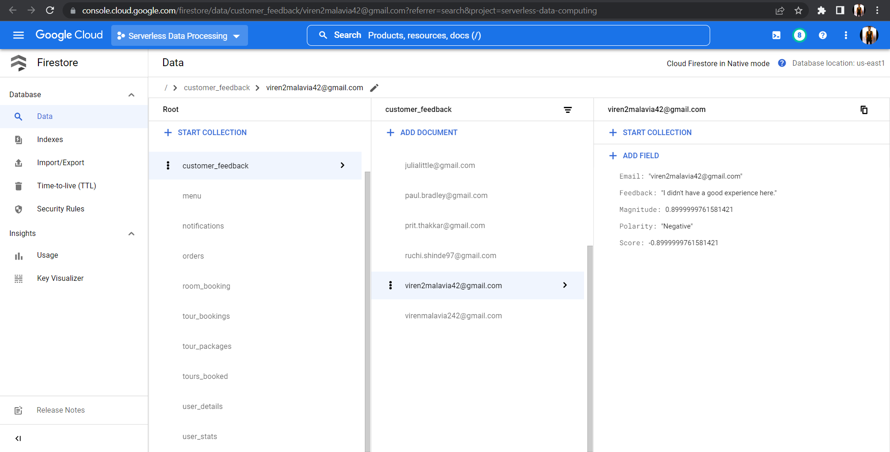

Figure 115 Screenshot displaying cloud Firestore getting updated with the user’s email, feedback, magnitude, identified polarity and sentiment score after submitting the feedback

1. Submitting neutral feedback

On submitting the feedback, the associated cloud function will be triggered which will perform sentiment analysis on the text to assign an appropriate sentiment score using Cloud Natural Language API. The below figures show what happens when a user submits neutral feedback.

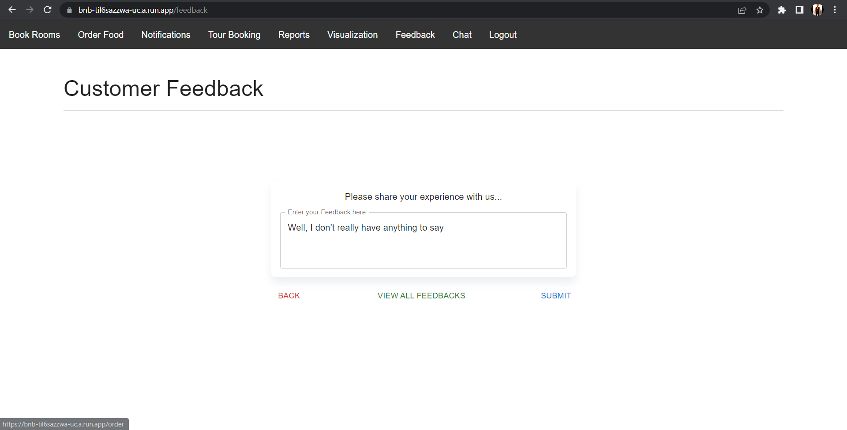

Figure 116 Screenshot displaying a test case where user enters neutral feedback

When feedback is submitted, an appropriate popup message will be displayed based on the polarity. As the submitted feedback in this case is neutral the below message will popup.

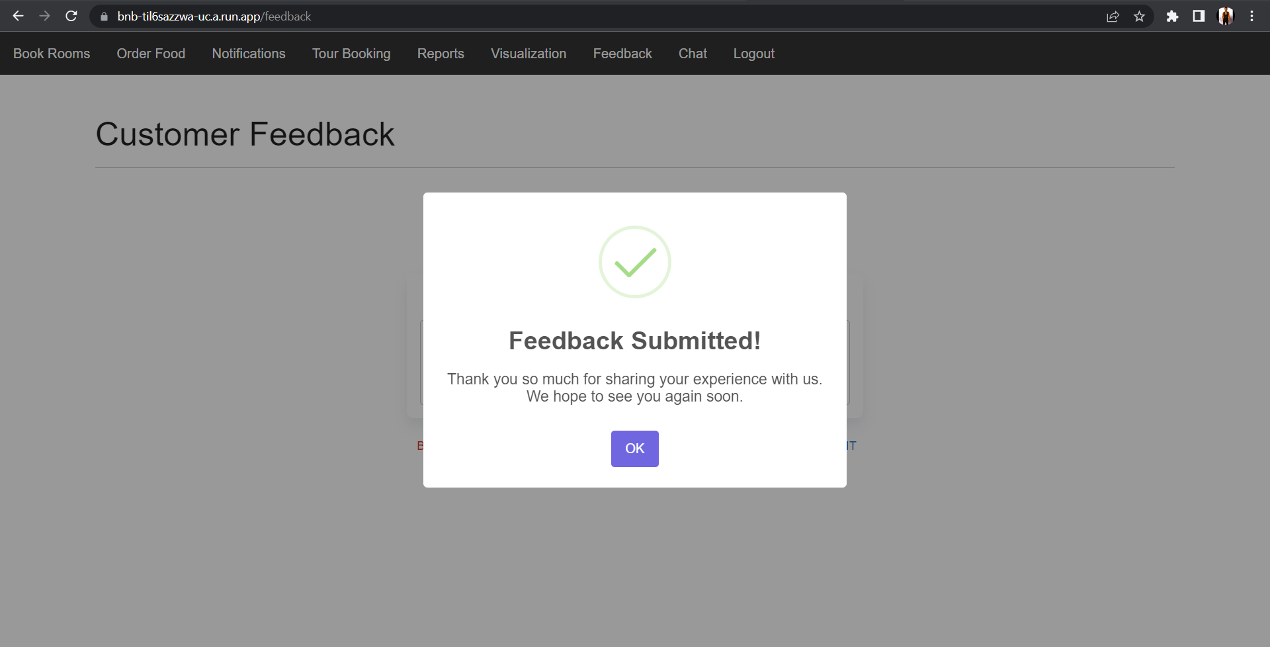

Figure 117 Screenshot displaying the appropriate popup message based on the identified polarity of the submitted feedback

After the associated cloud function is triggered and sentiment analysis is performed all the related data with the sentiment score will be stored in the ‘customer_feedback’ collection in cloud Firestore. The below given figure displays the stored feedback with neutral polarity as the submitted feedback was neutral.

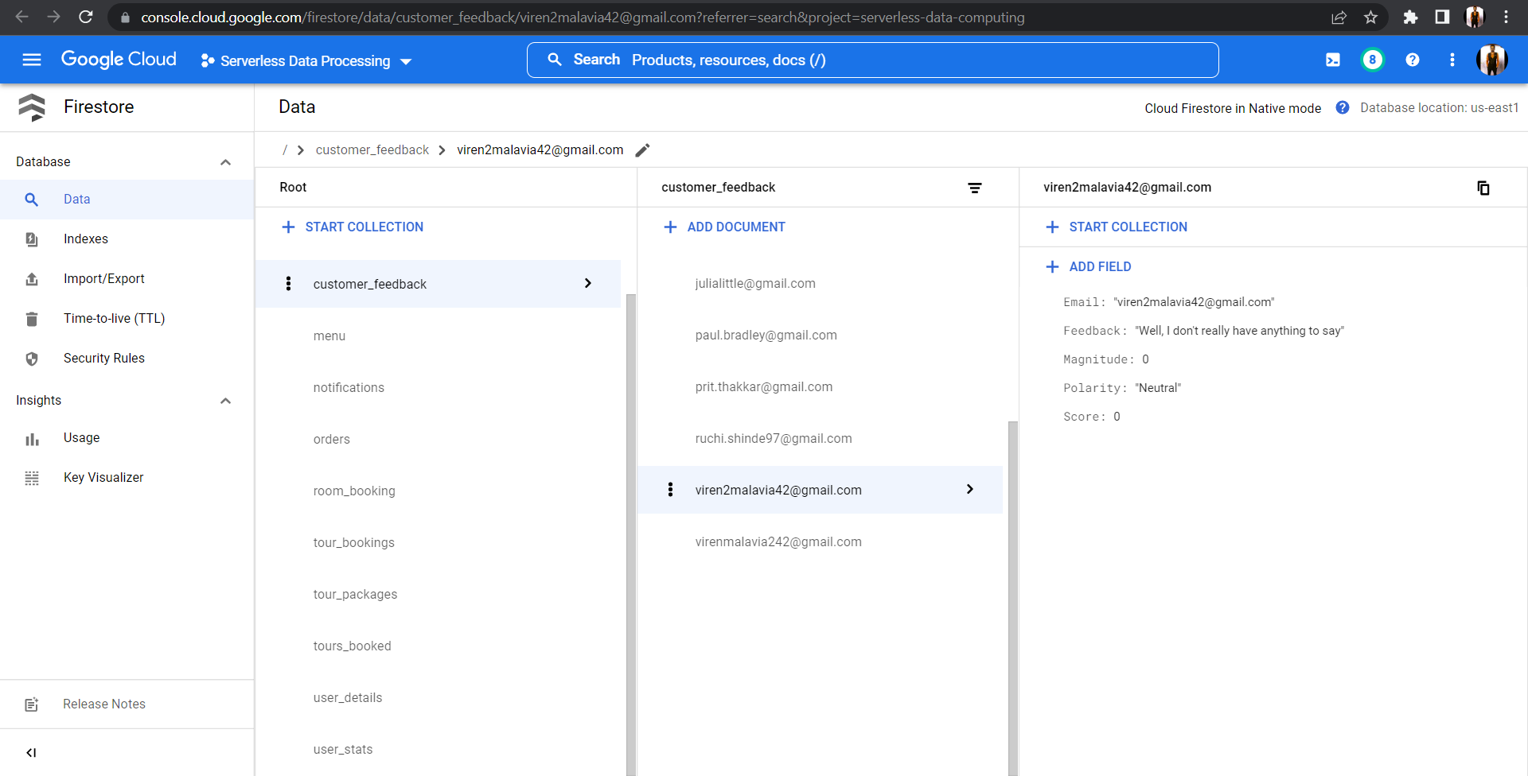

Figure 118 Screenshot displaying the submitted feedback on cloud Firestore with the user’s email, feedback, magnitude, identified polarity and sentiment score

1. Viewing all customer feedbacks

The users will be able to view all the customer feedbacks of our application with the feedback polarity by clicking on the view all feedbacks button.

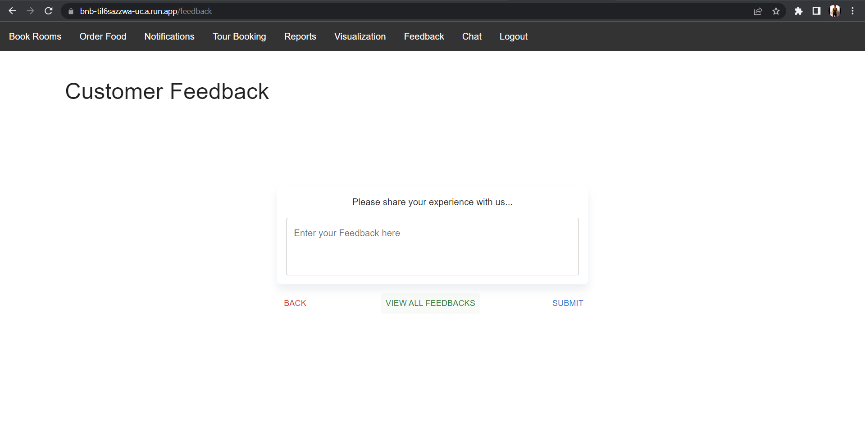

Figure 119 Users can click on the VIEW ALL FEEDBACKS button to view all application customer feedbacks

Below figures show the customer feedbacks page where users can view all the customer feedbacks with the type of polarity from either Positive, Negative, or Neutral.

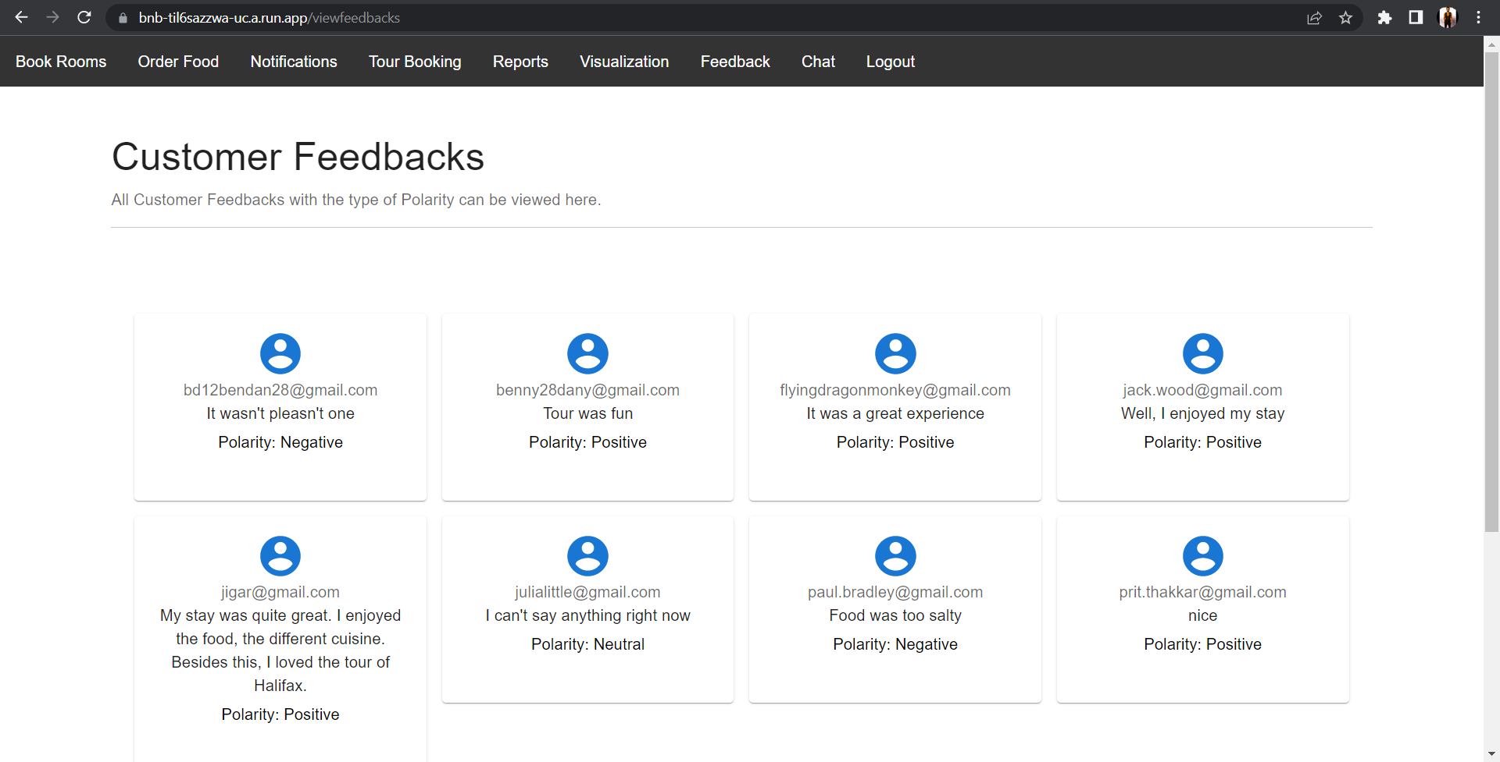

Figure 120 Screenshot displaying the customer feedbacks page with all the application feedbacks along with their polarity from either Positive, Negative, or Neutral

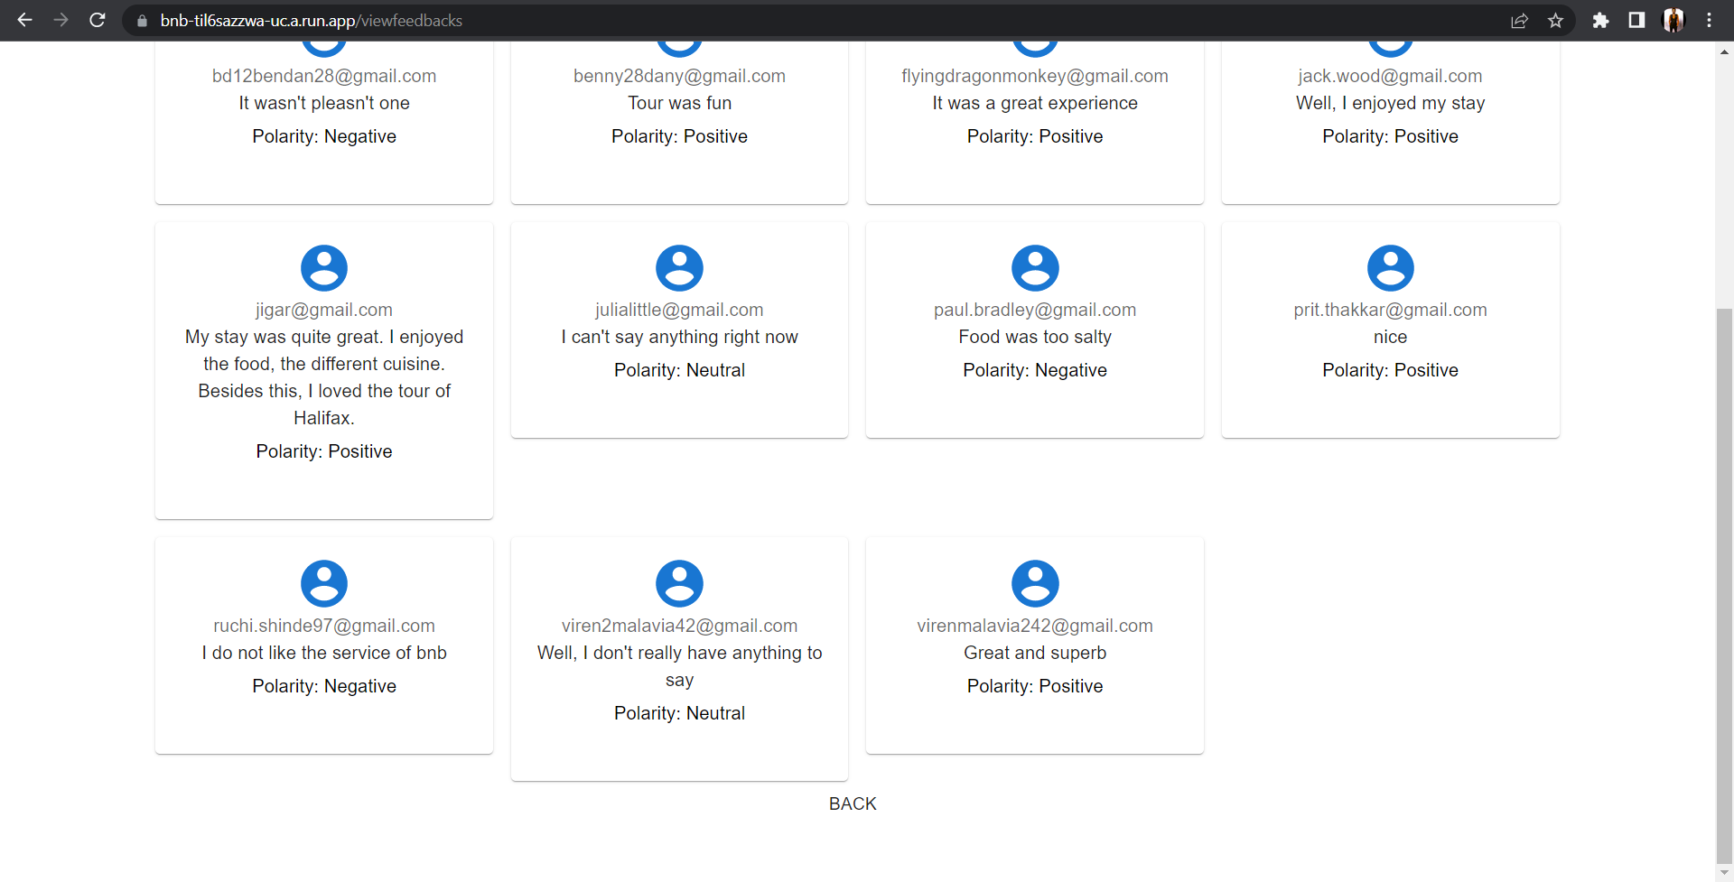

Figure 121 Screenshot displaying the customer feedbacks page with all the application feedbacks along with their polarity from either Positive, Negative, or Neutral

## **4.5 Web Application and Hosting**

The container registry with all our previous builds, and the deployed one marked as latest.

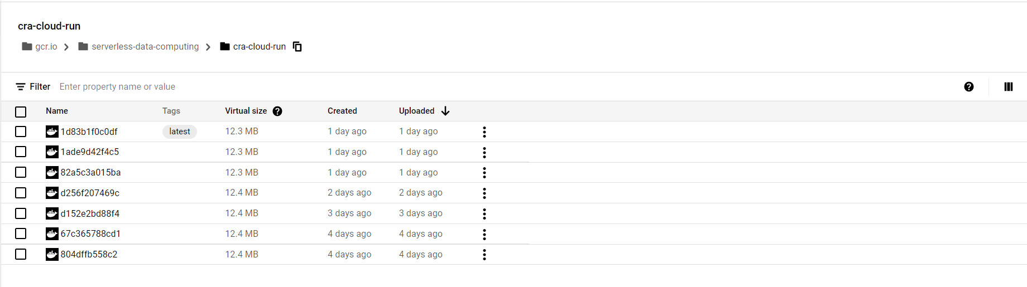

Figure 122 Google container registry, images stored at the registry

Cloud Run dashboard with bnb service up and running.



Figure 123 Cloud Run with serverless BNB deployed

Here we have some statistics on the bnb, its traffic, the region on which it is deployed and the URL on which the application is accepting requests.

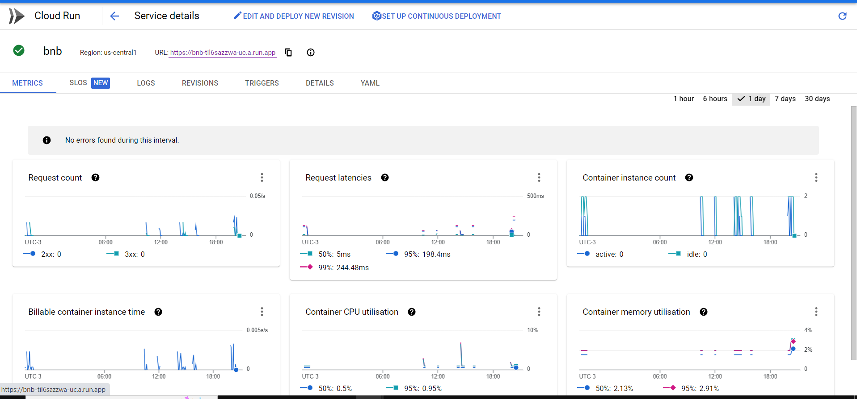

Figure 124 Traffic and invocation URL

Screenshot of Serverless BnB up and running.

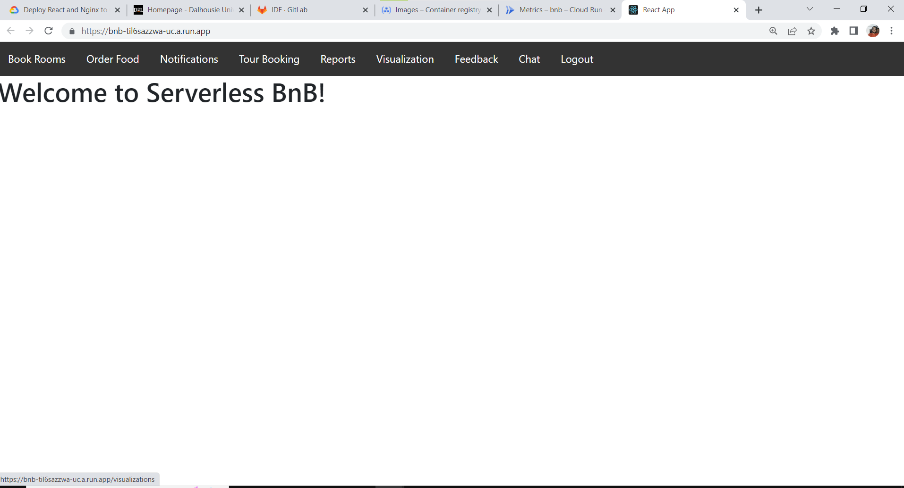

Figure 125 Deployed web application

## **4.6 Report Generation**

- For the report generation module, User login and logout statistics are stored in the Firestore. Whenever a user successfully signs in the login timestamp is stored in the firestore and whenever the user logs out of the application, the logout timestamp is stored in the firestore. On clicking the reports tab, the UI displays the report in the form of table of the past user login and logout timestamps and current login timestamp.



Figure 126 User login and Logout timestamp report

## **4.7 Visualizations**

1. Let us simulate a scenario where an unauthenticated user attempts to navigate to the visualizations page.

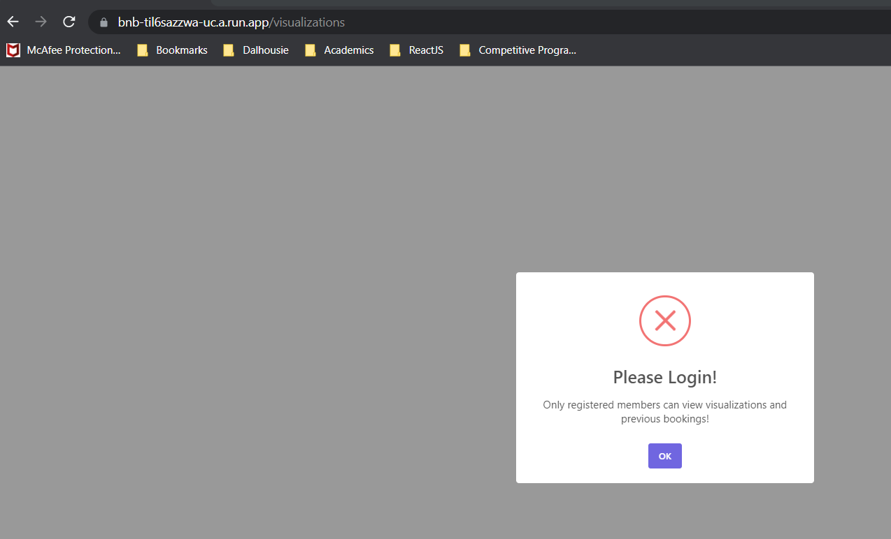

Figure 127 Unauthenticated user attempting to access the visualizations page

1. Visualizations Home Page

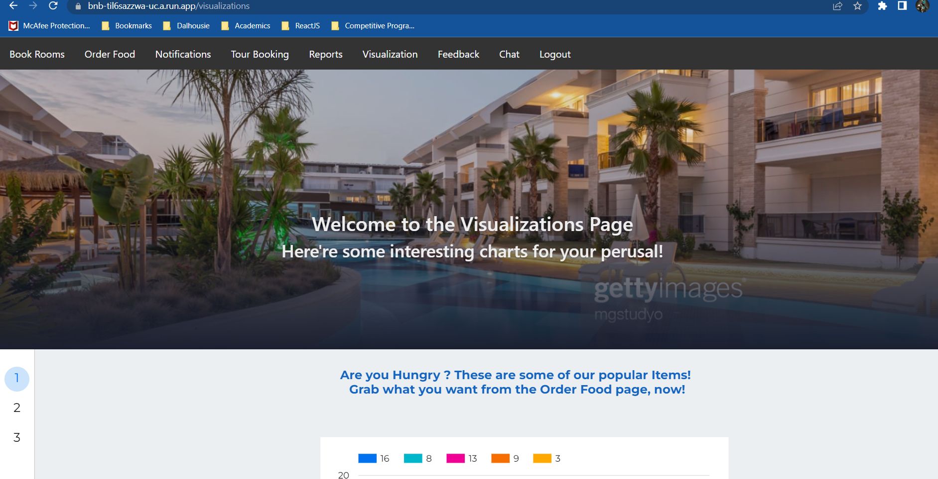

Figure 128 Visualizations Home page

1. Viewing Popular Food Orders

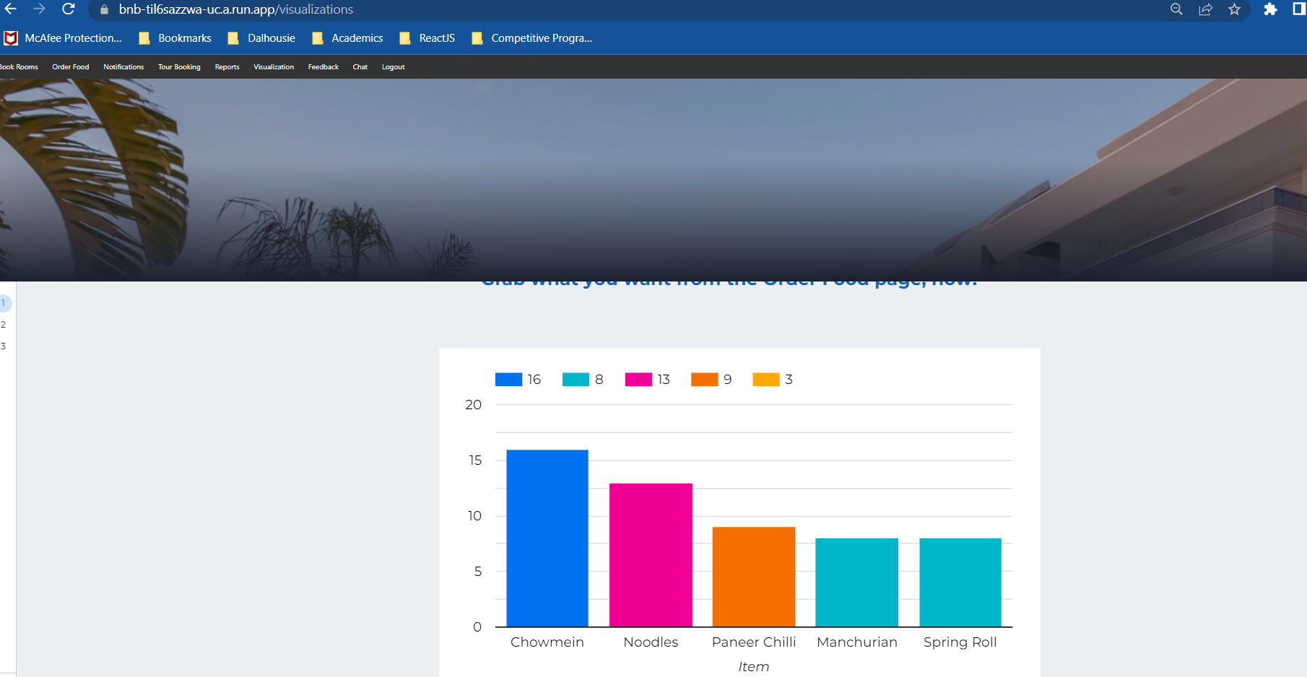

Figure 129 Top 5 Food Items

1. Viewing room reservation history

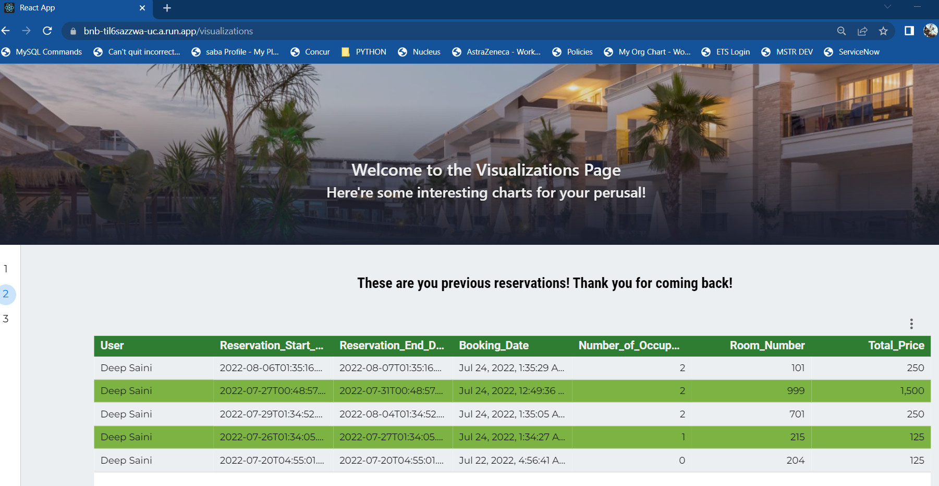

Figure 130 Room reservation history for each user

1. Viewing tour booking history

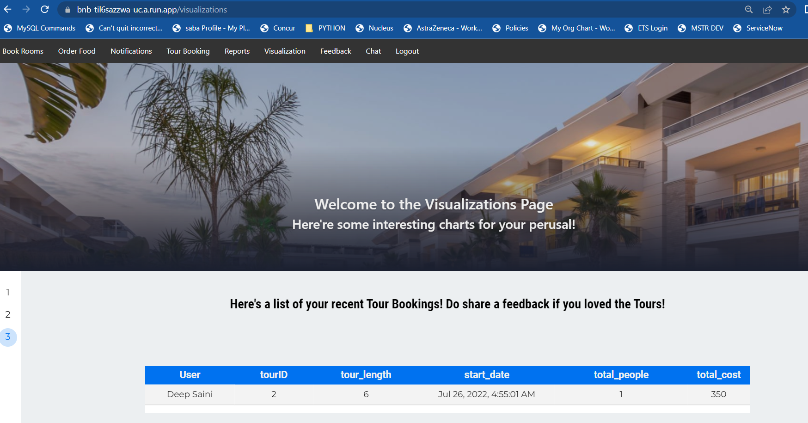

Figure 131 Tour Reservation History for each user

# Meeting Logs

Table 1: Meeting Logs

|  |  |  |  |  |
| --- | --- | --- | --- | --- |
| Date | Place | Attendees | Discussion Agenda | Duration |
| 18/5/22 | MS Teams | Benny, Kandarp, Ruchi, Viren, Prit | Understanding the requirements, cloud services and serverless architecture | 27m |
| 28/5/22 | MS Teams | Benny, Jaswant, Kandarp, Ruchi, Viren, Prit | Discussion on Cloud services | 30m |
| 29/5/22 | Wallace McCain Learning Commons | Jaswant, Kandarp, Ruchi, Viren, Prit | Database Schema, BnB features and assignment of features to devs, conceptual document task division | 1h20m |
| 31/5/22 | MS Teams | Benny, Jaswant, Kandarp, Ruchi, Viren, Prit | Finalized the conceptual document contents and formatting the doc | 40m |
| 30/6/22 | MS Teams | Benny, Jaswant, Kandarp, Ruchi, Viren, Prit | Discussed on the conceptual report feedback and worked on design document. | 30m |
| 3/7/2022 | MS Teams | Benny, Kandarp, Ruchi, Prit | Clarified doubts and reviewed the architectural diagram. | 48m |
| 16/7/2022 | MS Teams | Benny, Jaswant, Kandarp, Ruchi, Viren, Prit | Development progress check | 20m |
| 18/7/2022 | MS Teams | Benny, Jaswant, Kandarp, Ruchi, Viren, Prit | Development progress check and QnA preparation | 23m |
| 22/7/2022 | MS Teams | Benny, Jaswant, Kandarp, Viren, Prit | Development progress check and documentation | 20m |

# Individual Contribution

Table 2: Module Distribution

|  |  |  |
| --- | --- | --- |
| Banner ID | Name | Tasks |
| B00899629 | **Benny Tharigopala** | Room Reservation Module & Visualization Module |
| B00874871 | **Jaswanth Mandava** | Toor booking & Machine learning |
| B00873863 | **Kandarp Parikh** | User Management, Authentication & Report Generation |
| B00890731 | **Prit Thakkar** | Food Ordering & Message Passing |
| B00897784 | **Ruchi Shinde** | Online Support module |
| B00895669 | **Viren Malavia** | Machine learning, Feedback |

# Limitations

* The application is deployed on multi-cloud architecture as it is leveraging services of both Google cloud and AWS. If any of the service providers face down-time then the application won’t be fully functional.
* The management of configurations of various services becomes a bit difficult as multi-cloud approach is being used for application development. Moreover, ease of integration also reduces as we have to create pipelines to integrate cloud services of both the AWS and GCP.
* The generation of visualization graphs based on the Machine learning data is not a fully automated process. Thus, there exists an area of manual work to update reports and visualization reports.

# References

[1] “Amazon Cognito - Simple and Secure User Sign Up & Sign In | Amazon Web Services (AWS),” *Amazon Web Services, Inc.*, 2022. [Online]. Available: [**https://aws.amazon.com/cognito/**](https://aws.amazon.com/cognito/). [Accessed: Jul. 05, 2022]

[2] "Amazon QuickSight - Business Intelligence Service - Amazon Web Services", Amazon Web Services, Inc., 2022. [Online]. Available: <https://aws.amazon.com/quicksight/> . [Accessed: 04- Jul- 2022].

[3] "Conversational AI and Chatbots - Amazon Lex - Amazon Web Services", Amazon Web Services, Inc., 2022. [Online]. Available: <https://aws.amazon.com/lex/> . [Accessed: 04- Jul- 2022].

[4] “Features and capabilities of AutoML Natural Language | AutoML Natural Language Documentation | Google Cloud,” Google [Online]. Available:<https://cloud.google.com/natural-language/automl/docs/features>. [Accessed: 04-Jul-2022]

[5] “What is Pub/Sub?,” *Google Cloud*. [Online]. Available: <https://cloud.google.com/pubsub/docs/overview> . [Accessed: 05-Jul-2022].

[6] Kay, “Serverless Authentication with AWS Amplify: A Practical Guide - IOD – The Content Engineers,” *IOD - The Content Engineers*, Apr. 30, 2020. [Online]. Available: <https://iamondemand.com/blog/serverless-authentication-with-aws-amplify-a-practical-guide/#:~:text=Amplify%20is%20a%20serverless%20framework,services%20for%20different%20use%20cases>.. [Accessed: Jul. 05, 2022]

[7] C. McCrory, “Hosting a serverless web app using AWS Amplify – Towards AWS,” *Medium*, Jan. 30, 2022. [Online]. Available: [**https://towardsaws.com/hosting-a**](https://towardsaws.com/hosting-a) **serverless-web-app-using-aws-amplify-3f8c4ffd5a90**. [Accessed: Jul. 05, 2022]

[8] “Flowchart Maker & Online Diagram Software,” *Diagrams.net*, 2022. [Online]. Available: [**https://app.diagrams.net/**](https://app.diagrams.net/). [Accessed: Jul. 05, 2022]

[9] “Google Data Studio,” *Google.com*, 2014. [Online]. Available: [**https://datastudio.google.com/u/0/**](https://datastudio.google.com/u/0/). [Accessed: Jul. 05, 2022]

[10] “Caesar Cipher in javascript - LearnersBucket,” *LearnersBucket*, May 28, 2019. [Online]. Available: <https://learnersbucket.com/examples/algorithms/caesar-cipher-in-javascript/> . [Accessed: Jul. 25, 2022]

[11] “Extend Cloud Firestore with Cloud Functions  |  Firebase,” *Firebase*, 2022. [Online]. Available: <https://firebase.google.com/docs/firestore/extend-with-functions>. [Accessed: Jul. 25, 2022]

[12] “Getting started with DynamoDB and AWS SDKs - Amazon DynamoDB,” *Amazon.com*, 2022. [Online]. Available: <https://docs.aws.amazon.com/amazondynamodb/latest/developerguide/GettingStarted.html> . [Accessed: Jul. 25, 2022]

[13] “Deploy react and nginx to cloud run,” *Google Cloud*. [Online]. Available: <https://cloud.google.com/community/tutorials/deploy-react-nginx-cloud-run> [Accessed: 26-Jul-2022].

[14] “Perform simple and compound queries in Cloud Firestore,” *Firebase*. [Online]. Available: <https://firebase.google.com/docs/firestore/query-data/queries> [Accessed: 26-Jul-2022].

[15] “Schedule and run a cron job,” *Google Cloud*. [Online]. Available: <https://cloud.google.com/scheduler/docs/schedule-run-cron-job> [Accessed: 26-Jul-2022].

[16] “Node.js client library,” *Google Cloud*. [Online]. Available: <https://cloud.google.com/nodejs/docs/reference/pubsub/latest> [Accessed: 26-Jul-2022].

[17] “Http Cors,” *Google Cloud*. [Online]. Available: <https://cloud.google.com/functions/docs/samples/functions-http-cors> [Accessed: 26-Jul-2022]